Informatics Institute of Technology

In Collaboration With

The University of Westminster, UK



*The University of Westminster, Coat of Arms*

GenSum

Adaptive Generalized Text Summarization System using Optimized

Transformers

A dissertation by

Mr. Nazhim Kalam

W1761265 | 2019281

Supervised by

Mr. Torin Wirasingha

April 2023

Submitted in partial fulfilment of the requirements for the

BSc (Hons) Computer Science degree at the University of Westminster.

**DECLARATION**

I affirm that this dissertation, including its sub-components, is the product of my own original research endeavors. Furthermore, I confirm that I have not previously submitted or presented any of this content, in whole or in part, as part of any other degree or qualification program at any other university or institution. Any factual information obtained from credible external sources has been duly acknowledged through proper citation.

**Student Name**: Nazhim Kalam

**Registration Number**: w1761265 -- 2019281

**Signature: Date:** April 27, 2023



**ABSTRACT**

Abstractive text summarization systems have been integrated with various application in the world to perform text summarization and its nothing new to the field. However, with the prior research it found that in the domain of movies the need for performance improvement is required using latest approaches than the current traditional ML & DL methods, movie review summarization plays a major role in helping users to make better decisions by matching their interest with the reviews of the movie, this saves a lot of time and also improves businesses in their sales.

In 2017 researches from Google Brain introduced NLP Transformers, which is a latest approach to solve NLP problems and its increasingly been known and used nowadays over traditional ML & DL approaches like using basic LSTM, RNN approaches. The author explored ways in which to get an optimal solution using Transformer for abstractive text summarization and yet making a generalized solution which can be adapted with respect to any domain (be it hotels, movies, restaurants) and increase its performance as the system gets used over with time.

The author was able to experiment with few of the top tier transformer architectures to filter out the optimal model and integrated an automated hyperparameter searching mechanism which will find the best set of hyperparameters to train the model. **ROUGE1 of 80.8, ROUGE2 of 79.42, ROUGEL of 80.8, ROUGELSUM of 80.8** was the optimal evaluation metric result achieved from the BART model giving the best result.

**Keywords:** Natural Language Processing (NLP), Machine Learning (ML), Deep Learning (DL), Recall-Oriented Understudy for Gisting Evaluation (ROUGE), Inductive logic programming (ILP)

**Subject Descriptors:**

* Computing methodologies 🡪 Artificial intelligence 🡪 Natural language processing 🡪 Natural language generation
* Theory of computation 🡪 Theory and algorithms for application domains 🡪 Machine learning theory 🡪 Semi-supervised learning.
* Information systems 🡪 Information systems applications 🡪 Management and querying of encrypted data.
* Security and privacy 🡪 Database and storage security 🡪 Data mining.

# **PUBLICATIONS**

1. **A Review on Creating a Performance Adaptive Generalized Abstractive Text Summarization Using Optimized Transformers**

Conference: SmartNets 2023 - BDA-ML

Status: Submitted, In-Review

Venue: Asia, Colombo

Date: April 08, 2023

# **ACKNOWLEDGEMENT**

I am grateful for the supportive individuals in my life who have empowered me to exceed my previous limitations and achieve my current level of success, including the completion-of this final year research project.

I would like to express my deepest gratitude to Mr. Guhanathan Poravi, my esteemed module leader, for his consistent review and invaluable guidance that has tremendously improved my reports. His feedback has instilled in me the confidence to conduct research at any level. I am also grateful to my supervisor, Mr. Torin Wirasingha, for his contribution in refining my project idea and expanding its scope. I extend my appreciation to the evaluators of this project, who took the time to thoroughly review my work and provide valuable advice for its enhancement. Furthermore, I would like to thank all the interviewees and survey respondents, including industry and academia experts, as well as my senior and junior peers at IIT, for their invaluable input in the requirement gathering process.

I express my heartfelt appreciation to the esteemed lecturers at the Informatics Institute of Technology, as well as the supportive management, for the invaluable opportunities, unwavering support, and invaluable guidance they have provided me throughout my undergraduate degree. I would also like to acknowledge my fellow friends from university, whose continued support and positive influence have played a pivotal role in my growth as a developer/researcher. Their encouragement and camaraderie have fueled my rapid progress over the span of four years. Lastly, I extend my deepest gratitude to my parents for their unwavering support and encouragement in pursuing my dreams, and to my beloved family, friends, and significant other, whose unwavering encouragement has been a beacon of strength during challenging times.

**CONTENTS**

Publications iii

Acknowledgement Iv

List Of Tables Xi

List Of Figures Xiv

List Of Abbreviations Xvi

chapter 01. Introduction 1

1.1 chapter overview 1

1.2 problem domain 1

1.2.1 movie user reviews 1

1.2.2 text summarization 2

1.3 problem definition 2

1.3.1 problem statement 3

1.4 research motivation 3

1.5 research questions 3

1.6 research aim & objectives 4

1.6.1 research aim 4

1.6.2 research objectives 4

1.7 novelty of the research 8

1.7.1 problem novelty 8

1.7.2 solution novelty 8

1.8 research gap 8

1.9 contribution to the body of knowledge 9

1.9.1 research domain contribution 9

1.9.2 problem domain contribution 9

1.10 research challenge 10

1.11 chapter summary 10

chapter 02. Literature review 1

2.1 chapter overview 1

2.2 concept map 1

2.3 problem domain 1

2.3.1 user reviews 2

2.4 existing work 7

2.4.1 text summarization systems 7

2.4.2 algorithmic approaches for text summarization 8

2.4.3 usage of transformers 9

2.5 technological review 10

2.5.1 proposed architecture for the generalized text summarization system. 10

2.5.2 machine learning text summarization techniques 11

2.5.3 deep learning text summarization techniques 11

2.5.4 available datasets for generalized text summarization 12

2.5.5 available datasets for generalized text summarization 12

2.5.6 preprocessing techniques used in text summarization 12

2.6 evaluation techniques 13

2.6.1 evaluation approaches 13

2.6.2 benchmarking 16

2.7 chapter summary 17

chapter 03. Methodology 18

3.1 chapter overview 18

3.2 research methodology 18

3.3 development methodology 19

3.3.1 life cycle model 19

3.3.2 requirement elicitation methodology 19

3.3.3 design methodology 20

3.3.4 software development methodology 20

3.4 project management methodology 20

3.4.1 schedule 20

3.4.1.1 gantt chart 20

3.4.1.2 deliverables 21

3.5 resources 23

3.5.1 software requirements 23

3.5.2 hardware requirements 24

3.5.3 technical skills 24

3.5.4 data requirements 24

3.6 risks & mitigation 24

3.7 chapter summary 25

chapter 04. Software requirements specification 26

4.1 chapter overview 26

4.2 rich picture 26

4.3 stakeholder analysis 27

4.3.1 stakeholder onion model 27

4.3.2 stakeholder viewpoints 28

4.4 selection of requirement elicitation methodologies 29

4.5 discussion of findings 30

4.5.1 literature review 30

4.5.2 brainstorming 31

4.5.3 interviews 32

4.5.4 survey 34

4.5.5 self evaluation 37

4.5.6 prototyping 38

4.5.6 summary of findings 38

4.6 context diagram 40

4.7 use case diagram 41

4.8 use case descriptions 41

4.9 requirements 44

4.9.1 functional requirements 44

4.9.2 non-functional requirements 45

4.10 chapter summary 46

chapter 05. Social, legal, ethical & professional issues 47

5.1 chapter overview 47

5.2 slep issues and mitigation 47

5.3 chapter summary 48

chapter 06. Design 49

6.1 chapter overview 49

6.2 design goals 49

6.3 high level design 50

6.3.1 architecture diagram 50

6.3.2 discussion of tiers of the architecture 51

6.4 system design 52

6.4.1 choice of design paradigm 52

6.5 design diagrams 53

6.5.1 data flow diagrams 53

6.5.1.1 level 01 data flow diagram 54

6.5.1.2 level 02 data flow diagram 54

6.5.4 ui design 55

6.5.5 system process activity diagram 55

6.6 chapter summary 56

chapter 07. Implementation 57

7.1 chapter overview 57

7.2 technology selection 57

7.2.1 technology stack 57

7.2.2 data selection 58

7.2.3 programming language selection 59

7.2.4 development framework selection 59

7.2.5 libraries utilized 61

7.2.6 ide’s utilized 62

7.2.7 summary of technology selection 62

7.3 implementation of core functionalities 63

7.3.1 automated hyperparameter search & model training 63

7.3.2 model usage general & domain specific users 66

7.3.3 model retraining 68

7.3.4 data preprocessing 68

7.4 user interface 69

7.5 chapter summary 69

chapter 08. Testing 70

8.1 chapter overview 70

8.2 testing objectives & goals 70

8.3 testing criteria 70

8.4 model testing & evaluation 71

8.4.1 model testing 71

8.4.2 model evaluation 73

8.5 benchmarking 73

8.6 functional testing 74

8.7 module & integration testing 74

8.8 non-functional testing 75

8.9 limitations of the testing process 75

8.10 chapter summary 76

chapter 09. Evaluation 77

9.1 chapter overview 77

9.2 evaluation methodology & approach 77

9.3 evaluation criteria 77

9.4 self-evaluation 78

9.5 selection of evaluators 79

9.6 evaluation results & expert opinions 80

9.7 limitations of evaluation 82

9.8 evaluation of functional requirements 82

9.9 evaluation of non-functional requirements 82

9.10 chapter summary 82

chapter 10. Conclusion 83

10.1 chapter overview 83

10.2 achievement of research aim & objectives 83

10.2.1 achievement of aim 83

10.2.2 achievement of objectives 83

10.3 utilization of knowledge from the degree 83

10.4 use of existing skills 84

10.5 use of new skills 85

10.6 achievement of learning outcomes 85

10.7 problems and challenges faced 85

10.8 deviations 86

10.9 limitations of the research 86

10.10 future enhancements 86

10.11 achievement of the contribution to the body of knowledge 87

10.11.1 domain contributions 87

10.11.2 technical contribution 87

10.11.3 additional contributions 87

10.12 implementation code 87

10.13 concluding remarks 88

references i

appendix a – introduction v

a.1. Prototype feature diagram v

a.2. Project scope v

appendix b – literature review vii

b.1. Related work in abstractive text summarization vii

appendix c – srs x

c.1. Requirement elicitation methodologies x

c.2. Interview analysis x

c.3. Survey analysis xiii

c.4. Self-evaluation (competitor analysis) xiv

c.5. Use case descriptions xiv

c.6. Functional requirements xxi

appendix d – design xxii

d.1. Ui wireframes xxii

appendix e – implementation xxv

e.1. Selection of programming language xxv

e.2. Selection of deep learning (dl) framework xxvi

e.3. Selection of user interface (ui) framework xxvi

e.4. Selection of application programming interface (api) framework xxvii

e.5. Data preprocessing xxviii

e.6. User interface xxxii

appendix f – testing xxxvi

f.1. Functional testing xxxvi

f.2. Non-functional testing xxxviii

appendix g – evaluation xlii

g.1. Expert evaluators xlii

g.2. Evaluation of functional requirements xlii

g.3. Evaluation of non-functional requirements xliv

appendix h – conclusion xlvi

h.1. Status of research objectives xlvi

h.2. Achievement of learning outcomes xlviii

appendix i – concept map l

appendix j – review paper li

# **LIST OF TABLES**

Table 1: Research Objectives (Self-Composed) 4

Table 2: Comparison of Text Summarization Techniques (Self-Composed) 3

Table 3: Evaluation metrics for abstractive text summarization (Self-Composed) 13

Table 4: Comparison table for abstractive text summarization using transformers (Etemad, Abidi and Chhabra, 2021) 16

Table 5: Research Methodology (Self-Composed) 18

Table 6: Deliverables & Dates (Self-Composed) 21

Table 7: Risk Management Plan (Self-Composed) 24

Table 8: Stakeholder Viewpoints & Requirements (Self-Composed) 28

Table 9: Requirement Elicitation Methodologies (Self-Composed) 29

Table 10: Literature Review Findings (Self-Composed) 30

Table 11: Observations Findings (Self-Composed) 31

Table 12: Interview Thematic Analysis (Self-Composed) 32

Table 13: Survey Analysis (Self-Composed) 34

Table 14: Survey Thematic Analysis (Self-Composed) 37

Table 15: Prototyping Findings (Self-Composed) 38

Table 16: Summary of Findings (Self-Composed) 38

Table 17: Use Case Description Uc:07 (Self-Composed) 41

Table 18: Use Case Description Uc:03 (Self-Composed) 42

Table 19: Functional Requirements (Self-Composed) 44

Table 20: Non-Functional Requirements (Self-Composed) 45

Table 21: SLEP Issues & Mitigation 47

Table 22: Design Goals of The Proposed System (Self-Composed) 49

Table 23: Dataset Sources (Self-Composed) 59

Table 24: Development Framework Utilized (Self-Composed) 60

Table 25: Libraries Used with Reasonings (Self-Composed) 61

Table 26: Ide’s Used Along with Justifications (Self-Composed) 62

Table 27: Summary of Technology Selection (Self-Composed) 62

Table 28: Model Evaluation Results 73

Table 29: Benchmarking results 74

Table 30: Module & integration testing 74

Table 31: Evaluation criteria 77

Table 32: Self-Evaluation of The Author 78

Table 33: Categorization of selected evaluators 79

Table 34: Thematic analysis of expert feedback 80

Table 35: Utilization of Knowledge Gained from The Course 83

Table 36: Mitigations to Problems and Challenges Faced 85

Table 37: Related Work in Abstractive Text Summarization VII

Table 38: Stakeholder groups (*Self-Composed*) X

Table 39: Interview thematic analysis (*Self-Composed*) X

Table 40: Interview participant details XI

Table 41: Interview thematic analysis themes, conclusions & evidence XI

Table 42: Survey thematic analysis (*Self-Composed*) XIII

Table 43: Competitor Analysis (*Self-Composed*) XIV

Table 44: Usecase mappings (*Self-Composed*) XIV

Table 45: Use case description UC:01 (*Self-Composed*) XV

Table 46: Use case description UC:02 (*Self-Composed*) XVI

Table 47: Use case description UC:10 (*Self-Composed*) XVI

Table 48: Use case description UC:04 (*Self-Composed*) XVII

Table 49: Use case description UC:05 (*Self-Composed*) XVIII

Table 50: Use case description UC:06 (*Self-Composed*) XIX

Table 51: Use case description UC:08 (*Self-Composed*) XIX

Table 52: Use case description UC:09 (*Self-Composed*) XX

Table 53: ‘MoSCoW’ technique of requirement prioritization XXI

Table 54: Selection of Data Science Language XXV

Table 55: Selection of DL framework XXVI

Table 56: Selection of UI framework XXVI

Table 57: Selection of web framework XXVII

Table 58: Functional Testing XXXVI

Table 59: Non-functional testing XL

Table 60: Details of the expert evaluator(s) selected. XLII

Table 61: Evaluation of the implementation of functional requirements XLII

Table 62: Evaluation of the implementation of non-functional requirements XLIV

Table 63: Evaluation of the achievement of design goals XLV

Table 64: Status of research objectives XLVI

Table 65: Achievement of learning outcomes XLVIII

# 

# **LIST OF FIGURES**

Figure 1: Transformer Architecture Downloads Rate (Wolf et al., 2020) 5

Figure 2: Proposed Generalized Abstractive Summarization System Process Flow (Self-Composed) 10

Figure 3: Gantt Chart (Self-Composed) 21

Figure 4: Rich Picture Diagram (Self-Composed) 26

Figure 5: Stakeholder Onion Model (Self-Composed) 27

Figure 6: Context Diagram (Self-Composed) 40

Figure 7: Use Case Diagram (Self-Composed) 41

Figure 8: Three-Tiered Architecture (Self-Composed) 50

Figure 9: Data Flow Diagram - Level 01 (Self-Composed) 54

Figure 10: Data Flow Diagram - Level 02 (Self-Composed) 55

Figure 11: System Process Flow Chart (Self-Composed) 56

Figure 12: Technology Stack (Self-Composed) 58

Figure 13: Hyperparameter Range Initialization (Self-Composed) 63

Figure 14: Hyperparameter Search Using Optuna (Self-Composed) 64

Figure 15: Hyperparameter Results and Training Arguments (Self-Composed) 65

Figure 16: Model Training (Self-Composed) 65

Figure 17: General User Review Text Summarization (Self-Composed) 66

Figure 18: Assigning A Specific Model for The New Domain User (Self-Composed) 66

Figure 19: Domain Specific Text Review Summarization (Self-Composed) 67

Figure 20: Fetching Related Data for Model Retraining (Self-Composed) 68

Figure 21: Validation Accuracy by number of epochs – bart model (*Self-Composed*) 71

Figure 22: Validation Loss by number of epochs – bart model (*Self-Composed*) 71

Figure 23: Validation Accuracy by number of epochs – t5 model (*Self-Composed*) 72

Figure 24: Validation Loss by number of epochs – t5 model (*Self-Composed*) 72

Figure 25: Validation Accuracy by number of epochs – Pegasus model (*Self-Composed*) 72

Figure 26: Validation Loss by number of epochs – Pegasus model (*Self-Composed*) 72

Figure 27: Prototype Feature Diagram (Self-Composed) V

Figure 28: Homepage Wireframe (Self-Composed) XXII

Figure 29: Review History Page (Self-Composed) XXIII

Figure 30: User Profile Page (Self-Composed) XXIV

Figure 31: Preprocessing: Remove Markdown (Self-Composed) XXVIII

Figure 32: Preprocessing – Remove Hyperlinks (Self-Composed) XXVIII

Figure 33: Preprocessing: Remove Html Tags (Self-Composed) XXVIII

Figure 34: Preprocessing: Char Words Extension (Self-Composed) XXIX

Figure 35: Preprocessing: Handling Common Contractions (Self-Composed) XXIX

Figure 36: Preprocessing: Removing Special Characters (Self-Composed) XXX

Figure 37: Preprocessing: Resolving Spelling Mistakes (Self-Composed) XXX

Figure 38: Preprocessing: Removing Duplicates (Self-Composed) XXXI

Figure 39: Preprocessing: Restoring Missing Punctuations (Self-Composed) XXXI

Figure 40: Preprocessing: Grammarly Correction (Self-Composed) XXXI

Figure 41: GUI – Homepage (After Signup) (Self-Composed) XXXII

Figure 42: GUI – Review History Page (Self-Composed) XXXIII

Figure 43: GUI – User Profile (Self-Composed) XXXIV

Figure 44: GUI – Model Retraining Modal (Self-Composed) XXXIV

Figure 45: GUI – Homepage (Before Signup) (Self-Composed) XXXV

Figure 46: System Resource Manager Graph (Self-Composed) XXXVIII

Figure 47: Lighthouse landing page (*Self-Composed*) XXXIX

Figure 48: Lighthouse login page (*Self-Composed*) XXXIX

Figure 49: Lighthouse user profile page (*Self-Composed*) XXXIX

Figure 50: Lighthouse records page (*Self-Composed*) XXXIX

Figure 51: CodeFactor - Gensum repository (*Self-Composed*) XXXIX

Figure 52: CodeQL - Gensum repository (*Self-Composed*) XL

# **LIST OF ABBREVIATIONS**

|  |  |
| --- | --- |
| AI | Artificial Intelligence. |
| DL | Deep Learning |
| GUI | Graphical User Interface |
| ML | Machine Learning |
| NLP | Natural Language Processing |
| ROUGE | Recall-Oriented Understudy for Gisting Evaluation. |
| BLEU | BiLingual Evaluation Understudy. |
| T5 | Text to Transfer Transformer. |
| BART | Bidirectional Auto-Regressive Transformers. |
| BERT | Bidirectional Encoder Representations from Transformers. |
| PEGASUS | Pre-training with Extracted Gap-sentences for Abstractive Summarization Sequence-to-sequence |
| ILP | Inductive logic programming. |
| LSTM | Long Short-Term Memory. |
| RNN | Recurrent Neural Network. |
| CNN  SEQ2SEQ | Convolutional Neural Network.  Sequence to Sequence |
| RoBERTa | Robustly Optimized BERT Pre-training Approach |
| GPT-3  REST  GPU  API | Third Generation Generative Pre-Trained Transformer  Representational State Transfer  Graphical Processing Unit  Application Programming Interface |

# **CHAPTER 01. INTRODUCTION**

# **1.1 Chapter Overview**

In this chapter, a series of top-tier pretrained transformer designs are optimized using automated search hyperparameter optimization in an effort to improve the performance of abstractive text summarization for movie reviews while developing a generalized solution that may be used in other domains. Along with a review of previous studies and a presentation of the anticipated project timetable, the research problem, gap, challenge, and method will be discussed in the work plan.

# **1.2 Problem Domain**

## **1.2.1 Movie User Reviews**

A growing number of websites, like Amazon and the Internet Movie Database (IMBD), a website for movie reviews, allow users to publish reviews for things they are interested in, along with the growth of Web 2.0, where user interaction is prioritized. (Khan, Gul, Zareei, et al., 2020)

Online movie reviews are evolving into an important information source for users, with the continuous increase in data on the web (M and Mehla, 2019). However, online users post a significant number of movies reviews every day, hence making it difficult for them to manually summarize the reviews and determine their interest in the film. One of the challenging problems in natural language processing is mining and summarizing movie reviews. (Khan, Gul, Uddin, et al., 2020).

Text summary assist users or business decision-makers by compiling and analyzing a significant number of online reviews. (Alsaqer and Sasi, 2017).

These days, the majority of people research a film's reviews before selecting or watching it on any platform, such Netflix or Amazon Prime, but we also come across conflicting reviews that can be either good or bad. While most reviews are detailed and require a significant amount of time to review, this develops a problem where users aren't able to make quicker decisions. Therefore, by summarizing the review makes it easier and faster for users to make decisions. This can also help streaming services like Netflix quickly discover the viewing habits or preferences of their users (Dashtipour et al., 2021)

## **1.2.2 Text Summarization**

Today, there is a lot of textual material available, including news stories and reviews. Text summarizing helps us quickly find the key elements of the full piece by minimizing the quantity of text. (Mahajan et al., 2021).

Extractive summarization and abstractive summarization are typically the two methods of text summarization. When extractive summarizing, the most important lines from the context or article are plucked out without being altered in any way. Meanwhile, abstractive summarizing aims to create the sentences on its own and creates the summary; this is superior than extractive summarization since it is more meaningful to generate our own phrases inside the context rather than to utilize selected sentences from the context without any change. (Etemad, Abidi and Chhabra, 2021).

**1.2.3 Transformers**

Transformers in NLP is a novel architecture that aims to solve sequence-to-sequence tasks while handling long range dependencies with ease. It has surpassed competing neural models like CNN (Convolutional Neural Nets) and RNN (Recurrent Neural Nets) in terms of performance to appear as the dominant architecture for natural language processing (Wolf et al., 2020).

Transformers uses self-attention mechanism to target on selected areas of the input sentence followed by the encoder and decoder architecture (Etemad, Abidi and Chhabra, 2021).

# **1.3 Problem Definition**

In the domain of movie review summarization, currently there are no researches done using the latest deep learning approaches (***such as Transformers***) to solve this problem, standard machine & deep learning algorithms such as Naïve Bayes, RNN have been used, the usage of advanced deep learning approaches can be utilized in order to enhance the quality/accuracy of the text summarization.

Deep learning models take longer to train but they provide greater accuracy since they can simultaneously automate feature extraction and classification, whereas machine learning algorithms require feature selection at first. Therefore, applying deep learning techniques will help to improve the quality of text summarization and help the user in making better decisions (Etemad, Abidi and Chhabra, 2021).

## **1.3.1 Problem statement**

No prior research has looked into applying cutting-edge deep learning methods like Transformers to produce abstractive summaries from movie reviews, which can improve text summarization. This solution aims to be generic and accessible to any sector. (Khan, Gul, Zareei, et al., 2020).

# **1.4 Research motivation**

The identified problem can also be applied to several other domains which requires to improve the quality abstractive text summarization using the advanced approaches of deep learning, not only specific movie reviews, this is why a generalized solution was thought of initially (Kouris, Alexandridis and Stafylopatis, 2019).

As mentioned in the work of (Etemad, Abidi and Chhabra, 2021), syntactic and semantic issues with text summarization were the main issues that researchers were concerned on solving. and with respect to their research by exploring multiple deep learning techniques, they concluded that Transformer based models (T5 model) outperformed in all NLP tasks, this encourages the author to go deeper into the field of transformers optimization in order to enhance the quality of text summarization and address the constraints associated with the summarizing of movie reviews.

# **1.5 Research Questions**

**R**Q1: What are the top tier transformer architectures widely used and know for NLP problems related to text summarization?

**R**Q2: How can a pretrained transformer architecture be fine-tuned to get the optimal hyper parameters and to automate it for model retraining?

**R**Q3: What kind of evaluations should we perform after fine-tuning to filter out the best transformer architecture?

**R**Q4: How can domain generalization be integrated for system?

# **1.6 Research Aim & Objectives**

## **1.6.1 Research Aim**

***The aim of this research is to design, develop and evaluate an optimal adaptive generalized transformer architecture from a range of popularly used architectures by fine-tuning via automated hyperparameter optimization, therefore obtaining the recommended architecture's optimum performance***

A fully working system that can be utilized to perform abstractive text summarization based on the user input from any domain (movie, hotel, ecommerce etc.…) will be created by this research project. The quality of the resulting text summary or performance optimization will be the **main points** of emphasis. To get the best result, the usage of data preparation, data analysis, conducting hyperparameter tuning, and evaluating the models will be investigated.

Components will be built, necessary information will be gathered and researched, and performance will be assessed. The system may be utilized for private or public purposes on both a hosted server and a local browser. The data science models' source code will be made available in a public repository for future research and use. A research paper will be published and it end of this study.

## **1.6.2 Research Objectives**

For the research to be considered successful, its goals must be fulfilled

Table 1: Research Objectives (Self-Composed)

|  |  |  |  |
| --- | --- | --- | --- |
| **Objective** | **Description** | **LO** | **RQ** |
| Problem Identification | Comprehend and document the identified issue.  **RO1:** Perform research in a domain of interest and identify a sufficiently comprehensive problem that needs to be addressed.  **RO2**: Thoroughly explore and analyze potential solutions for addressing the problem.  **RO3**: Explore methods for developing an adaptive and generalized approach.  **RO4**: Create a schedule, determine associated deliverables, and develop a Gantt chart for the project. | LO1,  LO2 | RQ1,  RQ4 |
| Literature Review | Complete a thorough critical review of earlier related work.  **RO1:** Make a preliminary investigation on existing abstractive text summarization using deep learning approaches.  **RO2:** Make a preliminary investigation on why transformers architecture was the chosen deep learning choice for this research.  **RO3:** Analyze the top tier transformer architectures widely used.  **RO4:** Analyzing how the models can be fine-tuned via hyperparameter optimization.  **RO5:** Analyzing the different approaches used for model evaluation.  **RO6:** Analyze how the model can be generalized for every other domain. | LO1, LO4,  LO8 | **R**Q1,**R**Q2,**R**Q3,**R**Q4 |
| Methodology Selection and SLEP Framework | This defines the outline structure for the requirement analysis and the design process followed by the social legal ethical and professional issues.  **RO1**: Analyzing the Research Methodology approaches.  **RO2**: Analyzing the Development Methodology approaches.  **RO3**: Analyzing the Project Management Methodology approaches.  **RO4**: Analyzing the Solution Methodology approaches.  **RO5**: Analyzing the Social, Legal Ethical and Professional Issues which could develop during the phase of the project. | LO2,  LO6 | **R**Q4,**R**Q2,**R**Q1 |
| Requirement Elicitation | Defining the project's needs utilizing relevant approaches and tools in order to solve the projected research gaps and obstacles based on prior related research.  **RO1:** Gathering information related to the expected metadata required for the dataset to contain for the model training.  **RO2:** Gathering the requirements of transformer architectures for fine-tuning and understand the end to end user expectations.  **RO3:** Getting insights from domain experts to build a suitable system.  **RO4:** Gathering the requirements for handling generalization. | LO1, LO3, LO5 | **R**Q4,**R**Q2,**R**Q1 |
| Design | Considering the following when developing the suggested system:  **RO1:** Design a component to preprocess the dataset for the respective model inputs.  **RO2:** Design a component to store the top tier transformer models with their respective metadata, to use throughout.  **RO3:** Design a hyperparameter tuning component that can improve accuracy of the transformer model.  **RO4**: Design high-level architecture for the system. | LO1, LO5 | **R**Q2 |
| Implementation | Setting up a mechanism capable of addressing the gaps that were intended to be covered.  **RO1**: To develop data preprocessing component.  **RO2**: To develop a component that handles and stores the top tier transformer architectures for fine-tuning.  **RO3**: To develop the automated hyperparameter search component that handles all the top tier architectures assigned.  **RO4**: To develop a component for the model evaluations for the measured hyperparameters | LO1, LO5, LO7 | **R**Q2,**R**Q3 |
| Evaluation | Testing and evaluating the developed system (including the data science models with the suitable metrices)  **RO1**: Performing unit test, integration and performance testing along with a test plan created.  **RO2**: Evaluating all the transformer architectures used for fine-tune experimentations, using recommended scores such as (ROUGE or BLEU SCORE). | LO1,  LO5 | **R**Q3 |
| Documentation | Keeping track of and documenting the study project's ongoing progress and any challenges encountered. | LO6, LO8 | - |
| Publication | Ensure that the documentation, reports, and papers are well-structured and include a critical analysis of the research.  **RO1**: To publish a research paper on the related work done.  **RO2**: To publish the testing & evaluation results of the work done.  **RO3**: To publish the code implementation repository as public to be access by future research investigations, along with the models and datasets | LO4,  LO8 | - |

# **1.7 Novelty of the Research**

## **1.7.1 Problem Novelty**

The problem novelty of this research is, the lack of attempt to increase transformer performance in order to get better textual summarizing outcomes (Khan, Gul, Zareei, et al., 2020).

## **1.7.2 Solution Novelty**

The solution novelty for this problem is performing an automated approach for hyperparameter tuning & creating a retraining mechanism with newly exposed data to enhance its performance further using the optimal transformer (Etemad, Abidi and Chhabra, 2021).

# **1.8 Research Gap**

Based on previous work done (Khan, Gul, Zareei, et al., 2020) related to abstractive text summarization on movie reviews, the literature identifies for the need of using advanced deep learning approaches to improve the performance of text summarization for this movie domain over traditional machine learning approach.

This project focuses on Empirical gap in the Movie Domain, as well as Theoretical and Performance gaps in the area of transformer optimization. Transformers plays a major role in the field of deep learning especially at problems related to Natural Language Processing, by performing hyperparameter optimization on several transformer architectures we can contribute to the enhanced quality of abstractive text summarization and create a generalized model which can be adapted with the respective domains usage and improve the performance

# **1.9 Contribution to the body of knowledge**

Improving the performance of an existing solution is very common in the field of data science, as we can explore new algorithms or fine-tuning existing algorithms to get better results. The contributions for this project can be classified as theoretical contributions and domain contributions.

The following is a summarization of the authors contribution:

* ***Abstractive Text Summarization:*** *Automated Hyperparameter optimization + Model Retraining + Transformers + Deep Learning*
* ***Movie User Review & Generalization:*** *Research domain target is for Movie reviews, in addition the author makes the system generalized to adapt to any domain area*.

## **1.9.1 Research Domain Contribution**

There are various deep learning techniques that can be used to handle abstractive text summarization, however with respect to previous researches done, (Zhang, Xu and Wang, 2019) it is found that transformers outperform most of the other deep learning approaches as of today but there was no much research on optimizing them for a much better performance.

This research will be focused on creating a generalized solution by achieving the optimized transformer architecture from a couple of the top tier existing architectures, via fine-tuning and performing hyperparameter optimization along with handling abstractive text summarization (Liu and Wang, 2021), therefore we are able to maximize the performance of the recommended architecture. The author plans out to make use of generalization where any domain when used the model will be optimizing and adapting towards their respective domain.

## **1.9.2 Problem Domain Contribution**

Neural Networks makes up the backbone of deep learning algorithms which enables them to process complex unstructured data over normal means of machine learning algorithms (Mahajan et al., 2021). It is found that, the need for using advanced deep learning approaches has not been explored in the domain of movie review summarization.

Given that transformers perform well in this field, the proposed solution for this domain will be finding the recommended architecture along with hyper-parameter optimization, to reach its best performance. An additional contribution will be that, the proposed solution will be generalized to any other domain linked with the field of NLP text summarization.

# **1.10 Research Challenge**

The main objective of this research is to achieve the generalized optimal transformer architecture for the field of NLP abstractive text summarization. Transformers were introduced in 2017 by a team at Google Brain and are the most used choice for NLP problems replacing RNN models, given that this architecture was introduced not much longer back brings to a point where there is a lack of research done in the area of transformer optimization for the purpose of abstractive text summarization. (Wolf et al., 2020).

Therefore, creating and finding the recommended transformer architecture along with the optimal parameters which also handles generalization becomes a challenge with very fewer resources to look up to.

Additionally, identifying suitable datasets for this domain (Movie Reviews Summarization) and Generalization is challenging and necessitates a substantial amount of effort in data preprocessing where it is important since we are dealing with NLP and performance optimization related domain.

# **1.11 Chapter summary**

The author outlined the research effort, explained why the research and problem were innovative, and discussed potential challenges that could develop while attempting to tackle them in this chapter. Additionally, the key goals that must be attained for the research to be deemed successful were outlined and connected to the necessary learning outcomes for the degree.

# **CHAPTER 02. LITERATURE REVIEW**

# **2.1 Chapter Overview**

In this chapter, the author presents critiques on prior relevant work about the use of abstractive text summarization in the domain of movie review summarization, along with the usage of advanced deep learning approaches such as transformers. Additionally, the author tries to create a generalized model that will handle several other domains in addition, not just to only the movie domain.

Finally, the author determines the optimal transformer design that has been improved in order to produce the greatest outcomes by obtaining the optimum set of hyperparameters by model fine-tuning, performing hybridization and adaptive model retraining with new data and hyperparameters.

# **2.2 Concept Map**

The concept map illustrates the project scope that will be addressed in this literature review, and the nodes that are highlighted correspond to the project's primary study areas. The concept map was created to ensure that all necessary literature was covered. The concept map can be found in **APPENDIX I**.

# **2.3 Problem Domain**

The simplicity of selling products or services to customers is growing along with the usage of technology and the internet. Sellers utilize customer feedback to better decide how to improve sales and so attain customer satisfaction (Boorugu, Ramesh and Madhavi, 2019). When it comes to movies, people typically find it quite challenging to quickly determine whether a movie meets their demands by reading the reviews, which may occasionally be very lengthy and time-consuming (Khan et al., 2020).

## **2.3.1 User Reviews**

A user/customer review is typically referred to be written feedback from a customer who has used a product or service. Consumers frequently use user ratings and reviews to drive their purchasing decisions. Because the review data is unstructured, it becomes more challenging for consumers to compare and understand lengthier reviews (Lackermair, Kailer and Kanmaz, 2013).

User and customer reviews are extremely important to major corporations like tourism and hospitality as they constitute the primary engine for the country's economic growth and development. where tourists from over the world may blog about their experiences and share their reviews online in numerous formats (Mukherjee et al., 2020).

**2.3.2 Corporate Advantage**

It is also known that it costs at least five times as much time and money to acquire a new customer as it does to keep an existing one, so it is important to learn how to foster customer loyalty to the brand, business, or service that is being offered. Customer satisfaction is essential to the survival of corporate industries. Understanding client expectations through their feedback or reviews helps business industries grow and fix faults (Pizam and Ellis, 1999).

On the other hand, companies like Netflix or Amazon Prime can use the movie summaries to help users and understand the watching pattern or their interest. Likewise, the movie-related industries need to allow the customers to quickly scan the summary and quickly decide whether they should be watching it or not (Khan et al., 2020).

**2.3.3 Text Summarization**

With the massive accumulation of information/data on the internet nowadays, it is extremely difficult to extract relevant information from a large number of textual documents. The goal of text summarizing is to provide a condensed yet meaningful version of a lengthy textual content (Shi et al., 2020).

We all know that text summarization has several uses in a variety of internet-based fields, including search engines that are used for querying and e-commerce sites that utilize sentiment analysis to determine client satisfaction with items (Etemad, Abidi and Chhabra, 2021).

However, in the movie industry, consumers may utilize text summarization to simplify customer reviews of movies, which are often lengthy and time-consuming to read. This enables users to make better decisions when they decide whether or not to watch a certain movie (Khan et al., 2020).

**2.3.4 Abstractive and Extractive Techniques**

Generally, text summarization is classified into two which are; abstractive text summarization and extractive text summarization, however the approach for creating a hybrid model for text summarization is possible (Alsaqer and Sasi, 2017). The abstractive text summarization technique aims to produce the sentences on its own and then uses them to provide a coherent summary. Therefore, the summary's content will vary from the original context yet still convey the same idea (Mahajan et al., 2021). Additionally, it is well recognized that a strong abstractive summary encompasses the input's key details and is linguistically fluent (Zhang et al., 2020).

The extractive text summarizing method focuses on picking out key phrases or groups of phrases from the original input content and combining them to produce a concise yet insightful text summary. It is determined which sentences should be included as parts of the summary based on the statistical and linguistic characteristics of the sentences (Gupta and Lehal, 2010). A hybrid system is one that combines various strategies to produce a single system. However, hybrid text summarizing systems do exist, for instance, using a combination of extractive and abstractive summarization can be utilized to generate a hybrid system that uses encoder-decoders (Kirmani et al., 2019; Abolghasemi, Dadkhah and Tohidi, 2022).

Table 2: Comparison of Text Summarization Techniques (Self-Composed)

|  |  |
| --- | --- |
| **Abstractive** | **Extractive** |
| Paraphrases content like humans do, meaning it creates its own context (Mahajan et al., 2021) | Doesn’t create its own context but uses the best possible phrases from the original document (Gupta and Lehal, 2010) |
| A vast number of datasets are available to experiment working in this domain. | Capable of visualizing sentence scores and investigating gradient-based ways to calculating the contribution of each input token to score prediction (Pai, 2014) |
| There is a probability of creating information which may be faulty or that gives a different in meaning compared to the original text. | There is a possibility that the combined sentences made from the extracted sentences will contain errors. |

**2.3.5 NLP with Deep Learning**

NLP is a method for computers to intelligently and effectively analyze, comprehend, and derive meaning from human language, as opposed to other approaches that only focus on the interactions between human language and computers. Deep learning techniques are increasingly being used in the field of AI compared to traditional machine learning approaches due to their success rates in handling difficult high computing learning tasks (Lopez and Kalita, 2017; Mahajan et al., 2021).

In today's NLP, machine learning is prominent, but for the most part it only involves numerically optimizing the weights of characteristics and representations that have been created by humans. Deep learning aims to investigate how computers can utilize data to create features and representations suitable for challenging interpretation tasks (Socher, Bengio and Manning, 2012).

**2.3.6 Transformers**

Open-source library Transformers contains modern transformer architectures that have been thoroughly developed and are integrated by a common API. Pretraining has enabled the efficient use of this capacity for a wide range of activities, and these designs have permitted the construction of higher-capacity models. Transformers are designed to be easy for practitioners, expandable for researchers, and quick and reliable in industrial deployments (Wolf et al., 2020).

It has been demonstrated that the modern generation of pre-trained language models based on transformers is rather competent at identifying syntactic signals like noun modifiers, possessive pronouns, prepositions, or co-referents, as well as semantic cues like entities and relations (Brasoveanu and Andonie, 2020).

Hugging Face Hub offers a variety of transformer designs, including BERT, GPT2, T5, PEGASUS, and many others. The figure below represents the daily average for unique downloads of the pretrained transformer model architectures between Oct 2019 to May 2020 (Wolf et al., 2020).

Figure 1: Transformer Architecture Downloads Rate (Wolf et al., 2020)

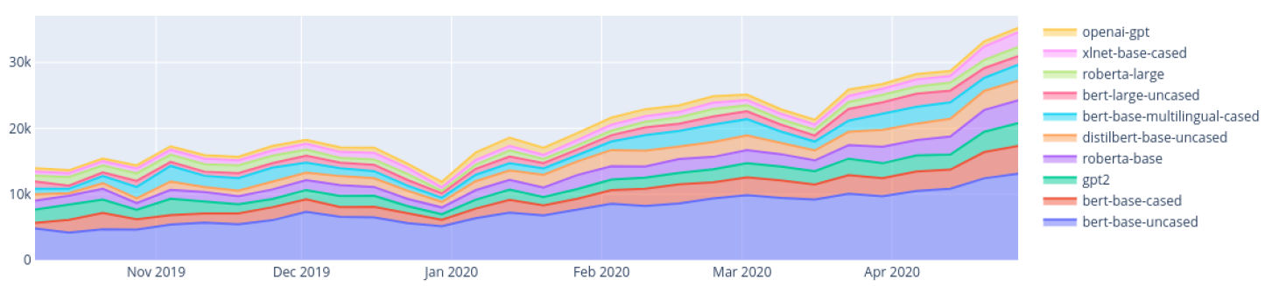

(Etemad, Abidi and Chhabra, 2021) research compares various other researchers approaches taken in order to perform abstractive text summarization, these techniques includes the use of transformers and other neural network approaches such as CNN and LSTM RNN networks. The research comparison table below only includes the approaches of transformers used taken abstractive text summarization.

**2.3.7 Hyperparameter Tuning**

Finding the ideal collection of parameter values to train an algorithm using in order to build a model relevant to the dataset is known as hyperparameter tuning (Liu and Wang, 2021). The calculation of the performance improvement that may be obtained by changing the value of each of the considered hyperparameters from the original value to the value indicated in the target configuration set by the tuning strategy is where hyperparameters make the biggest contribution to improving algorithm performance (Joy and Selvan, 2022).

There are several hyperparameters that play a significant role in performance enhancement; however, not all of the parameters do so; just a select handful do, for example, learning rate, weight decay, number of epochs, batch size, and warmup ratio. As a result, giving critical hyperparameters a higher priority is crucial (aws.amazon.com, 2022).

Automated framework tools, such as Optuna, an open-source framework for hyperparameter optimization built on the Python programming language, does hyperparameter tweaking. The application of numerous hyperparameter optimization techniques, including Grid Search, Random Search, TPE, and CMA-ES algorithms, was made easier by this framework (Joy and Selvan, 2022).

**2.3.8 Generalization**

Generalization now plays a significant part in resolving issues in numerous fields that are linked to the same issue. The capacity of a model to generalize to new, previously unobserved data that comes from the same distribution as the model's original data is known as generalization (Neyshabur et al., 2017).

Generalization is a useful strategy for starting with the foundation and improving or specializing in one's field as more unseen domain data becomes available. Therefore, the generalized solution will be able to adapt to even unseen domain data, making this solution to solve a common problem in multiple domain (Zhou et al., 2021).

**2.3.9 Data Expansion**

The quality of a machine learning or deep learning model depends on a number of factors, one of which is the amount and quality of data fed during model training. There are several approaches to increase or expand your available data one of which is data augmentation (making use of existing data points to create new data points). Making using of new data from the users end by saving as the model is used is another way of exposing new data for model retraining (Shorten and Khoshgoftaar, 2019).

When generalized models are required to adapt to become domain specific, model retraining will be considered with new data used by the specialized domain as the application is used.

# **2.4 Existing work**

There have been several works done on abstractive text summarization for the field of movie reviews, mainly using the traditional machine learning algorithms. However, there are several limitations which created the need for recent deep learning approaches in order to improve the **system’s performance.**

## **2.4.1 Text Summarization Systems**

There were multiple studies done previously in the area of text summarization, regarding both abstractive and extractive text summarization. (Khan et al., 2020) research is related to the domain of movie reviews summarization which is the same as this project domain, where the author has developed an automatic approach to summarize lengthy movie reviews along with the feature where the users are allowed to quickly recognize the positive and negative aspects of the movie with respect to the review processed with. The text summarization approach taken by the author is **extractive approach**, where sentence score ranking plays a major role in creating the summary.

The study of (Boorugu, Ramesh and Madhavi, 2019) is towards the domain of ecommerce but yet related to text summarization for customer reviews on the products they sell, so purpose being that, allowing other customer make better purchasing decisions on products, therefore the hassle of going through all the reviews to making a purchasing decision can be reduced to save time, **abstractive approach** is considered to create the summary, which is a better choice of approach.

The research of (Mukherjee et al., 2020) is another **extractive approach** for text summarization where the author develops a solution for generating personalized aspect-based opinion summaries using a dataset which consists of a large collection of online tourist reviews. In addition, the author has gone a step further to personalize the summary's qualities by using the user's interest. However, using abstractive summarization would be a more effective strategy but also challenging when user interest customization is considered because the sentences have been created using own words rather than with any sentence ranking technique.

(Gupta et al., 2021) research is a comprehensive comparison study with benchmarking results of various pretrained transformer architectures such as BART, BERT, T5, PEGASUS etc... for abstractive text summarization which is an **abstractive approach.** This study includes the various types of datasets been used to explore each model with the evaluations as benchmarking results. The author has also concluded the best performing transformer architecture as **T5** by comparing the evaluation results of the study.

The study conducted by (Mahajan et al., 2021) is also an **abstractive approach** to text summarization with the addition of proper grammar and no repeated words used using a deep learning approach with RNN and likewise (Etemad, Abidi and Chhabra, 2021)research also relates to an experimenting study with various deep learning approaches for abstractive text summarization along with the evaluation benchmarking with a goal in search for the best deep learning approach for the problem.

## **2.4.2 Algorithmic approaches for Text Summarization**

As described in this literature review's Problem Domain section, deep learning approaches are mostly given priority to than traditional machine learning approaches as they can handle highly computational tasks. The author came across of multiple deep learning techniques used aswell as machine learning techniques used for handling abstractive text summarization.

The study of (Khan et al., 2020) starts by first focusing on feature extraction, then transforming reviews into vector spaces, and applying the Naive Bayes machine learning method for review classification utilizing an undirected weighted graph-based ranking algorithm to rank score for each review phrase in graph and then, in order to construct the extractive summary, the highest scoring sentences are selected. However, the author has limited the use of sophisticated deep learning algorithms to improve performance by solely using standard machine learning approaches to tackle the problem.

(Boorugu, Ramesh and Madhavi, 2019) research made use of seq2seq model for text summarization along with the attention mechanism for improved accuracy and the Concept net Number batch word embedding model, which is superior than Glove. Utilizing a 1D convolutional layer, a max pooling layer, an LSTM layer, and finally a fully connected layer at the very end. However, the author's use of generic deep learning algorithms to handle this problem introduces a new constraint that prevents performance from being improved using the most recent deep learning strategy for NLP-related problems, transformers.

The research of (Mukherjee et al., 2020) liked mentioned earlier is an extractive method text summarization based on integer linear programming (**ILP** [Unsupervised method]) to choose an informative subset of opinions centered on the identified aspects. Utilize ROUGE-based criteria to assess and contrast the summaries and get competitive outcomes. Since the dataset is also constrained, extractive summaries could not be particularly insightful; thus, utilizing an abstractive technique might produce superior results, despite the dataset's constrained size.

The study of (Mahajan et al., 2021) focus of the authors' study is utilizing the **encoder-decoder** model with the attention layer to produce text summaries with good syntax and no repeated words. the creation of an encoder-decoder model with gated recurrent units and training it to provide an abstract summary of a piece of writing. Although the author employed deep learning, its application in production required real-time training so that it could be updated with the most recent content over time.

## **2.4.3 Usage of Transformers**

(Gupta et al., 2021) research employed pretrained models such Pipeline BART, BART modified, T5, and PEGASUS to deal with text summarization as a part of the comparison study done. The ROUGE Scores were used as the evaluation measures. During the experiments, the author employed transformer designs; however, the **hyperparameters** used were **default** and might be tuned for a better performance. The constraints consist of concentrating on developing more reliable models that can further expand the method to produce summaries of varying length and applicable for multi-document summarization.

(Etemad, Abidi and Chhabra, 2021)The author explores with deep learning methods in the broad text summarization domain to determine which method—among a collection that includes RNN, CNN, and Transformers—performs best. The author also considers metrics for model evaluations including BLEU and ROUGE, despite using sophisticated deep learning algorithms, the author was unable to undertake **hyperparameter** tuning to improve the method and obtain a better outcome.

# **2.5 Technological review**

There are many applications for text summarization systems today, especially when researching papers. Users may choose from a variety of contexts, such as research paper materials, customer reviews, etc., much more easily by using summaries to comprehend the context and pinpoint the key concepts. Text summarization tools assist researchers in frequently writing an abstract of their findings. With this technique, text summaries may be extracted or abstracted. In contrast to extractive text summarizing, the abstractive text summarization approach creates its own context, which is a far more logical or human-like written language, and can help with problem solving (Barna and Heickal, 2022). Text summarizers may be quite helpful in highlighting the key elements of reviews by providing a summary of user reviews, which can sometimes be very extensive and descriptive.

Traditional machine learning and deep learning approaches has been widely used for text summarization for the domain of movies reviews, however advanced deep learning approaches such as Transformers has not been explored for the domain of movie reviews but yet been used in other case scenarios. Even though traditional machine learning and deep learning approaches performed well, there was a limitation to push the boundaries with new approaches. That’s where transformer optimized was considered via repeated hyperparameter tuning with exposure to new data and making this generalized to any domain.

## **2.5.1 Proposed architecture for the Generalized Text Summarization System.**

Figure 2: Proposed Generalized Abstractive Summarization System Process Flow (Self-Composed) – ([*view high qual version*](https://drive.google.com/file/d/1leiRoTbLK7OU3-IS_mFnOH6GRkJF37Xd/view))

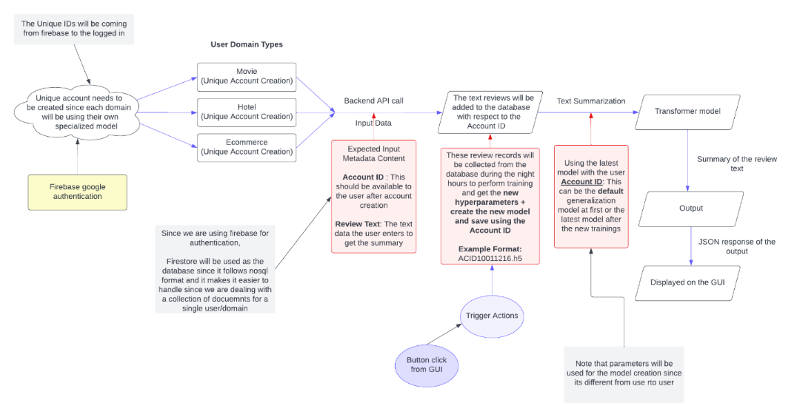

## **2.5.2 Machine Learning Text Summarization Techniques**

(Boorugu, Ramesh and Madhavi, 2019) points out a previous research where a system was built that uses a hybrid classifier approach with machine learning algorithm combination of SVM and Naïve Bayes in sync with fuzzy logic and they also concluded that with the increase in the classifier count the accuracy can also be increased. They also made use of supervised ML algorithms such as KNN for the classification of the reviews which then combining appropriate words for identifying the features of the product.

(Khan et al., 2020) proposed system was for the movies domain using the customer reviews, the author broke down proposed methodology into segments of which is preprocessing, feature extraction, review classification and finally review summarization. The Nave Bayes (NB) classification method, which is regarded as a robust classifier and may achieve greater accuracy, was used to categorize the reviews from negative to positive using supervised ML classification technique, It is clear that an extractive summarization approach was used because the text summarization phase was completed in several stages, starting with the creation of a graph from classified reviews, followed by the ranking of graph nodes and the selection of the top rank sentences for the summary generation.

Initially, these machine learning methodologies were given a lot of significance, but as time has progressed on, new technologies and techniques have emerged that can utilize deep learning techniques like RNN, CNN, etc. to perform better.

## **2.5.3 Deep Learning Text Summarization Techniques**

Numerous studies have been conducted on deep learning methods for abstractive text summarization, such as with the usage of CNN, LSTM-CNN, Convolutional Seq2Seq, Sequence to Sequence RNN, Convolutional Sequence to Sequence, Transformers, T5, BART, BERT etc.… which were trained on a general dataset such as from Gigaword, DUC 2002, DUC 2004, CNN Daily Mail, DUC, Xsum, Newsroom such datasets, in order to get an evaluation comparison on which outperforms the rest and eventually the T5 Transformer outperformed the rest of the other techniques in the case of abstractive text summarization (Etemad, Abidi and Chhabra, 2021).

(Shi et al., 2020) has conducted a thorough analysis of latest developments in seq2seq models for the task of abstractive text summarizing. The author's analysis includes a full review of several distinct seq2seq models for abstractive summarization.

Out of which transformers are the advanced deep learning approach for text summarization which is an encoder-decoder model with attention layer which helps it to generate better results than a traditional simple RNN architecture (Mahajan et al., 2021).

## **2.5.4 Available Datasets for generalized text summarization**

There are two datasets that the author will be exploring throughout the development of this project. One of which is the Amazon movie reviews dataset from Stanford University Education, which contains data within the span period of more than 10 years including 8 million review data records (McAuley and Leskovec, 2013).

This dataset will be used to test out the solution for the problem domain which is abstractive text summarization for movies. Given that the author is able to create the solution for the domain of movies then, the author then plans to generalize the solution using another dataset named as Gigaword which is from TensorFlow datasets which was used previously for creating generalized content for text summarization (Kouris, Alexandridis and Stafylopatis, 2019).

## **2.5.5 Available Datasets for Generalized Text Summarization**

There are two datasets that the author will be exploring throughout the development of this project. One of which is the Amazon movie reviews dataset from Stanford University Education, which contains data within the span period of more than 10 years including 8 million review data records (McAuley and Leskovec, 2013).

This dataset will be used to test out the solution for the problem domain which is abstractive text summarization for movies. Given that the author is able to create the solution for the domain of movies then, the author then plans to generalize the solution using another dataset named as Gigaword which is from TensorFlow datasets which was used previously for creating generalized content for text summarization (Kouris, Alexandridis and Stafylopatis, 2019).

## **2.5.6 Preprocessing Techniques used in Text Summarization**

Text preprocessing is very important when it comes to dealing with text related data. In earlier studies, a variety of text preprocessing approaches were utilized for text summarization.

Sentence segmentation is a fundamental step in NLP applications including IR, machine translation, semantic role labeling, and summarization. It is the process of identifying boundaries within a document that divides the document's text into sentences, typically from a strong point of punctuation like (full stop, explanation mark, question mark, etc.), Tokenization and stop words removal will then be performed. Tokenization will be carried out by the tokenizer program to split the sentences into distinct words by splitting them at whitespaces such as blanks, tabs, and any strong punctuation. Stop word removal is also used to remove frequently used words in the document such as "I," "an," and "a" because these words carry little meaning and are best removed from the document (Khan et al., 2020).

Other researchers have incorporated a variety of other techniques, including noise removal, which eliminates unnecessary text from the input document, such as the header and footer, and named entity recognition (NER), which recognizes words in the input text as names of things like people, places, and things, among others (Barna and Heickal, 2022).

Datasets may also contain unwanted records, null records, or redundant records that are absolutely useless. These records or rows with null values are eliminated, unnecessary HTML tags and URL links are also filtered off from the text as a part of text preprocessing. Contraction mapping is crucial and this will be handling which are converting short word formats into longer such as “aren’t” into “are not”. Converting the entire text content into a single case most preferably to lowercase, therefore further character filtration would become very simpler (Mahajan et al., 2021).

# **2.6 Evaluation Techniques**

## **2.6.1 Evaluation Approaches**

A machine learning model's performance, as well as its advantages and disadvantages, are understood through the process of model evaluation, which employs many evaluation measures. During the early stages of research, it's critical to evaluate models to determine their efficiency.

The table below shows the available measure and the metrics that can been used to **quantitatively** evaluate the text summarization system.

Table 3: Evaluation metrics for abstractive text summarization (Self-Composed)

|  |  |  |  |
| --- | --- | --- | --- |
| **Measure** | **Description** | | **Objective Orientation** |
| **Metric: 01** | | | |
| ROUGE | ROUGE also known as Recall-Oriented Understudy for Gisting Evaluation. Measures are made by comparison between an automatically generated summary/translation against a group of reference summaries (generally human created summaries) (Lin, 2004). ROUGE measures the **recall,** (according to how frequently the terms from the summaries created by humans appeared in those computer - generated.) | | Positively oriented.  Higher, the better |
| **Equations** | | | |
| **Rouge-1** | | | |
| Refers to the system summary and reference summary's overlap of unigrams (one-word sequence)*. $$ROUGE-1= \frac{(\sum_{Reference Summary }{\sum_{unigram }{{Count}_{match}(unigram)}})}{(\sum_{Reference Summary }{\sum_{unigram }{Count(unigram)}})}$$* | | | |
| **Rouge-2** | | | |
| Refers to the bigram (two-word-sequence) overlap between the system and the reference summaries $$ROUGE-2= \frac{\sum_{s∈\{RefSummaries\}}{\sum_{bigrams i∈S}{min⁡(count\left(i,X\right),count(i,S))}}}{\sum_{s∈\{RefSummaries\}}{\sum_{bigrams i∈S}{count(i,S)}}}$$ | | | |
| **Rouge-L** | | | |
| Measures the longest matching word sequence $${ROUGE-L}_{(candidate, references)} = \max_{k}\{{ROUGE-L}_{single}(candidate, {references}_{k})\}$$ | | | |
| **Metric: 02** | | | |
| BLEU | | BLEU also known as Bilingual Evaluation Understudy is a metric used for evaluation for the quality of machine generated text by comparing it with a reference text that is supposed to be generated. (Steinberger and Jezek, 2009). BLEU measures the precision (as to how much words in the generated summaries appeared in the human generated summaries) | Positively oriented.  Higher, the better |
| **Equations** | | | |
| $$BLEU=\frac{Number of words in the summary which are in gold standard}{Total number of words in the summary}$$ | | | |

Different versions of ROUGE exist, including ROUGE-1, ROUGE-N, ROUGE-L, and ROUGE-S. For example, ROUGE-L considers the longest common sequence, whereas ROUGE-S and ROUGE-SU consider skip sequences. (Etemad, Abidi and Chhabra, 2021). Out of which ROUGE-1, ROUGE-2 and ROUGE-L is considered as the least number ways to get a proper evaluation of the model and the scores lies between 0 to 1. Higher the score, the better.

(Steinberger and Jezek, 2009) Out of both of these evaluation metrics ROUGE score demonstrates the best performance for text summarization as compared to BLEU. (Lin, 2004)claims that they introduced ROUGE, an evaluation package for summarization, and carried out thorough evaluations of the automated measures present in the ROUGE package using three years' worth of DUC data.

## **2.6.2 Benchmarking**

The table given below is the benchmarking results of training transformers with generalized datasets for abstractive text summarization. The author will be also following the same measures for the evaluation benchmarking for the prototype, so it can be comparable.

Table 4: Comparison table for abstractive text summarization using transformers (Etemad, Abidi and Chhabra, 2021)

|  |  |  |  |  |  |  |
| --- | --- | --- | --- | --- | --- | --- |
| Researcher | Year | Type of model | Rouge 1 | Rouge 2 | Rouge L | Dataset |
| Haoyu Zhang et al. | 2019 | Transformer with BERT | 41.71 | 19.49 | 38.79 | CNN-Daily Mail |
| Andrew Hoang et al | 2019 | Transformer | 39.01  36.73  40.87 | 17.87  14.93  28.59 | 36.17  29.66  37.62 | CNN Daily Mail  Xsum  Newsroom |
| Kaiqiang Song et al. | 2019 | Transformer | 40.89  45.93 | 19.11  24.14 | 37.60  42.51 | Gigaword,  Newsroom |
| Mike Lewis et al. | 2019 | BART | 44.16  45.14 | 21.28  22.27 | 40.90  37.25 | CNN Daily Mail  Xsum |
| Itsumi Saito et al. | 2020 | RoBERTa Base | 45.80  45.42 | 22.53  22.13 | 42.48  36.92 | CNN Daily Mail  Xsum |
| Beliz Gunel et al. | 2020 | Transformer XL | 34.273 | 13.018 | 32.048 | CNN Daily Mail |
| Colin Raffel et al. | - | T5 | 43*.*52 | 21*.*55 | 40*.*69 | CNN Daily Mail |

# **2.7 Chapter summary**

The problem, technology domains, prior work, and assessment strategies were all broken down in a concept map at the beginning of this chapter. Then, these four areas were further divided into subtopics and examined based on the research and ideas presented in earlier works of literature. A critical analysis of all the literature has been conducted, contrasting the likes and dislikes of earlier research, potential future work described in the literature, and unique approaches that the author of this study proposes as potentials not before explored.

# **CHAPTER 03. METHODOLOGY**

# **3.1 Chapter overview**

To make sure the research process runs smoothly, it's important to have a clear definition of the methodology used. In this chapter, the author explains the selected methodologies and provides detailed explanations for their choices. Additionally, the chapter presents the project's needs, potential risks, plans to mitigate those risks, timeline, a plan for dividing work, and the expected results.

# **3.2 Research methodology**

When determining the quality of a project, there are a number of important factors to consider, including the cost incurred, the amount of time required, and the weight given to the project's scope. These factors must be effectively managed throughout the project's lifespan, which is when methodologies are required.

The table listed below are the chosen methodologies for the project, where Saunders Researched Onion model has been used (Saunders, Lewis and Thornhill, 2007).

Table 5: Research Methodology (Self-Composed)

|  |  |
| --- | --- |
| Research Philosophy | The author will explore and experiment with numerous techniques as part of a combined strategy to determine which is most effective for reaching the research aim, therefore the **pragmatism** approach was chosen among the positivism, pragmatism, realism, and interpretivism approaches. |
| Research Approach | This research experiments with several approaches to figure out the best, the **deductive approach** was taken into consideration this was because the research aims at applying a combination of existing model architectures to fine-tune and get the best. As the data analysis **qualitative method** were chosen. |
| Research Strategy | This area focuses on data collection with respect to the research questions created. **Survey and experiments** were the strategies considered to address the research questions. Both of these strategies are expected as an approach for the **quantitative result** at evaluation. |
| Research Choice | Weather the research is concerned with qualitative or quantitative aspects depends on the choice of methodology.  Even though we ultimately prioritize quantitative findings mainly, **multi-method** was taken into consideration for this study. This is partly because determining the qualitativeness of the data utilized for development is important since, in the end, it will influence the quantitative outcomes. |
| Time Horizons | **Cross-sectional** will be used since only during the requirement engineering and evaluation phase the data will be gathered and therefore not repeatedly collection over time. |
| Techniques and procedures | Here, data collecting and analysis methods are considered.  We'll utilize sources including internet news, discussions, reports, surveys, publications and organizational records. |

# **3.3 Development methodology**

## **3.3.1 Life cycle model**

The project's research development methodology of choice was the **Agile** Software Development Life Cycle. This is a result of the project's reliance on an iterative development method.

## **3.3.2 Requirement elicitation methodology**

Conducting Surveys via questionnaires, review more previous research done, experimenting with various transformer architectures and brainstorming will be the approaches taken in-order to communicate and gather **insights** for the projects need.

## **3.3.3 Design methodology**

The system's simplicity of expansion and future growth was considered by the author to support incremental methodology, therefore **SSADM (Structured Systems Analysis and Design Method)** was chosen as the Design Methodology for the project.

## **3.3.4 Software development methodology**

**Functional programming** methodology will be used for the development methodology for the project, this is due to the project's ease of future developer enhancement, making it simpler.

# **3.4 Project management methodology**

Prince2 is the chosen approach for project management. This aids the author's ability to be extremely flexible as well as operate in controlled environments.

## **3.4.1 Schedule**

### **3.4.1.1 Gantt chart**

The project’s schedule is presented as a Gantt chart below.

Figure 3: Gantt Chart (Self-Composed)

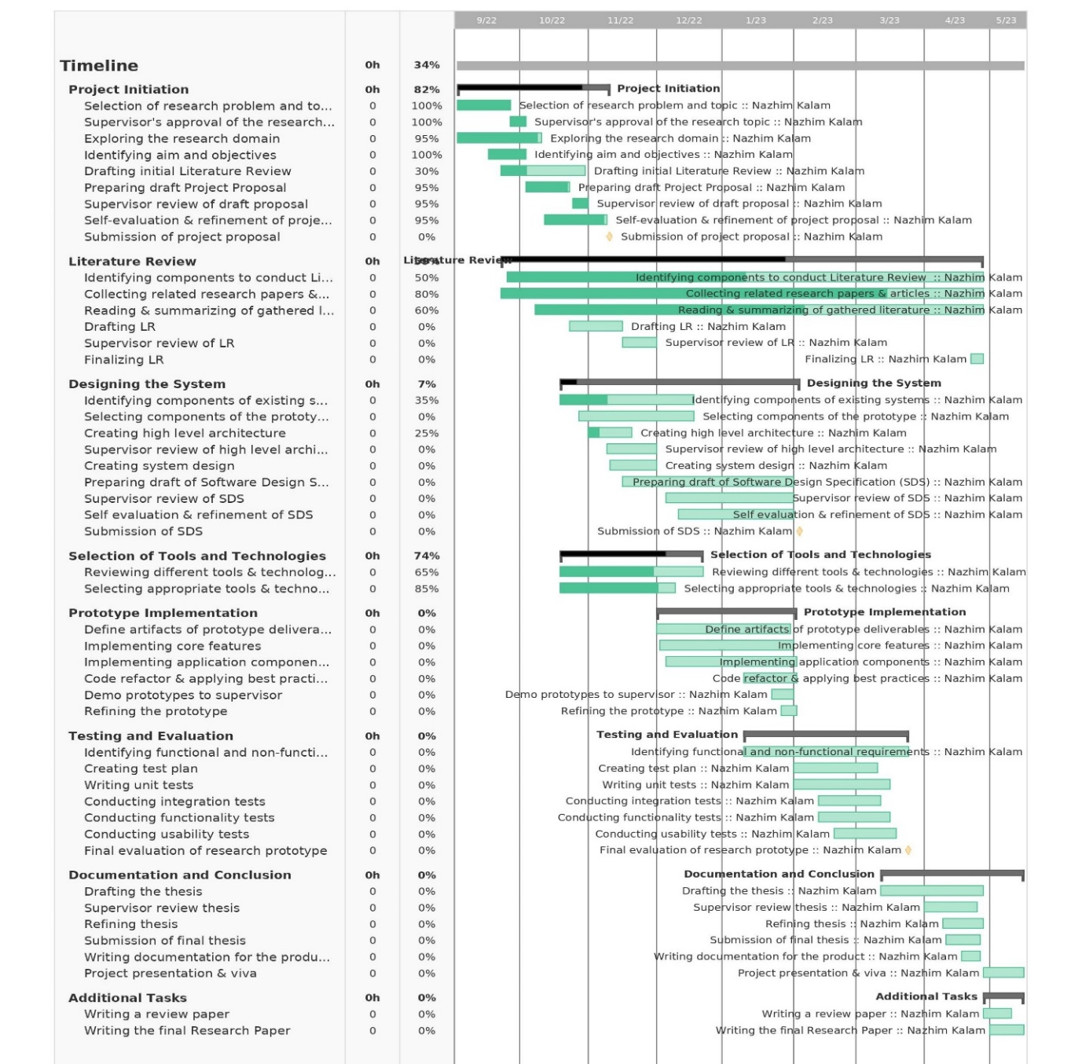

### **3.4.1.2 Deliverables**

The deliverables and respective dates are specified in the table below.

Table 6: Deliverables & Dates (Self-Composed)

|  |  |
| --- | --- |
| **Deliverable** | **Date** |
| **Project Proposal Document + Ethics Forms**  Initial proposal of the project. | 9th November 2022 |
| **Software Requirement Specification**  Documentation outlining the requirements that must be met, designed as the ultimate prototype, including data collection methods. | 24th November 2022 |
| **Proof of Concept with Implementation Presentation**  Performing a presentation regarding the implementation along with the proof of concept | 23rd December 2022 |
| **Project Specifications Design & Prototype**  A functional prototype with all its main features included as stated. Along with a documentation of the design approach followed. | 2rd February 2023 |
| **Test & Evaluation Report**  Documented Evaluation Report conducted on the Prototype. | 23rd March 2023 |
| **Draft Project Reports**  A draft thesis submission, in order to get supervisors feedback | 30th March 2023 |
| **Final Thesis**  Final report detailing the research and project decisions | 27th April 2023 |
| **Review Research Paper**  A review paper reviewing published existing systems in handling abstractive text summarization. | 2nd May 2023 |
| **Final Research Paper**  A research paper about the experimentations done with the transformers hyperparameters. | 15th May 2023 |
| **Public project repository**  A publicly accessible project repository to setup and test the development | 30th April 2023 |

# **3.5 Resources**

## **3.5.1 Software requirements**

* ***Operating System* –** Microsoft Windows OS will be used for the research, documentation and for the complete project implementation (end to end), due to its flexibility compared to another operating system.
* ***Python* –** Machine learning & Deep learning model development and APIs creation to serve the models and handle logic will be implemented by using the Python language. Python is a general-purpose language that has been used most widely in data-science related projects and in backend frameworks link Flask and Django.
* ***Flask* –** Backend web framework for API development for the prototype. This will be used to access/transfer data to and from the data science models developed.
* ***TensorFlow/Scikit learn Python packages* –** Libraries that will be used during the development of the data science models.
* ***Jupyter Notebook / Google Colab* –** Used for Machine-learning/Deep learning model development in this project, it’s an Integrated development environment for programming.
* ***TypeScript (React)* –** JavaScript framework which is used for the development of the frontend application interface of the project. Here is where the user will be able to input and view their data.
* ***Vscode* –** The project's development environment. This will be utilized while creating the codebase for the backend API and frontend development.
* ***Zotero* –** Referencing software that keeps a copy of all the articles as well as managing the references for research papers
* ***MS Office/ Google Docs/ Figma* –** Software & tools which will be used to create figures, reports and handle documentations.
* ***Google Drive/ GitHub* –** Backup platform and code management system to help keep backup of all documents and code.
* ***Git* –** Version control system which will be used to keep track of the changes made in the project code and manage code changes.
* ***Firebase* –** Application development platform which helps to build and grow apps, its also known as the Backend As a Service.

## **3.5.2 Hardware requirements**

* **Core i5x Processor (8th generation) or above –** Above average processing power required to perform high resource intensive tasks (such as model training).
* **Nvidia MX130 GPU or above –** To handle data science model training processes.
* **16GB RAM or above –** Sufficient amount of RAM needed to run multiple applications (client + server), model training also consumes a lot of CPU and RAM.
* **Disk space of 30GB or above –** To store project data and applications.

## **3.5.3 Technical skills**

* Good understanding about machine learning and deep learning concepts.
* Good understanding about Natural Language Processing and its data preprocessing methods.
* Good understanding about transformers and how to work with hyperparameters in general along with the knowledge of its use.
* Research writing skills

## **3.5.4 Data requirements**

* Amazon Movie review data **–** From Stanford University Education.
* Gigaword, Xsum & CNN Daily News dataset – From TensorFlow datasets which will be used for generalization model.

# **3.6 Risks & mitigation**

The table given below defines the possible risks which can be encountered during the process of the project development along with the possible mitigation steps.

Table 7: Risk Management Plan (Self-Composed)

|  |  |  |  |
| --- | --- | --- | --- |
| **Risk** | **Magnitude** | **Frequency** | **Mitigation Plan** |
| Losing the development project codebase/repository | 5 | 4 | Using GitHub and external backup to keep a latest copy of the project codebase. |
| Personal computing breaks down during the project timeline progress. | 5 | 4 | Upload the complete backup to GitHub and Google Drive, use University Lab service to continue project work, till personal machine recovery. |
| Unable to complete all mentioned project deliverables on time | 4 | 4 | Prioritize and create a timeline to complete the deliverables. |
| Project documentation corruption | 5 | 3 | Use a dedicated folder under the same GitHub repository and push all latest documentation changes & use cloud-based documentation approach |
| Insufficient knowledge on the project domain | 5 | 3 | Performing an intensive research on the problem domain along with the research domain. |
| Any unavoidable personal health risk – Sickness | 3 | 1 | Create weekly goals to complete and keep them updated. |

# **3.7 Chapter summary**

In this chapter, the author explained the methodology they used and provided an explanation for their choice. The author also gave detailed descriptions of the research, development, and project management methodologies they followed. Additionally, the chapter outlined the project requirements, work division plan, expected outcomes, and identified potential risks along with their mitigation strategies.

# **CHAPTER 04. SOFTWARE REQUIREMENTS SPECIFICATION**

# **4.1 Chapter overview**

This chapter explains the process of identifying and gathering essential needs from stakeholders. The author discusses the use of a rich picture diagram and a stakeholder onion model to record stakeholder engagement, interaction points, and individual responsibilities. The chapter also covers the techniques used for requirement gathering, including creating functional and non-functional requirements, use case diagrams, and prototypes based on the gathered results.

# **4.2 Rich picture**

Figure 4: Rich Picture Diagram (Self-Composed) – *(*[*view high qual version*](https://drive.google.com/file/d/1G7NWf8vOlmrxNzONPKzv4nm6RZPmIPUd/view?usp=share_link)*)*

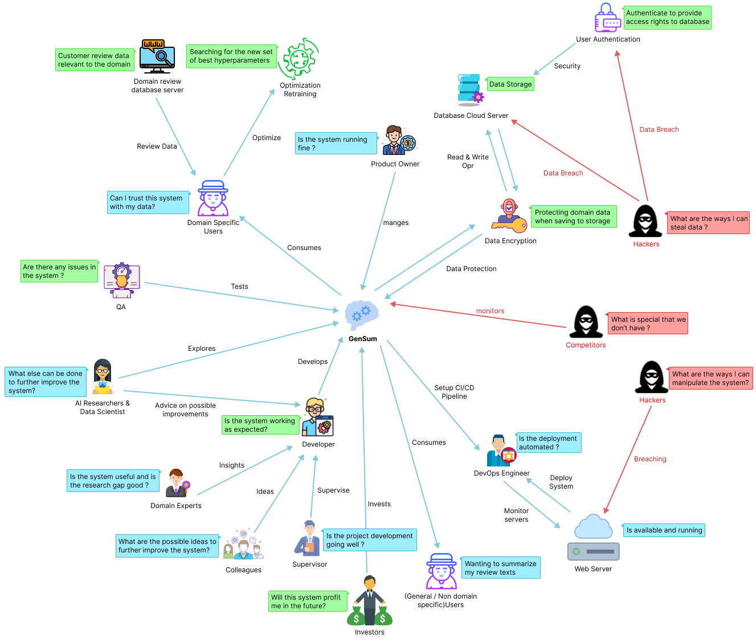

The diagram above depicts a bird's-eye view of the surrounding region, as well as how certain stakeholders might interact with the system and profit from it. Along with the knowledge gained by the researcher to improve the system, the potential negative impacts on the design and prospective critical analyses are also identified.

# **4.3 Stakeholder analysis**

The section that follows acknowledges significant stakeholders involved with the system, their relationships, and their individual roles. The stakeholder onion model represents this information, and stakeholder perspectives elaborate on it.

## **4.3.1 Stakeholder onion model**

Figure 5: Stakeholder Onion Model (Self-Composed) – *(*[*view high qual version*](https://drive.google.com/file/d/1OjkWofiu8G7wAD0SMHx2oYOYZY2fhykU/view?usp=share_link)*)*

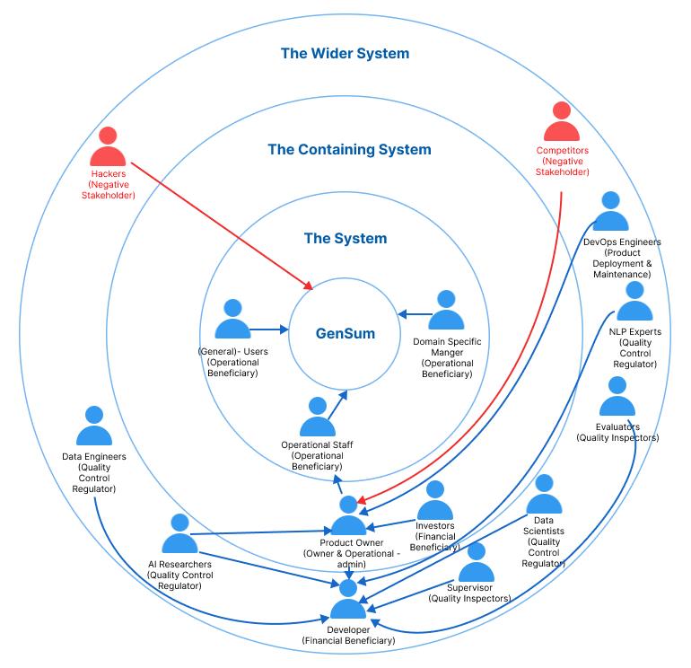

## **4.3.2 Stakeholder viewpoints**

The table below provides information about the stakeholders, their functions, and the actions related to them.

Table 8: Stakeholder Viewpoints & Requirements (Self-Composed)

|  |  |  |
| --- | --- | --- |
| **Stakeholder** | **Role** | **Benefits/Description** |
| Developer | Functional beneficiary | Works on developing the system |
| Investors | Profit is generated through system investment and money from marketing and user subscriptions. |
| Product Owner | Owner & Operational admin | Owns the system and has control over the system |
| Data Scientists | Quality Control Regulator | Provides performance enhancements for the models and algorithms used in data science. |
| Data Engineers | Gives guidance on potential data that may be used to generate the best suggestions possible. |
| AI Researchers | Conduct research in the specified area to enhance and implement reliable text summarizing models. |
| NLP Experts | Offers specialized guidance and insights on the field  knowledge, to enhance the functionality of the system. |
| Domain Specific Manager | Operational Beneficiary | Text reviews are used as inputs for abstractive summarization, and the model is retrained with prior inputs as new data to increase performance. |
| General Users | Unless specifically assigned or retrained, typical users will utilize a general abstractive summarization model. |
| Operational Staff | Ensures that the system is up and functioning while responding to user requests and problems. |
| DevOps Engineers | Product Deployment & Maintenance | Makes ensuring the system is up and running in the cloud and is serving users without being throttled |
| Hackers | Negative Stakeholder | May manipulate the review data stored in the database which will affect the retraining process. |
| Competitors | May build competing systems that may outperform the existing system. |
| Evaluators | Quality Inspector | Checks to see if the system is ready for production use and puts it through its paces. |
| Supervisor | Checks to see if the system development is progressing well without any issues. |

# **4.4 Selection of Requirement Elicitation Methodologies**

There were several requirement elicitation approaches used to collect needs for the creation of the research project. The approaches selected for this were literature review, survey, interviews, prototyping, brainstorming and self-evaluation. The following is a discussion of the rationales behind selecting the mentioned requirement elicitation approaches.

Table 9: Requirement Elicitation Methodologies (Self-Composed)

|  |  |
| --- | --- |
| **Method** | **Description** |
| Literature Review | To determine research gaps in the chosen domain of interest and the intended topic of study at the project's outset, the author conducted a thorough literature analysis. Current systems were researched together with comparable technologies that might be applied to the existing systems that were referenced in literature in order to discover research gaps available in technologies that can be used. |
| Survey | A questionnaire was utilized as a survey instrument to obtain requirements and opinions from possible users of the suggested system. The author will benefit from this sort of poll in understanding people's thought processes and expectations for the prototype. It will also enable the author to explain whether or not the targeted users will benefit from the suggested solution. |
| Interviews | Interviews were performed to gain expert insight into domain-specific requirements and to determine the best method to address the issue at hand while adding to the body of knowledge through research. Interviews were determined to be the greatest source of information because the field is new and the technical expertise needed is very precise. Additionally, this technique allowed for the qualitative evaluation of the suggested system, allowing for the identification of any shortcomings or difficulties that could need to be resolved during prototyping. |
| Prototyping | The project was chosen to follow the Agile Software Development Life-cycle, thus prototyping would allow the author to test and evaluate the prototype while iteratively trying out several alternative implementations to find any potential areas for improvement. |
| Brainstorming | Whether you're attempting to come up with a broad subject before you start your research, you're trying to focus more specifically, or you're determining what evidence to use for a particular paragraph, brainstorming is a useful technique to produce ideas at every step of the process. In order to assess the system for personally, the author has a number of brainstorming sessions with his colleagues at various project stages. |
| Self-Evaluation | Self-evaluation is done in order to examine the currently available applications, do competitor analyses on the current systems, and get insight into how negative stakeholders, such as hackers, can breach the system and find a way around to protect the data and the system. |

# **4.5 Discussion of Findings**

The relevant key stakeholders are split up into groups where the chosen best methodology was used for each group. **APPENDIX C.1** contains a complete breakdown of these stakeholders.

## **4.5.1 Literature review**

Table 10: Literature Review Findings (Self-Composed)

|  |  |
| --- | --- |
| **Discussion of Findings** | **Citation** |
| In the completion of the literature review on the existing work done, it was identified that abstractive text summarization systems for customer reviews helps users to make better and quicker decisions on their actions let it be on buying products or watching a movie, user review summarization proves to save time for customers. | (Boorugu, Ramesh and Madhavi, 2019) |
| When exploring technologies that can be applied to achieve the required outcome, it was clear that traditional machine learning and deep learning approaches were only used for abstractive text summarization in the domain of movie reviews. Leaving the usage of advanced deep learning approaches such as Transformers untouched for this domain. | (Khan et al., 2020) |
| It was identified that transformer optimization has not been looked into when working with transformers in abstractive text summarization domain in general and not specific to the movie domain. | (Gupta et al., 2021) |
| Dataset related to working with model generalized has been used previously and is recommended to be used if researchers are willing to work with the idea of generalization for the domain of abstractive text summarization. | (Kouris, Alexandridis and Stafylopatis, 2019) |

## **4.5.2 Brainstorming**

The author engaged in brainstorming across various project phases. These were carried out both with the authors' colleagues and supervisors as well as through a self-analysis process.

Table 11: Observations Findings (Self-Composed)

|  |  |
| --- | --- |
| **Criteria** | **Discussion of Findings** |
| Able to figure out several other research gaps/ limitations which can be fit into the current project domain in order to increase the magnitude of research effort. | Multiple ideas were brought up as the result of the brainstorming session. The concept of creating a performance adaptive generalization model was brought up by the authors supervisor, along with several other approaches to increase the performance of the system exponentially such like making use of the new data from the domain users for retraining and combine all data with the common domain for retraining since the data count increases with respect to the common domain user. |

## **4.5.3 Interviews**

Interviews with experts and researchers in the relevant domains were performed to obtain insights on the technical domain competence. To determine the project requirements, experts and researchers in ML and abstractive text summarizing systems were chosen. 2 PhD candidate in ML and Computational Linguistics, 1 NLP Researcher, 2 Software Architects, 1 Software Engineer and 1 Lecturer with MSc completion were interviewed. The interview outcomes were processed to a thematic analysis based on the following themes. Interview participant details can be found at over **APPENDIX C.2**

Table 12: Interview Thematic Analysis (Self-Composed)

|  |  |
| --- | --- |
| **Code** | **Theme** |
| Data handling | Data Collection & Data Preprocessing |
| Transformer architectures | Best performing transformer architectures |
| Generalization | Handling adaptive generalization |
| Research scope | Research gap and scope |
| Hyperparameter tuning | Automatic hyperparameter tuning & model retraining |
| Hybrid transformers | Looking into hybrid transformer combinations |
| Custom transformers | Customizing the transformer architecture |
| Prototype | Prototype features and suggestions |
| Business benefits | Understanding which and how businesses would benefit |
| Evaluations | Understanding the importance and evaluation ways |

|  |  |
| --- | --- |
| **Theme** | **Conclusion** |
| Data handling | Data accessibility and data preparation techniques are crucial considerations for a data science project. Since every domain would initially employ the same model, PhD candidates proposed utilizing validated and well-researched datasets for the field of generalization to ensure the quality of data. Since text data may contain characters from other languages unless the project is restricted to English language support alone, NLP experts raised worry about the language of the text included in the project scope. |
| Transformer architectures | The interviewees stated that NLP tasks like text summarization and sentiment analysis may be successfully solved using transformer designs like BERT, GPT-2, Roberta, T5, and others. They advised using the most recent version of these models because they are frequently upgraded and developed in new, improved forms. To keep track of these upgrades, they advised examining daily analytics from websites like Hugging Face, such as download and like counts. |
| Generalization | Due to their scalability and performance advantages, the software engineers and architects suggested employing NoSQL databases like MongoDB or Firebase for storing data related to domain specific managers. |
| Research scope | Experts agree that using optimized transformers to solve the issue is a brilliant idea, but given the project's time constraints, they advise prioritizing the movie domain and postponing the task of developing a broader adaptive solution. |
| Hyperparameter tuning | The NLP researchers and Lectures suggested several ways of using tools and libraries to help with hyperparameter tuning since doing this manually is very time consuming and unnecessary effort. |
| Hybrid transformers | The hybrid transformer combination with ensemble techniques was well-loved by PhD applicants, but many believed the project scope was growing too large and risky for the time available. |
| Prototype | Interviewees are interested in the novel domain-specific retraining system and recommended incorporating a pretrained model for sentiment analysis if time allows. |
| Business benefits | Most of the interviewees suggested the Movie domain, Tourism, Ecommerce, Book, Researchers would find this useful in summarizing their customer reviews on their businesses. |
| Evaluations | PhD candidates and NLP experts emphasized the need for evaluations in the adaptive generalization model and suggested limiting the project to a maximum of three domains for easier comparison and clearer demonstration |

## **4.5.4 Survey**

Table 13: Survey Analysis (Self-Composed)

|  |  |
| --- | --- |
| **Question** | Have you ever realized that reading lengthy reviews takes a significant amount of time? |
| **Aim of question** | To determine whether the audience as a whole considers reading lengthy reviews to be a time-consuming activity. |
| **Findings & Conclusion**  It can be concluded that a large part of the audience (more than 90% of the audience) finds that’s reading lengthy reviews is a time-consuming hassle which also proves that they would appreciate if there would be a quicker approach for this problem, like a summarization. This also concludes to see a positive correlation from the results which was expected from the author of the project. | |
| **Question** | Do you believe that developing a generic system for all domains would be a wise course of action? |
| **Aim of question** | Ensuring that developing a generic system would be beneficial in all domains |
| **Findings & Conclusion**  It can be concluded that most of the participants (more than 90% of the audience) agrees that developing a generalized system which can adapt to the domain as they use, is beneficial and worth the effort to process with the project research. This also concludes to see a positive correlation from the results which was expected from the author of the project | |
| **Question** | Who do you think will most benefit from this system? |
| **Aim of question** | Getting to know about the thoughts of the participants about to whom the system would mostly benefit from? |
| **Findings & Conclusion**  It can be concluded that a majority of the participants (more than 60%) finds that this system will benefit the movie, restaurant, tourist, hotel, ecommerce domains (these domains were considered since they are mostly interacted with the users on a daily bases and uses customer reviews for their domain as a part of their business) as well as the general users. | |
| **Question** | How much do you think that this system would benefit you? |
| **Aim of question** | Getting to know how much the system would benefit the general participants which are NOT domain specific |
| **Findings & Conclusion**  From the statistics graph, it can be concluded that roughly 75% of the audience finds that the system would benefit them for their general work or needs given that it’s not domain specific to them, which is a positively correlated result from the achieved statistics. | |
| **Question** | How much do you think that this system would benefit businesses? |
| **Aim of question** | Getting to know from the participants as to how much the system would benefit businesses/domains in solving this problem. |
| **Findings & Conclusion**  From the statistics graph, it can be concluded that roughly 84% of the audience finds that the system would benefit the businesses, which is a positively correlated results from the achieved statistics and that’s what the author expected to achieve. | |
| **Question** | Before making a reservation or booking a movie or a hotel, do you read the customer reviews? |
| **Aim of question** | Getting an idea from the audience if in general they give importance to customer/user reviews to any domain before consuming their product or services. |
| **Findings & Conclusion**  It can be concluded that a majority of the participants (more than 95% of the audience) agrees that they value and read customer reviews before they consume one’s product or service. Therefore, making customer reviews a major contributing factor for business growth. | |
| **Question** | How much you think customer reviews are important with respect to any domain? |
| **Aim of question** | Getting an idea from the audience to see how much they value customer reviews. |
| **Findings & Conclusion**  From the statistics graph, it can be concluded that roughly 90% of the audience finds that customer/user reviews are very important irrelevant to the domain, which is a positively correlated results from the achieved statistics and that’s what the author expected to achieve. | |
| **Question** | Which additional features would you want to see in this system. |
| **Aim of question** | To identify the systems non-functional requirements which could potentially improve the system. |
| **Findings & Conclusion**  The majority of participant responses were concerned with classifying the review text's sentiment after it had been summarized and with managing a list of review uploads so as to add filtering for the summarized review text based on the sentiment, whether it was positive or negative, along with the sentiment score. | |

Table 14: Survey Thematic Analysis (Self-Composed)

|  |  |
| --- | --- |
| **Code** | **Theme** |
| Convenience | User-friendly |
| Adjustability | Flexibility |
| Insights | Reliability |
| Advancement | Future Enhancement |

|  |  |
| --- | --- |
| **Theme** | **Conclusion** |
| User-friendly | A group of participants required to upload more than one review and a time/bulk at once. |
| Flexibility | A majority of the participants requested for sentiment of the summary and the sentiment score to be also included with the output. |
| Reliability | A majority of the participants found the system being useful in the industry with time. |
| Future Enhancement | Few participants requested integrate a recommendation system for a specific domain. |

## **4.5.5 Self Evaluation**

Comparing similar products from competitors and existing products gives the author an idea of making the project more unique and distinguish new approaches to solve the problem (**Competitor Analysis**). The author will also self-evaluate as to what data needs to be protected and how from the hackers. Few of the abstractive text summarization tools which are out there are listed and is available at [**APPENDIX C.3**](#_C.3._Self-Evaluation_(Competitor)**.**

In the case of hackers stealing data from the database, **data encryption** can be applied therefore database will only contain the encrypted text data which will be then later decrypted from the decryption key when need, this will be most needed when performing the model retraining.

## **4.5.6 Prototyping**

Table 15: Prototyping Findings (Self-Composed)

|  |  |
| --- | --- |
| **Criteria** | **Discussion of findings** |
| In-order to look into the feasibility of continuing the project research a prototype was planned to be worked on. | During the iterative prototype process, the author encountered several requirements and obstacles, including the challenge of finding a suitable dataset with desired metadata in the movie domain. After intensive evaluation, the author discovered a large dataset with 8 million entries, but preprocessing it was difficult due to its size and noisy text. To automate the hyperparameter search, the author experimented with a framework called "Optuna." The system will be retrained using new data from the domain user, and the author plans to study at least three top-tier transformer designs to choose the best one. |

## **4.5.6 Summary of findings**

Table 16: Summary of Findings (Self-Composed)

|  |  |  |  |  |  |  |  |
| --- | --- | --- | --- | --- | --- | --- | --- |
| **Id** | **Finding** | **LR** | **Survey** | **Self-Evaluation** | **Interview** | **Brainstorming** | **Prototyping** |
| 1 | The proposed system would benefit businesses (domain specific users) and general users (not domain specific) |  | ✓ |  |  | ✓ |  |
| 2 | For the movie domain the limit of abstractive text summarization can be further pushed using optimized transformers to increase performance this being the existing limitation | ✓ |  |  | ✓ | ✓ |  |
| 3 | It’s clear that customer/user reviews are valued and reviewed mostly by a vast majority of the audience before they consume or use any product or service (applies to any domain) | ✓ | ✓ |  | ✓ | ✓ |  |
| 4 | It’s clear that users spend lot of time review long reviews and they would like it being short to save time and make quicker decisions. | ✓ | ✓ |  |  | ✓ |  |
| 5 | Hyperparameter tuning is one way to increase the performance of the system and it can be done both manually or by automated tools like Raytune, Optuna etc.… | ✓ |  |  | ✓ |  | ✓ |
| 6 | Data preprocessing for the domain of Movies and Generalization is requires a lot of effort since the datasets are mostly raw data difficult to find specially in the case of movie reviews (with expected metadata) | ✓ |  |  |  |  | ✓ |
| 7 | Additional features such as sentimental and sentimental score of the review summary is mostly expected from the users. |  | ✓ |  |  |  |  |
| 8 | Creating a hybrid transformer model to further increase the performance is a suggested improved. |  |  |  | ✓ | ✓ |  |
| 9 | It’s clear on what are the suitable evaluation metrics to be used for abstractive text summarization. | ✓ |  |  | ✓ |  |  |
| 10 | It’s clear on what the top tier transformer architecture that could be explored. | ✓ |  |  | ✓ |  |  |
| 11 | Making use of larger new data for retraining for a specific domain, from companies/businesses who uses data which are of the same domain. (e.g.: - 50 different restaurants data can be combined for retraining give that the domain is “Restaurants”) |  |  |  | ✓ | ✓ |  |
| 12 | Making use of data encryption to protect the data from hackers breaking into the database to steal data. |  |  | ✓ |  | ✓ |  |

# **4.6 Context Diagram**

The boundaries and interactions of the system should be established before development. The graphic below shows how the system is situated.

Figure 6: Context Diagram (Self-Composed)

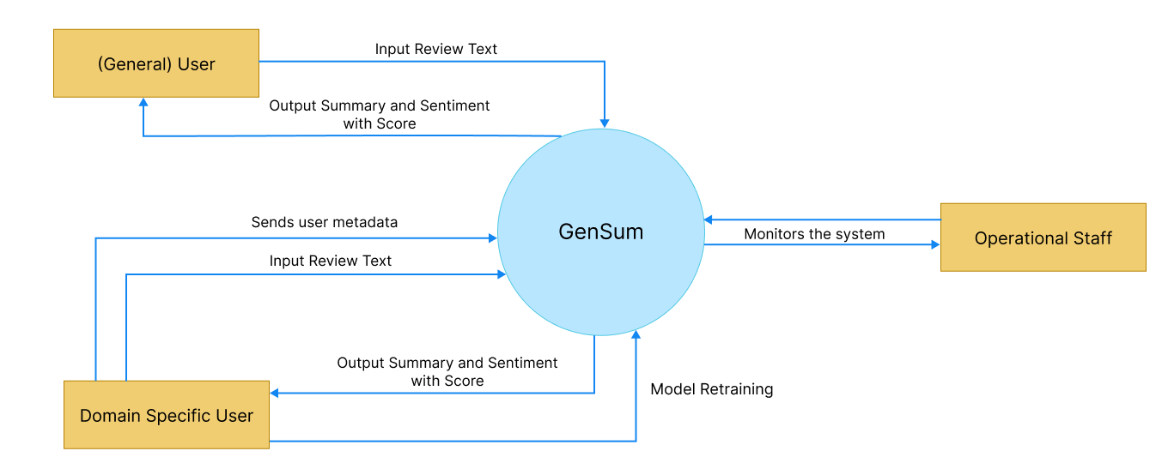

# **4.7 Use case Diagram**

Figure 7: Use Case Diagram (Self-Composed)

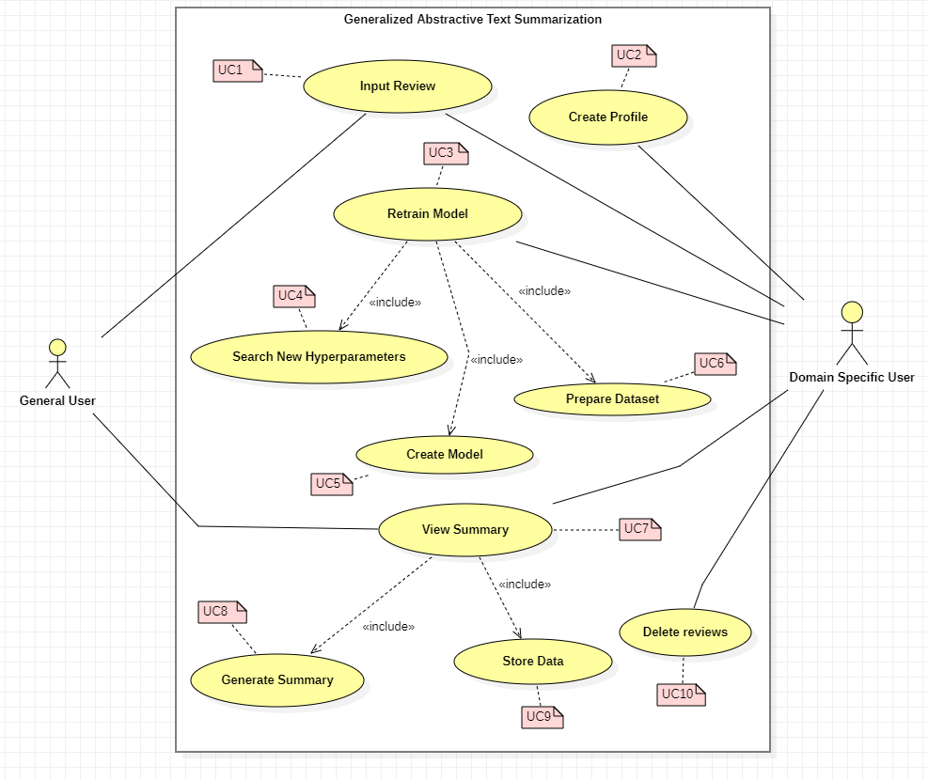

# **4.8 Use case Descriptions**

Usecase diagrams with the highest importance are given below, the rest of the Usecase descriptors are available at **APPENDIX C.4.**

Table 17: Use Case Description Uc:07 (Self-Composed)

|  |  |  |
| --- | --- | --- |
| Use Case Name | View Summary | |
| Use Case Id | UC:07 | |
| Description | Displays a summarized version of the uploaded review text from the domain user’s end. | |
| Primary Actor | General User, Domain Specific User | |
| Pre-Conditions | The text review data must go through specific text preparation techniques before the summary can be produced. | |
| Extended use cases | None | |
| Included use cases | UC10, UC02 | |
| Trigger | A user selects to summarize a given customer/user review text. | |
| Main flow | **Actor** | **System** |
| 1. The user enters the review text on the text field from the GUI. 2. Clicks on “Generate Summary” from the GUI | 1. The system does the data preprocessing for the input review text. 2. Loads the generalized transformer model. 3. Generates the summary using the model. 4. **(If Domain Specific User)** stores the input review and summary into the database. 5. Returns the summary response back to the GUI |
| Alternative flows | None | |
| Expectational flows | Displays an error message if the network request fails (server is down, or internet issues from client). | |
| Post Conditions | Success end condition: The user is presented with the summarized review text. | |

Table 18: Use Case Description Uc:03 (Self-Composed)

|  |  |  |
| --- | --- | --- |
| Use Case Name | Retrain Model | |
| Use Case Id | UC:03 | |
| Description | Performs model retraining with the new data from the database, to find the new best set of hyperparameters. | |
| Primary Actor | Domain Specific User | |
| Pre-Conditions | The actor should be a Domain Specific User and have an account created. | |
| Extended use cases | None | |
| Included use cases | UC05, UC06, UC07 | |
| Trigger | The Domain Specific User clicks on the “Perform model retraining” button | |
| Main flow | **Actor** | **System** |
| 1. Domain Specific logs into their account 2. Clicks on “Perform model retraining” from the GUI | 1. The system pulls all the data with respect to the user id from the database. 2. Combines data of the common domains (only if user consent is given to use their data) 3. Finds new set of hyperparameters for the model with respect to new data. 4. Trains the model using the new hyperparameters. 5. Saves the model with the user Id 6. Updates the status in the database if succeed/fails |
| Alternative flows | None | |
| Expectational flows | Displays an error message if the network request fails (server is down, or internet issues from client). | |
| Post Conditions | Success end condition: The user will be able to see the recent status of the model if the retraining is successful or failed | |

# **4.9 Requirements**

## **4.9.1 Functional Requirements**

Based on the significance of the system demands, the ‘MoSCoW’ approach was utilized to identify their priority levels. The details related to the priority levels are detailed at **APPENDIX C.5.**

The Usecase description along its mapping id is also listed at **APPENDIX C.4.**

Table 19: Functional Requirements (Self-Composed)

|  |  |  |  |
| --- | --- | --- | --- |
| **FR ID** | **Requirement** | **Priority Level** | **Use Case** |
| FR1 | Both general and domain specific users must be able to enter a review text from the GUI considering as the starting point of the summary generation. | M | UC01 |
| FR2 | Only Domain Specific Users should be able to sign up and create an account after entering the necessary details required | S | UC02 |
| FR3 | The system could allow the ability to update the account details of the domain user after creating the account | C | UC02 |
| FR4 | The system must undergo model retraining with the new data stored in the database for the specific domain user, when its triggered from the GUI with the user’s consent. | M | UC03 |
| FR5 | The system could be able to perform model retraining automatically during off peak hours every day. | C | UC03 |
| FR6 | The system must be able to find the new set of best hyperparameters with the usage of the new data. | M | UC04 |
| FR7 | The system must be able to able to retrain the model with the new best hyperparameters and create the model | M | UC05 |
| FR8 | The system must be able to pull the new data from the database to recreate the new dataset for retraining. | M | UC06 |
| FR9 | The system should be able to combine all the data from a common group of domains when creating the dataset only given that the consent is approved to use their data | C | UC06 |
| FR10 | The system must be able to process the review text and display the summary output on the GUI | M | UC07 |
| FR11 | The system must be able to use the latest trained model to generate the summary for the review text | M | UC08 |
| FR12 | The system could also find the sentiment of the generated summary if its positive or negative and return the result. | C | UC08 |
| FR13 | The system could make use of a hybrid model for the text summarization. | C | UC08 |
| FR14 | The system must store the entered user review and generated summary to be stored in the database for retraining purposes. | M | UC09 |
| FR15 | The system should encrypt the data when saving into the database (both the review and summary) | S | UC09 |
| FR14 | The system could allow the domain users to delete the reviews from the database. | C | UC10 |

## **4.9.2 Non-Functional Requirements**

The non-functional requirements are prioritized into two level of which are “Important” and “Desirable”

Table 20: Non-Functional Requirements (Self-Composed)

|  |  |  |  |
| --- | --- | --- | --- |
| **NFR ID** | **Requirement** | **Specification** | **Priority Level** |
| NFR1 | The system needs to be simple enough for non-technical individuals to utilize without much effort. | Usability | Important |
| NFR2 | Meaningful error messages should be displayed if anything goes wrong | Usability | Desirable |
| NFR3 | Summary generation should be done within 3000ms | Performance | Important |
| NFR4 | Following coding standards and best practices | Maintainability | Important |
| NFR5 | Any domain users are able to use the application and model performance will adapt with respect to the domain | Generalization | Important |
| NFR6 | The system should protect against data corruption by attackers, and testing can ensure this. | Security | Desirable |
| NFR7 | The prototype can be used by several domains and multiple businesses under a single domain, then the system may have to support many concurrent user-requests. | Scalability | Desirable |

# **4.10 Chapter summary**

To illustrate how the system interacts with society and the system stakeholders in this chapter, a Rich Picture Diagram was developed. The Saunder's Onion model, which took the influence flow from each stakeholder into account, was used to depict the stakeholders. Requirement gathering techniques were utilized to obtain all the essential data and the opinions of possible system stakeholders. Finally, the use cases, functional requirements, and non-functional requirements for the system were specified using the knowledge gathered from the requirement elicitation methodologies.

# **CHAPTER 05. SOCIAL, LEGAL, ETHICAL & PROFESSIONAL ISSUES**

# **5.1 Chapter overview**

In this chapter, the social, legal, ethical, and professional concerns that emerged during the course of this project are delineated, along with the measures that were implemented to address them.

# **5.2 SLEP issues and mitigation**

The table presented below provides a detailed analysis of the identified social, legal, ethical, and professional (SLEP) issues, as well as the corresponding mitigation strategies that were employed.

Table 21: SLEP Issues & Mitigation

|  |  |
| --- | --- |
| **Social** | **Legal** |
| * The dissertation refrains from mentioning the names of the interviewees. * During the conducted survey, no personal details were collected from the respondents to ensure their anonymity. The respondents were kept anonymous throughout the survey process. * The information obtained during the research was not saved or stored elsewhere, ensuring that the data remained secure and confidential. | * All the datasets used in the research are freely available for the public to access. * The tools and technologies utilized in the research are either open source or provided to students free of charge, thereby enabling wider access and use by researchers and students. * The codebase utilized in the research is available on GitHub under the open-source MIT license, allowing others to access and use it freely. |
| **Ethical** | **Professional** |
| * The participants were provided with clear information regarding the intended use of the data that was collected from them. * The work presented in this report is entirely original and has not been reproduced elsewhere. All the ideas taken from external sources have been appropriately cited, and credit has been given where it is due. | * Throughout the project, the team made every effort to adhere to professional standards to ensure the quality and integrity of the work. * The responses and evaluations received during the research were not tampered with, and any limitations encountered during the study were clearly stated and acknowledged. |

# **5.3 Chapter summary**

In this chapter, the author has expounded upon the social, legal, ethical, and professional issues that were encountered during the research process, and has outlined the measures taken to address and resolve them.

# **CHAPTER 06. DESIGN**

# **6.1 Chapter overview**

This chapter discusses the design decisions made to establish an appropriate architecture for implementation based on the requirements obtained. High-level design, low-level design, design diagrams, and UI wireframes have been used to describe how the design goals are meant to be achieved while demonstrating the reasoning for selected design decisions.

# **6.2 Design goals**

The design goals that should be achieved by the system are specified in the table below.

Table 22: Design Goals of The Proposed System (Self-Composed)

|  |  |
| --- | --- |
| **Design Goal** | **Description** |
| Performance | To find the new set of hyperparameters with the new data, model retraining requires a significant amount of time. As a result, the newly created dataset (with unseen data) should be accurately made, and it is best if it takes the least amount of time to query the data from various businesses within the same domain to create the dataset. Moreover, other core functionalities should be designed effectively to increase overall performance. |
| Correctness | The correctness & quality of the output should be of the highest possible level utilizing the optimized transformer architecture. Since several approaches are considered in order to get the optimized solution the expected output should of the best possible form. |
| Usability | The system's usability must be straightforward for users of all levels of knowledge because its primary function is to summarize review text for any domain, including movies and general users. |
| Adaptability | Adopting new features or components need to be a simple procedure. The system shouldn't be broken if a component is added or removed, and it shouldn't be affected overall. |
| Scalability | In a production environment, the system may need to accommodate a large number of concurrent user requests. This should be manageable by the backend. The system should be easily expandable to accommodate new data. |

# **6.3 High Level Design**

## **6.3.1 Architecture Diagram**

The system has a three-tier architecture that separates the data, logic, and presentation levels. The research contribution of the system includes generalization and domain-specific adaptive hyperparameter tuning and data preprocessing.

Figure 8: Three-Tiered Architecture (Self-Composed)

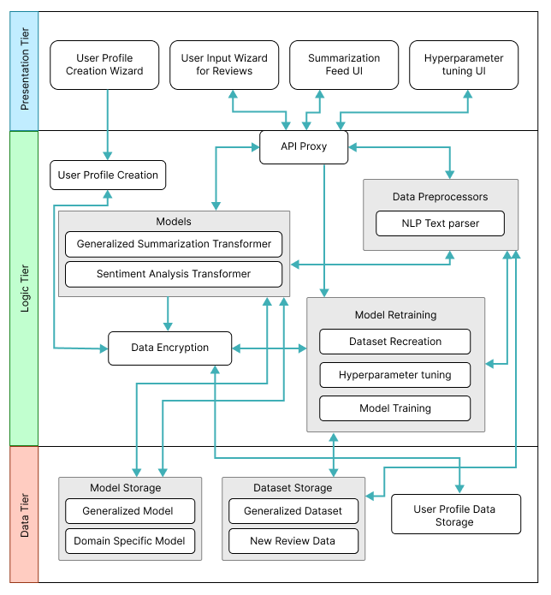

## **6.3.2 Discussion of tiers of the architecture**

**Data Tier**

1. Model Storage - The text summarization models which will be used for both generalized text summarization and domain specific text summarization will be stored here.
2. Generalized Model – The model which will be used by general users to generated review summarized, this model will be hyperparameter tuned for genialized purpose.
3. Domain Specific Model – The model will be used by domain specific users for review summarization, this model will be replaced whenever the model retraining is triggered from the domain user.
4. Dataset Storage – The data which is required for model training will be available.
5. Generalized Dataset – The data which is used for creating the generalized model will be stored for retraining when it comes to domain specific model retraining.
6. New Review Data – The data stored here are from the domain users when they use the application, the data will be storage and used for retraining along with the generalized dataset.
7. User Profile Data Storage – The metadata data related to the domain specific user when creating the user profile will be stored, for updating and profile deletion.

**Logic Tier**

1. User Profile Creation – Allowing to create unique user profiles for each domain user, main purpose comes when working with model retraining to figure out the data to be used.
2. API Proxy – Interface which allows the frontend to communicate with the backend services via HTTP calls/ request.
3. Data Preprocessors – The text data that will be used as input for the text summarizer must be cleaned using the preprocessing code.
4. NLP Text parser – Responsible for cleaning the input text review when received from the API endpoint.
5. Models – The model which will be responsible in generating the summary from the input review and find the sentiment of the summary generated.
6. Generalized Summarization Transformer – This is the summarization model which will be used, an adaptive model depending on the domain and type of user interacting with the model with optimized hyperparameters.
7. Sentiment Analysis Transformer – This model will be used to classify the generated summary into positive or negative sentiment.
8. Data Encryption – Data encryption is in charge of data protection/safety, keeping domain data extremely secure and leaving it useless even if it is stolen.
9. Model Retraining – Responsible for retraining the model with new data and finding new set of hyperparameters.
10. Dataset Recreation – Responsible for recreating the dataset with new data which has been given as input from the domain users
11. Hyperparameter tuning – Responsible for finding the new best set of hyperparameters using the new data.
12. Model Training – Responsible for training the new model with the new set of hyperparameters found.

**Presentation Tier**

1. User Profile Creation Wizard – The UI that presents the user to create a new profile if they are planning to use the software for their domain business, or a general user to skip the sign up if only a generalized summary is required.
2. User Input Wizard for Reviews – The UI that will request the user to input the review which needs to be summarized.
3. Summarization Feed UI – The UI that displayed the summarized text for the input review.
4. Hyperparameter tuning UI – The UI that triggers model retraining when the domain user performs an action on it.

# **6.4 System Design**

## **6.4.1 Choice of Design Paradigm**

The main reason behind the author going ahead with **SSADM (Structured Systems Analysis and Design Method)** over **OOAD (Object-Oriented Analysis and Design)** to build the protype was due to the ease of ability to extend the system features when it comes to future developments of the system. Given below are the other factors as to why the choice of SSADM was considered:

* Object Oriented approaches will not make a greater benefit since the main core project research lies towards Data Science.
* Ability to demonstrate the MVP (Minimum Viable Product) prototype implementation for the research application is more convenient.
* More time efficient when concerned with the time constraint of having to complete the documentation research along with the project implementation.

# **6.5 Design diagrams**

## **6.5.1 Data Flow diagrams**

In order to show the relationships between components and provide a clearer understanding of how data flows across the whole system, the context diagram's components have been extensively broken down in the diagram below, which was detailed in the SRS previously.

### **6.5.1.1 Level 01 Data Flow diagram**

Figure 9: Data Flow Diagram - Level 01 (Self-Composed)

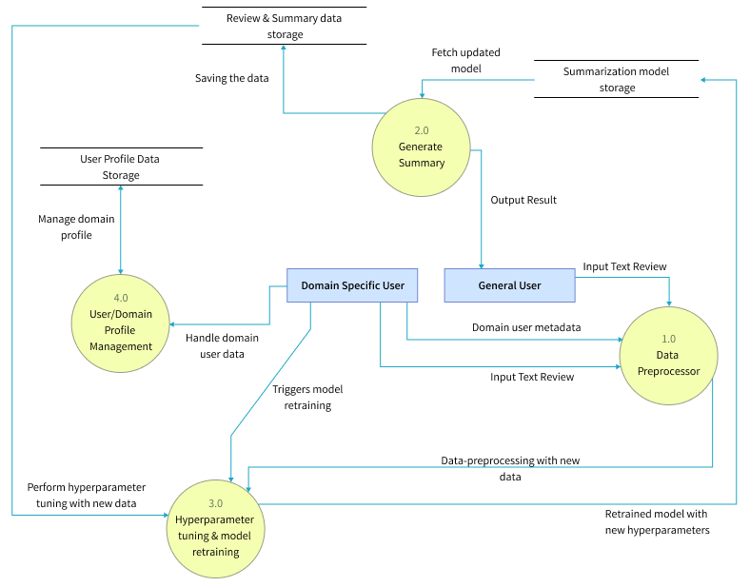

### **6.5.1.2 Level 02 Data Flow diagram**

The level 02 data flow diagram given below is a further breakdown of the core hyperparameter tuning and model retraining proposed in the level 01 data flow diagram.

Figure 10: Data Flow Diagram - Level 02 (Self-Composed)

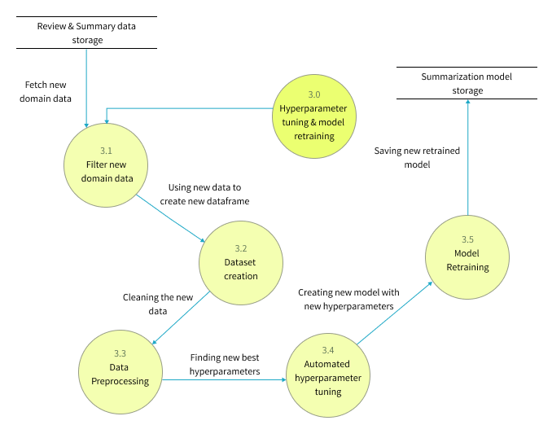

## **6.5.4 UI design**

Given the specifications acquired from the target audience, the author chose a web application for the simulation of the proof-of-concept application. A wireframe design was created to depict the key user interface aspects in the system and is available in **APPENDIX D.1.**

## **6.5.5 System process activity diagram**

The flowchart given below represents the algorithm’s flow and the decision structures which explains the flow of the system which is initially expected requirement.

Figure 11: System Process Flow Chart (Self-Composed) – *(*[*view high qual version*](https://drive.google.com/file/d/11YyNSDSeN89-tCgTe2Yb1IinlAa0x98n/view?usp=share_link)*)*

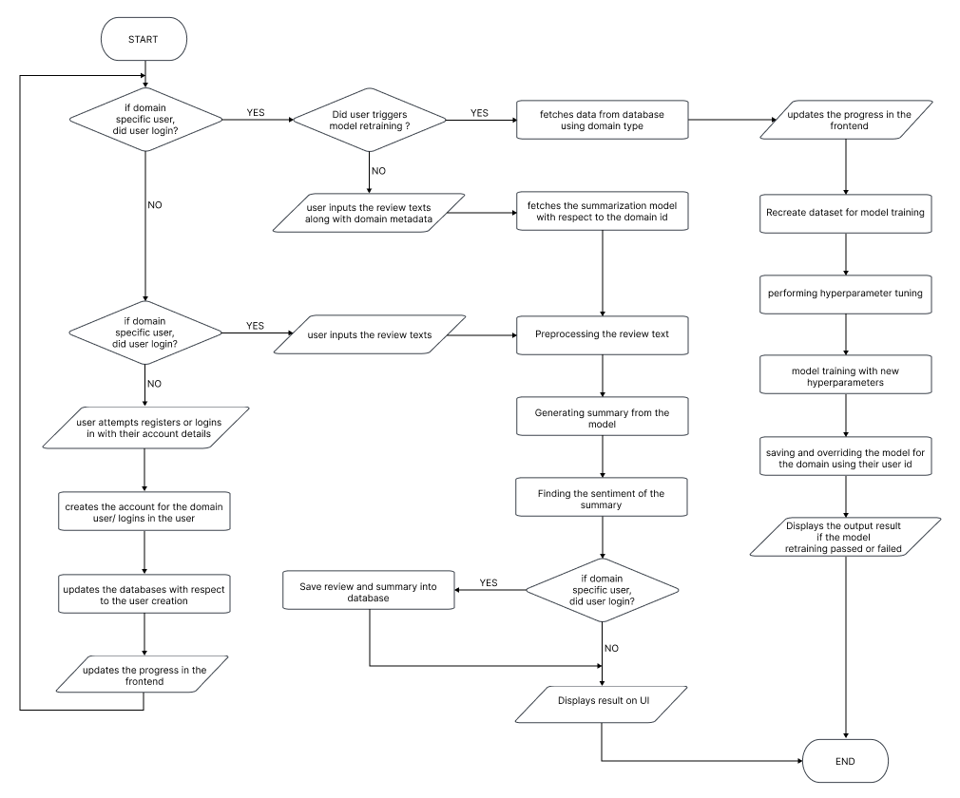

# **6.6 Chapter summary**

This chapter provides an in-depth examination of the project's design, including its architectural features and explains the core flow via data flow diagrams. The chapter concludes with a preview of the user interface wireframes that will be utilized to facilitate interaction between the end-user and the system.

# **CHAPTER 07. IMPLEMENTATION**

# **7.1 Chapter overview**

This chapter will provide a thorough overview of the technologies, supporting tools, and languages utilized for the project development, as well as the fundamental implementation of the research prototype.

# **7.2 Technology selection**

## **7.2.1 Technology stack**

The technologies utilized to implement the prototype at each tier are given below.

Figure 12: Technology Stack (Self-Composed)

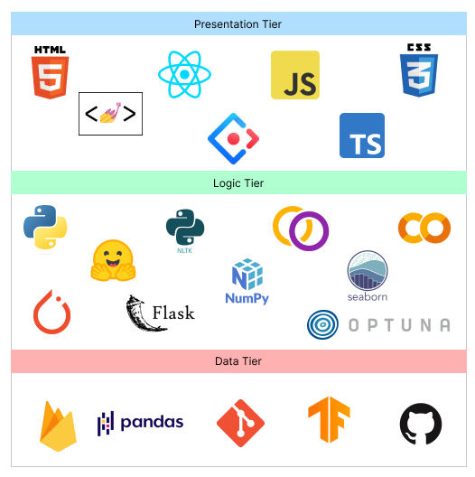

In preference to macOS and Linux, **Windows** will be the operating system used for project development and documentation. This is due to a wider variety of software available, which ensures that it has more industry-standard tools than Linux and macOS, along with better compatibility and familiarity, which make things simpler to use and manage.

## **7.2.2 Data selection**

Given that the project relies heavily on data science, it is essential to use data from trustworthy sources to train the model. This ensures that the data is accurate and leads to the development of a more accurate model for general text summarization.

The goal of the project was to develop an adaptive generalized text summarization model, so a generalized dataset for text summarization was necessary to establish the base model. **TensorFlow datasets**, being a reputable source of data, offered multiple options for this dataset.

The table below shows the datasets which have been used by previous researchers, therefore this can experiment for the protype development.

Table 23: Dataset Sources (Self-Composed)

|  |  |  |
| --- | --- | --- |
| **Dataset** | **Source** | **Purpose** |
| CNN Dailymail | TensorFlow Datasets | Model Generalization |
| Gigaword | TensorFlow Datasets | Model Generalization |
| Xsum | TensorFlow Datasets | Model Generalization |
| Amazon movie reviews | Stanford University Data | Domain Testing |
| Hotel Reviews | Kaggle | Domain Testing |

During the training process, all three of these datasets (CNN Dailymail, Gigaword, and Xsum) were utilized with various transformer architectures to determine which dataset resulted in the best evaluation metrics. Of the three datasets, Xsum performed the best, so it was selected as the final dataset for the project. All resources related to the dataset used can be found in **APPENDIX E.1.**

## **7.2.3 Programming Language Selection**

In this study, we employed the programming language **Python** for the implementation of our Machine Learning models and Backend APIs. Python is a widely-used language known for its readability, simplicity and versatility, making it an ideal choice for our research project. This language has a broad range of use cases including web development, data analysis, scientific computing and machine learning. Additionally, Python has a large and active community, providing ample resources and support. Furthermore, the availability of various libraries and frameworks such as NumPy, pandas, and TensorFlow, made Python a powerful tool for our data science and machine learning tasks.

**TypeScript** (it’s a superset of JavsScript) was chosen for the frontend development in order to display dynamic content and create a highly interactive and engaging user experience. A further analysis of this can be found at **APPENDIX E.2**

## **7.2.4 Development Framework Selection**

The author has chosen several development frameworks for the project covering all areas, the table given below describes the purpose of choosing each framework and whats it used for in the project.

The author has conducted an analysis on the deep learning frameworks at **APPENDIX E.3****,** an analysis on the UI frameworks at **APPENDIX E.4**and about the API frameworks at **APPENDIX E.5**

Table 24: Development Framework Utilized (Self-Composed)

|  |  |
| --- | --- |
| **Framework** | **Reason for choosing** |
| React | ReactJS provides reusable components for efficient application development, and its open-source nature and strong community support enable continuous developments and learning tools, making it a handy solution for developers. |
| Ant Design | Ant Design is a popular React UI framework that offers a large selection of pre-built components, encourages consistency and usability, and enables for style customization using CSS-in-JS. It also reduces build time by using tree-shaking compatibility. Overall, it provides a complete and effective frontend development solution. |
| Flask | Flask is a Python micro web framework that is lightweight, easy to learn, and provides for flexibility in developing application structures. It is useful for developing backend APIs since it provides a straightforward approach to manage routing and request processing, as well as a built-in development server and different extensions that can be used to extend an API's capabilities. |
| Optuna | Optuna is a Python open-source framework for hyperparameter optimization that is simple to use, efficient, and has built-in parallelization support. It also offers built-in support for popular machine learning libraries, as well as automated early halting and distributed parallel optimization. It is a robust and adaptable library that can aid in the improvement of machine learning model performance. |
| PyTorch | PyTorch is a Python open-source machine learning framework that is built on Torch library and makes use of GPU capability. Because of its straightforward and easy-to-use API, vast selection of pre-built neural network layers and modules, powerful features such as dynamic computation graphs and automated differentiation, and strong community support, it's a solid choice for developing machine learning models. It is widely used in business and academia for machine learning model research and development. |

The data science core employs transformer models from Hugging Face, which have been fine-tuned with the datasets used in this research project. The purpose of retraining the model is to experiment with various hyperparameter changes.

## **7.2.5 Libraries Utilized**

Table 25: Libraries Used with Reasonings (Self-Composed)

|  |  |
| --- | --- |
| **Library** | **Reasoning for selection** |
| Firebase | Used for providing backend services for mobile and web application development. |
| Axios | Used for handling HTTP requests in JavaScript. |
| Redux | Used to control the state of JavaScript applications in a predictable manner by the use of actions, reducers, and a central store. |
| Hugging face Transformers | Hugging Face transformers library is a state-of-the-art natural language processing library that provides pre-trained transformer models and tools for fine-tuning them on specific tasks. |
| NLTK | NLTK is a library for natural language processing that provides tools for tasks such as tokenization, stemming, and part-of-speech tagging, as well as a wide range of corpora and resources for training and evaluating language models. |
| Rouge | A library for evaluating the quality of text summaries, it is used to compare an automatically generated summary or a peer summary to one or multiple reference summaries. |
| Pandas | Pandas is a library for data manipulation and analysis, it provides data structures and data analysis tools for handling and manipulating numerical tables and time series data, it is widely used for data preprocessing and data cleaning tasks in data science. |
| NumPy | NumPy is a library for scientific computing with Python, it provides support for large, multi-dimensional arrays and matrices of numerical data, as well as a large collection of mathematical functions to operate on these arrays |
| Matplotlib & Seaborn | Used for creating static, animated, and interactive visualizations in Python |
| Gramformer | Used for generating text using GPT-3 model, it's developed by Hugging Face. It provides an easy to use API that allows developers to fine-tune GPT-3 models on their own data and use them for text generation, it supports for various tasks such as text completion, text generation, and text classification. |
| Flask | Used for creating web APIs using Python to communicate with the transformer model and handling HTTP requests. |

## **7.2.6 IDE’s Utilized**

Table 26: Ide’s Used Along with Justifications (Self-Composed)

|  |  |
| --- | --- |
| **IDE** | **Justification for selection** |
| VSCode | Best known for its adaptability, usefulness, and performance, it offers a wide range of capabilities, such as debugging, Git integration, syntax highlighting, and extensions to personalize the environment. |
| Google Colab | Due to its connection with Google Drive and availability of free GPUs, it’s helpful for developing machine learning models via a cloud environment. |
| Jupyter Notebook | Due to their interactive and readable format, making it ideal for local experimentation, documentation and collaboration. |

## **7.2.7 Summary of Technology Selection**

Table 27: Summary of Technology Selection (Self-Composed)

|  |  |
| --- | --- |
| **Component** | **Tools** |
| Programming Languages | TypeScript, Python |
| Development Framework | Flask, PyTorch, Optuna |
| UI Framework | Ant Design, React |
| Libraries | NLTK, Rouge, React, Pandas, Gramformer, Matplotlib & Seaborn, Axios, Transformers (from hugging face) |
| IDE – Research | Google Colab, Jupyter Notebook |
| IDE – Product | VSCode |
| Version Control | Git, GitHub |
| Data storage | Firebase |

# **7.3 Implementation of Core Functionalities**

The project's core functionalities include the experiments of top-tier transformer architectures to determine the optimal one, applying data preprocessing steps, automating hyperparameter searching, retraining the model with new data fetched from the database and new hyperparameters, and having the model be able to summarize reviews from both domain users and general users.

## **7.3.1 Automated Hyperparameter Search & Model Training**

The author did a research on different approaches to automate the hyperparameter searching, because manual hyperparameter tuning is total waste of time. Multiple hyperparameter tuning frameworks were available, however Optuna was chosen due to its flexibility and ease of use.

Figure 13: Hyperparameter Range Initialization (Self-Composed)

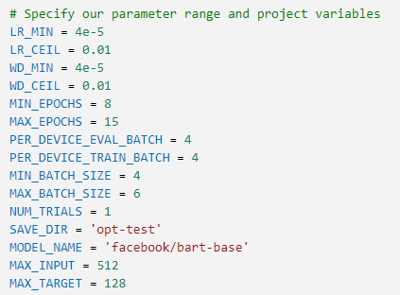

The code snippet above illustrates how the hyperparameters are initialized with a group of values, some of which are within a range based on the setting of the min and max parameters. In order to determine the optimal parameter values from the initialized range, these parameters will be utilized during hyperparameter search training. If no range is specified, the default will start at zero.

Figure 14: Hyperparameter Search Using Optuna (Self-Composed)

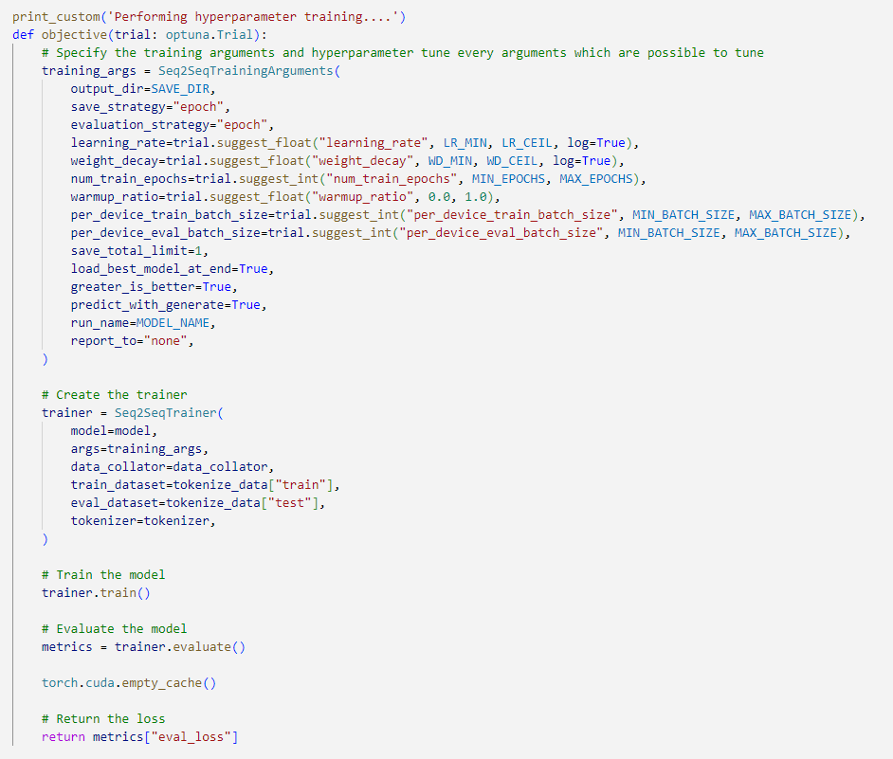

The above snippet shows how the Optuna framework is integrated with the model training code to perform automated hyperparameter search. The main performance contributing parameters are considered for the hyperparameter searching this includes learning rate, weight decay, num of training epochs, warmup ratio, batch size.

Figure 15: Hyperparameter Results and Training Arguments (Self-Composed)

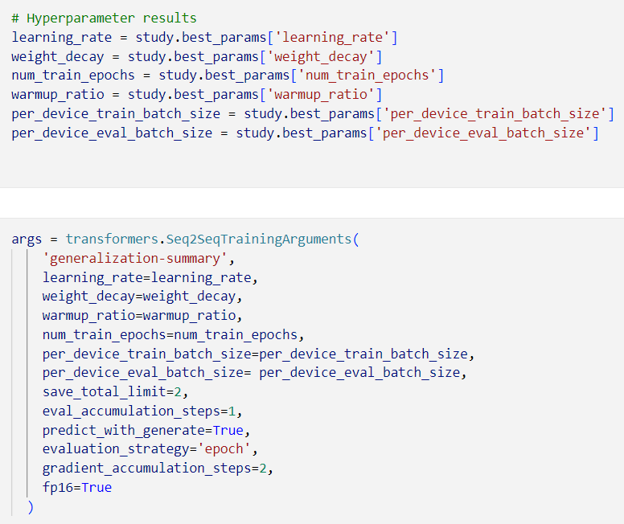

The above snippet demonstrates how to result of the hyperparameter search is used within the training arguments for model training.

Figure 16: Model Training (Self-Composed)

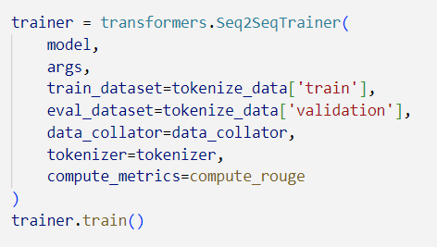

The above code snippet is the model training initiation with the optimal hyperparameters.

## **7.3.2 Model Usage General & Domain Specific Users**

Figure 17: General User Review Text Summarization (Self-Composed)

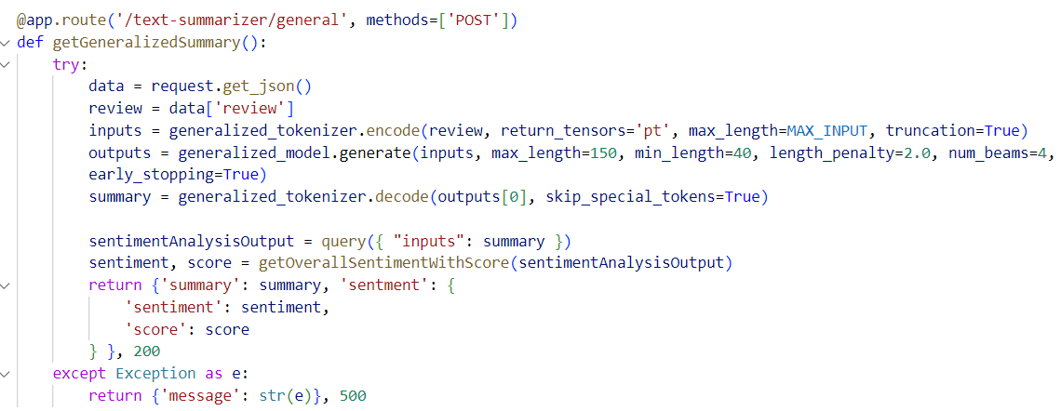

The above code snippet is an API endpoint which handles text (review) summarization for the general users where they don’t need to create and account or have specialized model assigned to them instead the general model is utilized.

Figure 18: Assigning A Specific Model for The New Domain User (Self-Composed)

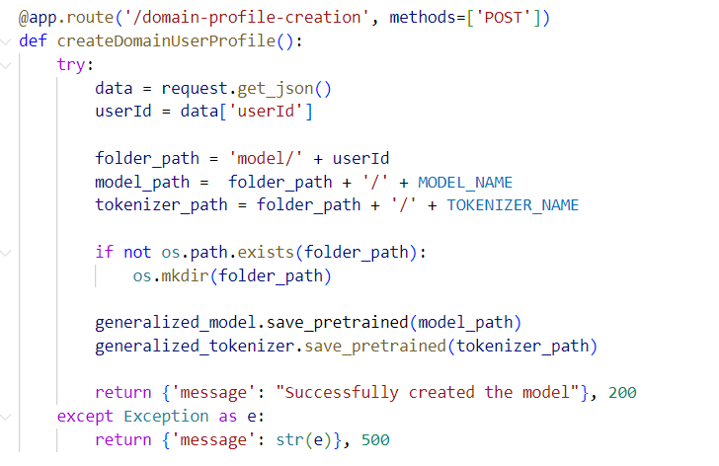

The above code snippet describes an API for assigning a copy of the generalized model for the user id of the domain (given that the domain user signed up for the application), the reason for creating a copy is for retraining purposes with new data.

Figure 19: Domain Specific Text Review Summarization (Self-Composed)

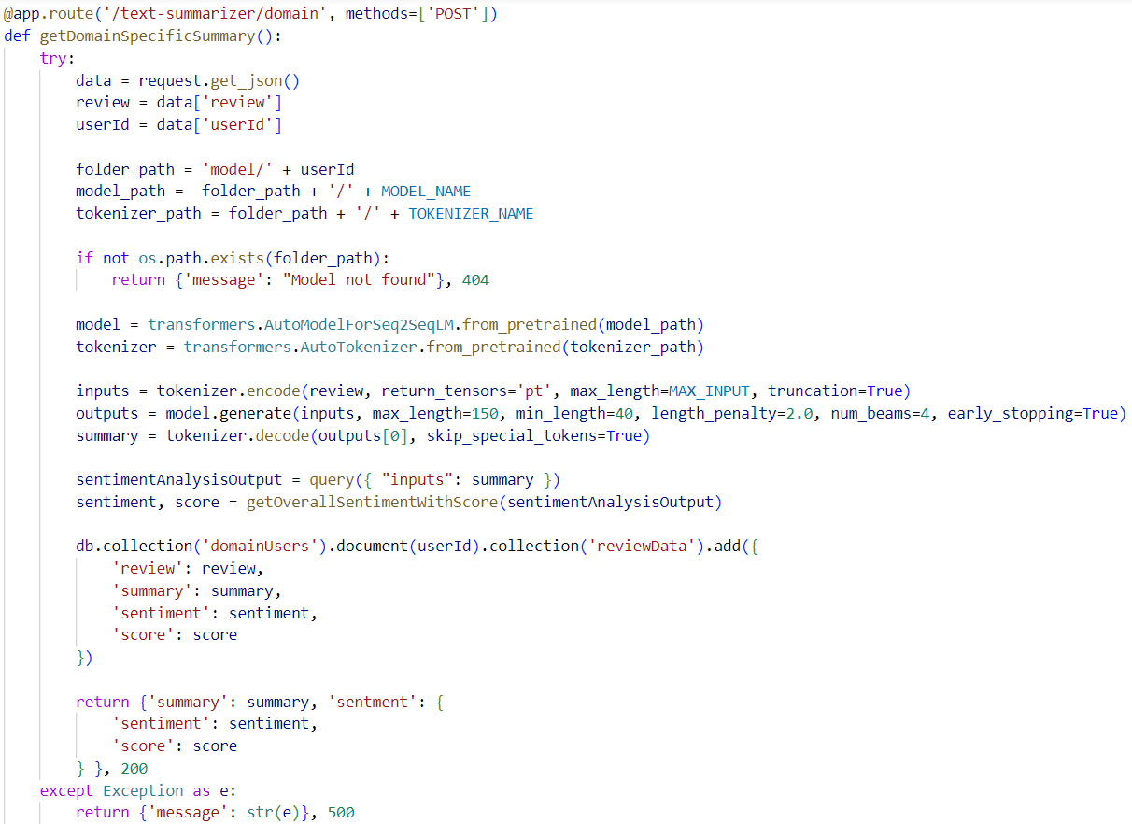

The code uses a domain-specific model to generate a summary, saves the input/output to a database, and analyzes sentiment using a pre-trained transformer from Hugging Face API.

## **7.3.3 Model Retraining**

Figure 20: Fetching Related Data for Model Retraining (Self-Composed)

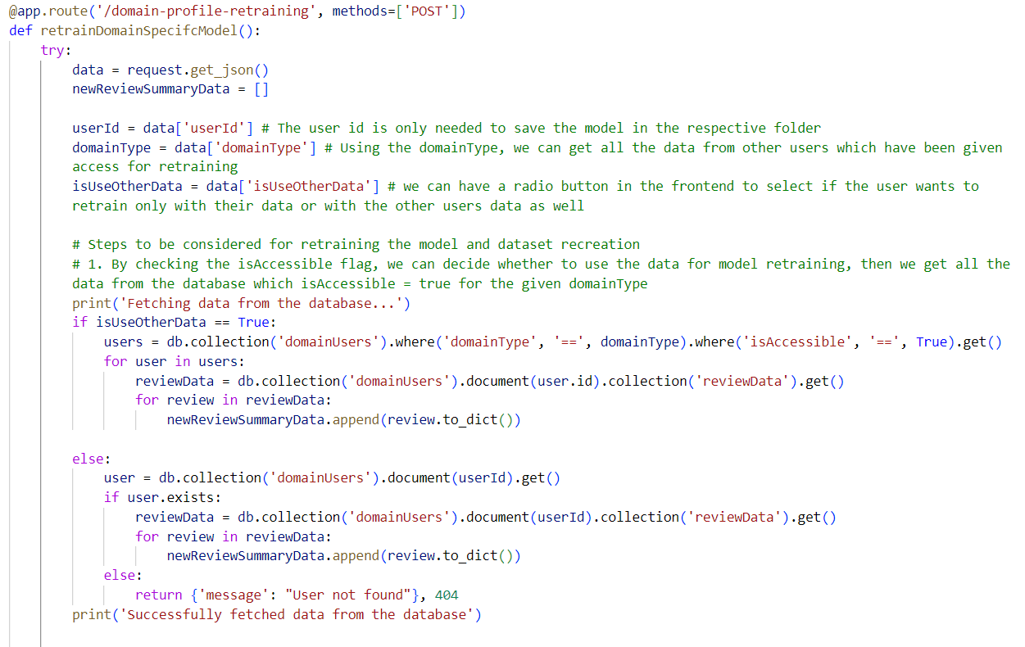

The code snippet above describes the necessary data fetched from the database to create the new dataset for model retraining, once the new dataset is created it is passed through a function to perform hyperparameter tuning and then retrain the model. Once completed retraining, the old model will be replaced with the new model in the folder path location.

## **7.3.4 Data Preprocessing**

The raw dataset was contaminated with a lot of noise, numerous data preprocessing steps were required to clean the data before model training. The related preprocessing scripts can be found at **APPENDIX E.6**.

# **7.4 User interface**

Screenshots of the final GUI are placed under **APPENDIX E.7**.

# **7.5 Chapter summary**

The chapter discusses the tools, technology, and languages utilized to create the research prototype. The fundamental functionality is covered, along with insights and samples of code for the implemented algorithms, moreover the testing and evaluation related code for the models is discussed.

# **CHAPTER 08. TESTING**

# **8.1 Chapter Overview**

After achieving an acceptable level of implementation, it is imperative to subject the system to rigorous testing to ascertain that its functionalities operate as intended. This chapter entails conducting comprehensive testing on both the system and the utilized model. The testing methodologies employed encompass functional, non-functional, integration, and model testing, all aimed at providing an extensive evaluation of the system's performance.

# **8.2 Testing objectives & goals**

The primary objective of testing is to verify that the system functions in the expected manner. Achieving this objective requires meeting several testing goals.:

* Confirm the model's performance is optimized to its fullest potential.
* Ensure that the implemented functionalities are in line with the "Must have" and "Should have" criteria of the MoSCoW technique.
* Identify any necessary bug fixes or improvements that need to be applied to the application.
* Ascertain if the critical non-functional requirements have been satisfied.
* Perform baseline benchmarking to establish a standard for comparing the system's future performance.

# **8.3 Testing criteria**

Before proceeding with the testing phase, a specific set of standards was established to assess the system using two different methods.

* **Functional Quality** – This involves examining the system's developmental traits and technical specifications to determine its conformity to the designated design based on functional requirements.
* **Structural Quality** – This evaluates the system's non-functional requirements while simultaneously ensuring that it satisfies the functional requirements' performance criteria.

# **8.4 Model testing & evaluation**

## **8.4.1 Model testing**

Three transformer architectures, considered to be the most prominent, were employed to train the datasets, and subsequently, conducted testing on all of them. The figures presented below display the validation accuracy and loss for each of the three models, facilitating the selection of the model that performed the best.

|  |  |
| --- | --- |
| Figure 21: Validation Accuracy by number of epochs – bart model (*Self-Composed*) | Figure 22: Validation Loss by number of epochs – bart model (*Self-Composed*) |

The figures shown above depict the outcomes of testing the BART model, where all the rouge scores exhibit an upward trend as the number of epochs increases.

These results were obtained after conducting hyperparameter tuning, which yielded a higher score compared to the benchmark scores reported in earlier research.

Similarly, there is a considerable decline in the validation loss as the number of epochs increases, indicating that the model is enhancing its capability to generate precise predictions.

|  |  |
| --- | --- |
| Figure 23: Validation Accuracy by number of epochs – t5 model (*Self-Composed*) | Figure 24: Validation Loss by number of epochs – t5 model (*Self-Composed*) |

The presented figures demonstrate the testing results of the T5 model, where all the rouge scores exhibit an exponential increase and eventually plateau as the number of epochs increases. Similarly, the validation loss also shows an exponential decrease with respect to the number of epochs. Nevertheless, the overall results indicate that the BART model performs slightly better than the T5 model.

|  |  |
| --- | --- |
| Figure 25: Validation Accuracy by number of epochs – Pegasus model (*Self-Composed*) | Figure 26: Validation Loss by number of epochs – Pegasus model (*Self-Composed*) |

The illustration above depicts the testing outcomes of the Pegasus model, indicating a poor performance despite identifying the optimal hyperparameters for the given training dataset. The rouge scores remain consistently low, and the validation loss graph depicts no variation due to the lack of improvement in accuracy.

## **8.4.2 Model Evaluation**

The evaluation metrics for the models were computed based on the recommended criteria from the literature review and the author's proficiency in evaluating machine learning models. These metrics were then presented in **LR Chapter**, under the "**Evaluation**" topic.

According to previous research conducted by (Steinberger and Jezek, 2009), among the primary scoring methods of ROUGE and BLEU, ROUGE and its metric versions are regarded as the most appropriate for achieving optimal results.

Table 28: Model Evaluation Results

|  |  |  |  |  |
| --- | --- | --- | --- | --- |
| **Model** | **Rouge1** | **Rouge2** | **RougeL** | **RougeLSum** |
| Bart | 80.78 | 79.42 | 80.80 | 80.83 |
| T5 | 80.75 | 79.76 | 80.77 | 80.79 |
| Pegasus | 10.07 | 1.21 | 8.34 | 8.33 |

According to the evaluation provided, it is evident that the Bart transformer model performs better than the other two models, while Pegasus has the poorest performance.

The inadequate performance of Pegasus model could be due to multiple reasons even if it has undergone optimization and suitable preprocessing. Pegasus and Bart have different model architectures which can impact how they comprehend and represent text data. Pegasus uses a transformer-based encoder-decoder framework while Bart uses a denoising autoencoder framework. It's possible that one architecture may be better suited for a specific dataset than the other.

**Domain Model Evaluation**

The adaptive generalized solution was tested with two different domains - **movies** and **hotels** - to demonstrate the effectiveness of the approach.

Testing dataset:

1. **Movie Review**: The dataset was provided by Stanford University, which are amazon movie review data (SNAP, no date).
2. **Hotel Review**: The dataset was provided by Kaggle (Jonathanoheix, 2018).

The following are the evaluation results for each domain when tested with the corresponding dataset listed above after model retraining with unseen data.

Figure 27: Hotel Domain (Cinnamon Type) Evaluation

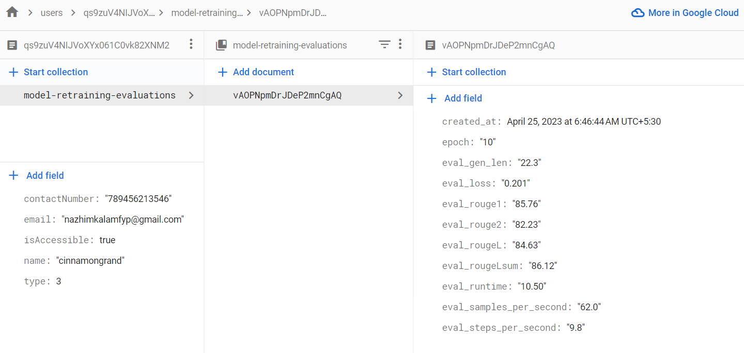

Figure 28: Movie Domain (Scope Cinema Type) Evaluation

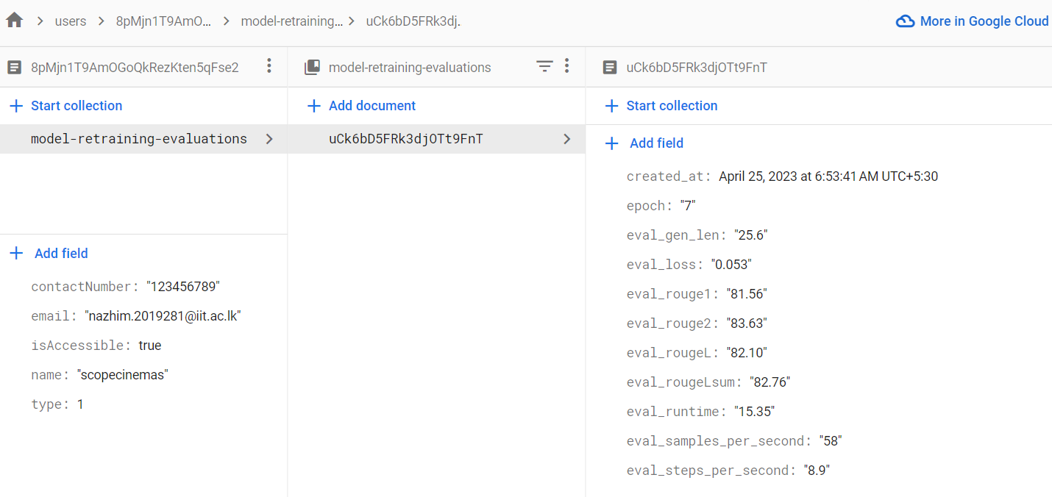

Based on the figures presented, it is evident that the performance of the domain-specific model improves as new data is added. Therefore, each domain is expected to have its own model and continually improve it over time. The idea of generalization is considered proven based on the results presented.

# **8.5 Benchmarking**

Previously, in **LR chapter** under the “**Benchmarking**” topic it discussed the benchmarking results of training transformers with generalized datasets for abstractive text summarization. The table given below is a benchmarking comparison with the previous researched results and the authors results.

Table 29: Benchmarking results

|  |  |  |  |  |  |  |
| --- | --- | --- | --- | --- | --- | --- |
| **Year** | **Type of model** | **Rouge1** | **Rouge2** | **RougeL** | **Is optimized** | **Dataset** |
| 2019 | Transformer | 36.73 | 14.93 | 29.66 | No | Xsum |
| 2019 | Bart | 45.14 | 22.27 | 37.25 | No | Xsum |
| 2020 | RoBERTa | 45.42 | 22.13 | 36.92 | No | Xsum |
| 2023 | Bart | 80.78 | 79.42 | 80.80 | Yes | Xsum |

The presented table indicates the benchmarking outcomes of transformer models utilized by previous researchers between 2019 and 2020 on the same dataset (Xsum) utilized by the author. The final result displayed in the table (Year 2023) represents the author's ultimate evaluation result, which demonstrates almost a two-fold improvement in performance compared to earlier researchers who did not optimize their models.

# **8.6 Functional testing**

The system was assessed to determine if it complies with the functional requirements outlined in **SRS** **Chapter** through the use of functional testing. A breakdown of the functional testing that was conducted can be found in **APPENDIX F.1**.

# **8.7 Module & integration testing**

The high-level architecture diagram depicted in **Design** **Chapter** illustrated that the system's logic was divided into modules. To ensure that each module operates as intended, they underwent testing.

Table 30: Module & integration testing

|  |  |  |  |  |
| --- | --- | --- | --- | --- |
| **Module** | **Input** | **Expected result** | **Actual result** | **Status** |
| NLP Text parser | Triggered when input review text | Preprocessing the input data | Preprocessing the input data. | Passed |
| Dataset recreation | Triggered during model retraining | Decrypts data from the database and creates new dataset | Decrypts data from the database and creates new dataset | Passed |
| Data Encryption | Triggered when domain user generates summary | Review text gets encrypted and stored into the database | Review text gets encrypted and stored into the database | Passed |
| Hyperparameter tuning | Triggered during model retraining | Using the new dataset, new hyperparameters are found | Using the new dataset, new hyperparameters are found | Passed |
| Model training | Triggered during model retraining | Using the new dataset and new hyperparameters, model retraining is triggered | Using the new dataset and new hyperparameters, model retraining is triggered | Passed |
| User profile creation | Triggered when domain user firstly signup | Assigns a copy of the generalized model for the user | Assigns a copy of the generalized model for the user | Passed |

# **8.8 Non-functional testing**

The system's non-functional requirements were evaluated to assess how well they correspond with the non-functional requirements and design objectives specified in **SRS Chapter**. **APPENDIX F.2** details the specific breakdown of the non-functional testing that was executed.

# **8.9 Limitations of the testing process**

Although the system underwent comprehensive testing, it has not been deployed or hosted yet, which makes it difficult to conduct production-grade load testing within the given timeframe.

# **8.10 Chapter summary**

In the beginning of this chapter, the aims of the testing process and the standards for conducting it were introduced. The evaluation of the models in use was performed by testing the main research component, and functional, non-functional, and integration testing were utilized to assess the system. Ultimately, any constraints of this methodology were identified.

# **CHAPTER 09. EVALUATION**

# **9.1 Chapter Overview**

Once the prototype design was successfully implemented and optimized through multiple testing combinations to achieve maximum performance, the system was assessed in accordance with the requirements outlined in the **SRS chapter**. This particular chapter is devoted to the project's evaluation, which includes self-evaluation by the author and evaluations by technical, domain, and industry experts.

# **9.2 Evaluation Methodology & Approach**

The primary focus of this research to design and implement an adaptive generalized abstractive text summarization system using optimized transformers. Although the system produces text output, it employs numerical data for decision-making, rendering it a quantitative analysis for assessing its efficacy. Additionally, a qualitative analysis by domain experts is necessary to establish its reliability. This chapter will present the results of a **thematic analysis** of the feedback obtained through the aforementioned qualitative analysis.

# **9.3 Evaluation Criteria**

In preparation for the evaluation process, it is essential to establish unambiguous criteria to evaluate all aspects of the research thoroughly. The following table delineates the specific criteria that the author established before initiating the evaluation.

Table 31: Evaluation criteria

|  |  |  |
| --- | --- | --- |
| **CR ID** | **Criterion** | **Purpose** |
| CR1 | Selection of research domain | To confirm the importance of the selected area of study, subject matter, and gap in research. |
| CR2 | Research contribution | To assess the importance of the discovered results and their contributions to the existing pool of knowledge. |
| CR3 | Research documentation quality | To verify that sufficient literature has been examined and that the entire research procedure has been recorded and presented with an acceptable level of quality. |
| CR4 | Development approach | To verify that sufficient literature has been examined and that the entire research procedure has been recorded and presented with an acceptable level of quality. |
| CR5 | Quantitative analysis of results | To verify the metrics employed to assess and analyze the outcomes generated by the research. |
| CR6 | Limitations & Improvements | To recognize any constraints or shortcomings and opportunities for future research. |
| CR7 | Usability & UI/UX | To confirm that the product created for demonstration purposes is user-friendly for end-users. |

# **9.4 Self-Evaluation**

The table presented below depicts the author's self-assessment based on the aforementioned standards.

Table 32: Self-Evaluation of The Author

|  |  |
| --- | --- |
| **CR ID** | **Author’s self-evaluation** |
| CR1 | The selected research domain pertained to a technical application of significant utility, which holds promise for adoption by various users across diverse domains. However, given its relatively recent introduction, identifying domain experts presents a challenge. |
| CR2 | This research has made significant contributions in several areas aimed at enhancing the performance of text summarization using transformers. Firstly, it has made technical contributions in developing a generalized system for text summarization that can enhance domain-specific performance. Secondly, the contribution to the domain being to improve performance for review summarization for the domain of movies. |
| CR3 | The documentation has been produced to an exceptional level of quality, with Microsoft Word being utilized for all report documentation in order to ensure consistency across diagrams, tables, and internal links along with external links (video demonstration links). Nevertheless, LaTeX has been employed for the creation of both review papers and research papers. |
| CR4 | Considerable resources have been dedicated to gathering and preparing data to achieve optimal outcomes. Extensive experimentation has been conducted on several high-level transformer structures with diverse comprehensive datasets. Furthermore, state-of-the-art technologies and software have been employed throughout the process. |
| CR5 | The assessment outcomes of the model were produced within the Google Colab notebooks that were utilized for training the model. |
| CR6 | After finalizing the system, the author recognized a few areas where enhancements and improvements could be made, and suggested these as potential areas for future research. |
| CR7 | The user interface and experience of the final product has been designed in a way that is both usable and minimalistic. |

# **9.5 Selection of Evaluators**

Evaluators were selected based on grouping, which was necessary to receive feedback on all aspects of the project. The table below illustrates the breakdown of the groups.

Table 33: Categorization of selected evaluators

|  |  |
| --- | --- |
| **CAT ID** | **Category** |
| CAT1 | Experts who have conducted research in the areas of Text Summarization Systems, Data Science, Data Engineering, and Machine Learning. |
| CAT2 | Experts who possess expertise in NLP (Natural Language Processing) and transformers. |
| CAT3 | Possible end users of the application |

# **9.6 Evaluation Results & Expert Opinions**

The opinions and feedback from the experts mentioned earlier were analyzed using thematic analysis. The results of this analysis are presented in the table below.

Table 34: Thematic analysis of expert feedback

|  |  |  |  |
| --- | --- | --- | --- |
| **CR ID** | **CAT ID** | **Theme** | **Summary of Opinions** |
| CR1 | CAT1 | Text Summarization System choice gap | The utilization of text summarization can be highly advantageous for businesses, particularly in the realm of ecommerce where reviews play a crucial role in driving sales. |
| Technical research gap | The adoption of transformers as an approach for the domain is preferred over conventional methods, and further investigation into its optimization can prove advantageous. |
| CAT2 | Domain research gap | The identified objective is to bridge the gap in performance optimization and develop a solution that is more generalized. |
| CAT3 | Usefulness of domain research. | As it is an adaptive solution, there currently exists no generalized application to address the performance issue in this new domain application. |
| CR2 | CAT1 | Contribution of technology to text summarization systems. | The issues with conventional approaches have been clearly identified, and there is a clear understanding of the methods required to resolve this problem. |
| CAT2 & CAT3 | Domain Contribution | The proposed solution is a valuable contribution since there is currently no such solution available, and creating it as a plugin for businesses could provide significant benefits. |
| CR3 | CAT1 | Displaying of content | The utilization of Microsoft Word documents to their fullest potential was acknowledged, and the research conducted was thorough, including the presentation of statistical data. |
| CAT1 & CAT2 & CAT3 | The problem-solving approach used | A comprehensive analysis of various angles was undertaken to approach the solution, and a more logical approach has been adopted. |
| CR4 | CAT1 | Data preprocessing | Significant effort has been devoted to data pre-processing, as experimentation was conducted using multiple datasets, requiring additional time and resources. |
| CAT1 & CAT2 | Experimentation of transformers with datasets for generalization | The selection of transformer models for experimentation was thoroughly considered and adequately justified. |
| CAT1 & CAT2 & CAT3 | Development approach for adaptive generalization | The chosen direction was deemed suitable by all, and a systematic and methodical approach was employed within the given timeframe. |
| CR5 | CAT1 & CAT2 & CAT3 | Analysis of the text summarization model | The current evaluation, using the ROUGE metric, indicates a significant improvement in performance compared to previous benchmarking results, with a performance gap exceeding 50%. ROUGE is considered the most suitable metric for evaluating such models. |
| CR6 | CAT1 & CAT2 | Model modifications: hybrid approach or customizing layers | The author attempted to explore the use of hybrid models and customization of existing models, but due to the limited timeframe, it was challenging to implement these approaches effectively. |
| CAT3 | New feature additions | Prior to generating a summary, it would be advisable to incorporate a paraphrasing function, considering the possibility that users might input text with grammatical errors. |
| CR7 | CAT1 & CAT2 | Great to have a working application for the model | As the model appears to be functioning well during testing, developing a functional application for users would be a wise choice. |
| CAT 3 | Minimalistic UI design | The design of the UI is very simple and clean, where most of the users found it attractive to use. |

# **9.7 Limitations of Evaluation**

As there is a scarcity of experts in the research domain (Transformers), only a limited number of expert opinions were obtained. This was apparent during the requirement gathering phase, as the author reached out to numerous ML/DL domain experts for more insights on the research concept, but only a few were able to provide relevant information. Therefore, only the experts specified in **APPENDIX G.1** possessed the required knowledge and expertise to provide constructive feedback. Nevertheless, traditional ML/DL experts were also approached to obtain feedback, as it could still prove to be beneficial.

# **9.8 Evaluation of Functional requirements**

The breakdown of completed functional requirements is provided in **APPENDIX G.2**.

# **9.9 Evaluation of non-functional requirements**

The breakdown of completed non-functional requirements and the attainment of the design goals are presented in **APPENDIX G.3**.

# **9.10 Chapter summary**

In this chapter, the implemented system was evaluated by establishing evaluation criteria that comprehensively covered all aspects of the system. The author conducted self-evaluation and obtained feedback from evaluators, which was analyzed through thematic analysis. The evaluation report presented the achievement of the proposed design goals, along with the evaluation of functional and non-functional requirements.

# **CHAPTER 10. CONCLUSION**

# **10.1 Chapter Overview**

This chapter concludes the research project, highlighting the core functionality of the MVP's implementation. It reviews the project's achievements, obstacles encountered, and documents the author's prior knowledge and modules of the program that supported the project, along with any new knowledge and skills acquired.

# **10.2 Achievement of Research Aim & Objectives**

## **10.2.1 Achievement of Aim**

**“***The aim of this research is to design, develop and evaluate an optimal generalized transformer architecture from a range of popularly used architectures by fine-tuning via hyperparameter optimization, therefore obtaining the recommended architecture's optimum performance.***”**

The aim of the research was achieved by **designing, developing, and evaluating** a performance adaptive generalized transformer. The core functionality was automated to meet the project requirements, and the evaluation of the work is presented in the implementation chapter.

## **10.2.2 Achievement of Objectives**

**APPENDIX H.1** lists the achievement status of the research objectives mentioned in Chapter 01, with "Completed" next to successfully completed tasks and "Incomplete" next to unfinished ones.

# **10.3 Utilization of knowledge from the degree**

Table 35: Utilization of Knowledge Gained from The Course

|  |  |
| --- | --- |
| **Module(s)** | **Utilized Knowledge** |
| Machine Learning | Having a solid grasp of the concept of data collection and preprocessing, as well as machine learning model training, proved to be instrumental in creating the models used in this research project. |
| Applied AI | The author gained a comprehensive understanding of the theoretical principles behind ML models through their knowledge of how algorithms interact during the model-building process. |
| Software Development Group Project | The module acted as a trial run for the Final Year Project, giving students the basic skills needed to plan, conduct and evaluate research, thus providing them with the necessary confidence and knowledge for their final year project. |
| Object Oriented Programming | The understanding of object-oriented programming and the significance of creating classes helped improve the development aspect of the project. |
| Python Programming (PP1) | This project involves the use of Flask, a web framework for the Python programming language. The PP1 module introduced the author to working with Python. |
| Database Systems | The understanding of using queries to communicate with the database from the webserver system facilitated read and write operations for the project. |
| Web Design & Development | The concepts learned from this module were used to develop the user interface (UI) of the prototype, and the foundational knowledge of using HTML, CSS, and JS was instrumental in transitioning to working with more advanced frameworks like React. |

# **10.4 Use of Existing Skills**

* **Full-Stack Web Development** – The author utilized advanced technologies for a full stack web development project while working on several R&D projects during their internship at 99x.
* **Machine Learning / Deep Learning** – During the author's internship, they were involved in several R&D projects related to data science and also utilized various online learning resources to develop their skills in machine learning.
* **Documentation Writing** – The author became proficient in project documentation during their internship and while working on the SDGP module report.

# **10.5 Use of New Skills**

* **Text Summarization Systems –** The author lacked prior experience in text summarization systems and thus conducted research on various techniques using publicly accessible online resources from YouTube, GitHub, Google Colab, and others.
* **Data Preprocessing Techniques –** The project domain being text summarization, the author had to acquire new text preprocessing techniques to ensure the data was meaningful.
* **Hyperparameter Optimization –** The author explored and experimented with hyperparameter tuning frameworks to automate the hyperparameter search, referring to tutorials and technical articles to implement this in the project.

# **10.6 Achievement of learning outcomes**

In **APPENDIX H.2**, there is a presentation of the accomplishment of the learning objectives.

# **10.7 Problems and Challenges faced**

Table 36: Mitigations to Problems and Challenges Faced

|  |  |
| --- | --- |
| **Problem/Challenge** | **Mitigation** |
| Significant training time and computing resource limitations. | The author uses Google Colab to train transformer-based models due to the high GPU power demands of the training process. |
| Limited experts for the domain | The author conducted interviews with domain experts for requirement gathering by reaching out to them via LinkedIn since there were limited opportunities for in-person interactions with domain experts. |
| Power outages were frequent, causing battery and internet connectivity issues. | The author persevered with the project despite power outages by working late or early in the morning at co-working spaces. |

# **10.8 Deviations**

The author's original goal was to develop an optimized solution for ***movie review summarization*** using transformers. However, after discussions with supervisors, it was decided that the author's technical contribution of automated hyperparameter tuning for transformers was not significant enough. As a result, the idea of creating a ***performance adaptive generalized solution*** was considered to continue the research implementation.

It's great to see that the author was able to complete the core functionalities for the prototype, even with the challenge of time constraints mentioned by the experts interviewed for the requirement gathering. It shows the author's determination and ability to overcome obstacles to achieve the project's goals.

# **10.9 Limitations of the research**

* The author tried to implement additional performance improvements like model hybridization after completing the core implementation. However, due to the limited time available, the amount of research required for transformer hybridization was significant, which prevented the author from continuing.
* The author did not explore various other transformer models for abstractive text summarization due to limitations of GPUs.

# **10.10 Future enhancements**

* This sentence suggests that transformer hybridization can be used to improve the performance of text summarization models in the future.
* The author suggests that including text paraphrase models for user reviews would be a sensible approach since there is a potential that user reviews entered are not always accurate.
* The author suggests applying key word extraction for the sentiment classification of the review summary in order to identify which key words contributed to the sentiment classification and to help domain users improve their service.

# **10.11 Achievement of the Contribution to the Body of Knowledge**

The author made successful contributions to the problem domain of movie review summarization by implementing the system and making deviations from the initial goal to create a generalized solution. They also made technical contributions to improve the system's performance, but due to limited time, they were unable to explore all possibilities. Finally, the author made additional contributions to bring the research project to a conclusion.

## **10.11.1 Domain Contributions**

The author as able to address the performance gap listed for movie review summarization, in order for the need of advanced approaches to increase the performance and achieve a better result.

Moreover, generalization approach considered here contributions to various other domains facing the similar problem to be address as a common.

## **10.11.2 Technical Contribution**

Using a top-tier explored transformer model, automating hyperparameter search for every domain, and use the newly exposed data to automate model retraining with the searched optimal set of hyperparameters.

Currently, there are no such approaches taken from the research done by the author, and the author believes that this approach would benefit multiple domains at the same time.

## **10.11.3 Additional Contributions**

1. Research-based Data Preprocessing scripts specifically for text summarization issue domains.
2. Sentiment Analysis on the generated review summary
3. Experimented the model training with multiple datasets, to get the best possible set of evaluation results.

# **10.12 Implementation code**

All related code and documentation material are made available in GitHub by the author at <https://github.com/nazhimkalam/gensum/tree/main>

# **10.13 Concluding remarks**

The conclusion of this study finds that the author was able to design, build, and evaluate an adaptive generalized abstractive text summarization system using optimized transformers and automated hyperparameter tuning and model retraining. The purpose of this chapter was to determine if the author met the goals and objectives of the project, and to examine the role of the author's prior knowledge and academic background in supporting the research. Additionally, the author discusses the new skills they acquired during the project and the challenges and obstacles they encountered, as well as the deviations taken and the limitations of the research. The author also goes in detail about the opportunities for future improvements and also discusses about the contribution to the body of knowledge which include domain, technical and additional contributions made. The author is currently working on publishing a research paper based on their findings.

# **REFERENCES**

Abolghasemi, M., Dadkhah, C. and Tohidi, N. (2022). HTS-DL: Hybrid Text Summarization System using Deep Learning. *2022 27th International Computer Conference, Computer Society of Iran (CSICC)*. 23 February 2022. Tehran, Iran, Islamic Republic of: IEEE, 1–5. Available from https://doi.org/10.1109/CSICC55295.2022.9780395 [Accessed 26 October 2022].

Alsaqer, A.F. and Sasi, S. (2017). Movie review summarization and sentiment analysis using rapidminer. *2017 International Conference on Networks & Advances in Computational Technologies (NetACT)*. July 2017. Thiruvanthapuram, India: IEEE, 329–335. Available from https://doi.org/10.1109/NETACT.2017.8076790 [Accessed 10 October 2022].

Barna, N.H. and Heickal, H. (2022). An Automatic Abstractive Text Summarization System. *Dhaka University Journal of Applied Science and Engineering*, 6 (2), 39–48. Available from https://doi.org/10.3329/dujase.v6i2.59217.

Boorugu, R., Ramesh, G. and Madhavi, K. (2019). Summarizing Product Reviews Using Nlp Based Text Summarization. *International Journal of Scientific & Technology Research Volume*, 8 (10), 1127–1133.

Brasoveanu, A.M.P. and Andonie, R. (2020). Visualizing Transformers for NLP: A Brief Survey. *2020 24th International Conference Information Visualisation (IV)*. September 2020. Melbourne, Australia: IEEE, 270–279. Available from https://doi.org/10.1109/IV51561.2020.00051 [Accessed 2 November 2022].

Etemad, A.G., Abidi, A.I. and Chhabra, M. (2021). A Review on Abstractive Text Summarization Using Deep Learning. *2021 9th International Conference on Reliability, Infocom Technologies and Optimization (Trends and Future Directions) (ICRITO)*. 3 September 2021. Noida, India: IEEE, 1–6. Available from https://doi.org/10.1109/ICRITO51393.2021.9596500 [Accessed 10 October 2022].

Gupta, A. et al. (2021). Automated News Summarization Using Transformers. *ArXiv*, abs/2108.01064.

Gupta, V. and Lehal, G.S. (2010). A Survey of Text Summarization Extractive Techniques. *Journal of Emerging Technologies in Web Intelligence*, 2 (3), 258–268. Available from https://doi.org/10.4304/jetwi.2.3.258-268.

Joy, J. and Selvan, M.P. (2022). A comprehensive study on the performance of different Multi-class Classification Algorithms and Hyperparameter Tuning Techniques using Optuna. *2022 International Conference on Computing, Communication, Security and Intelligent Systems (IC3SIS)*. 23 June 2022. Kochi, India: IEEE, 1–5. Available from https://doi.org/10.1109/IC3SIS54991.2022.9885695 [Accessed 24 October 2022].

Khan, A. et al. (2020). Movie Review Summarization Using Supervised Learning and Graph-Based Ranking Algorithm. *Computational Intelligence and Neuroscience*, 2020, 7526580. Available from https://doi.org/10.1155/2020/7526580.

Kirmani, M. et al. (2019). Hybrid Text Summarization: A Survey. In: Ray, K. Sharma, T.K. Rawat, S. et al. (eds.). *Soft Computing: Theories and Applications*. Advances in Intelligent Systems and Computing. Singapore: Springer Singapore, 63–73. Available from https://doi.org/10.1007/978-981-13-0589-4_7 [Accessed 1 November 2022].

Kouris, P., Alexandridis, G. and Stafylopatis, A. (2019). Abstractive Text Summarization Based on Deep Learning and Semantic Content Generalization. *Proceedings of the 57th Annual Meeting of the Association for Computational Linguistics*. 2019. Florence, Italy: Association for Computational Linguistics, 5082–5092. Available from https://doi.org/10.18653/v1/P19-1501 [Accessed 24 October 2022].

Lackermair, G., Kailer, D. and Kanmaz, K. (2013). Importance of Online Product Reviews from a Consumer’s Perspective. *Advances in Economics and Business*, 1 (1), 1–5. Available from https://doi.org/10.13189/aeb.2013.010101.

Lin, C.-Y. (2004). ROUGE: A Package for Automatic Evaluation of Summaries. 8.

Liu, X. and Wang, C. (2021). An Empirical Study on Hyperparameter Optimization for Fine-Tuning Pre-trained Language Models. Available from http://arxiv.org/abs/2106.09204 [Accessed 24 October 2022].

Mahajan, R. et al. (2021). Text Summarization Using Deep Learning. *International Research Journal of Engineering and Technology (IRJET)*, 08 (05th May 2021), 1737–1740.

McAuley, J.J. and Leskovec, J. (2013). From amateurs to connoisseurs: modeling the evolution of user expertise through online reviews. *Proceedings of the 22nd international conference on World Wide Web - WWW ’13*. 2013. Rio de Janeiro, Brazil: ACM Press, 897–908. Available from https://doi.org/10.1145/2488388.2488466 [Accessed 19 November 2022].

Mukherjee, R. et al. (2020). Read what you need: Controllable Aspect-based Opinion Summarization of Tourist Reviews. *Proceedings of the 43rd International ACM SIGIR Conference on Research and Development in Information Retrieval*. 25 July 2020. 1825–1828. Available from https://doi.org/10.1145/3397271.3401269 [Accessed 10 October 2022].

Neyshabur, B. et al. (2017). Exploring Generalization in Deep Learning. *undefined*. Available from https://www.semanticscholar.org/reader/d53fb3feeeab07a0d70bf466dd473ec6052ecc07 [Accessed 9 November 2022].

Pai, A. (2014). Summarizer Using Abstractive and Extractive Method. *International Journal of Engineering Research*, 3 (5), 5.

Pizam, A. and Ellis, T. (1999). Customer satisfaction and its measurement in hospitality enterprises. *International Journal of Contemporary Hospitality Management*, 11 (7), 326–339. Available from https://doi.org/10.1108/09596119910293231.

Shi, T. et al. (2020). Neural Abstractive Text Summarization with Sequence-to-Sequence Models. Available from http://arxiv.org/abs/1812.02303 [Accessed 10 October 2022].

Shorten, C. and Khoshgoftaar, T.M. (2019). A survey on Image Data Augmentation for Deep Learning. *Journal of Big Data*, 6 (1), 60. Available from https://doi.org/10.1186/s40537-019-0197-0.

Socher, R., Bengio, Y. and Manning, C.D. (2012). Deep Learning for NLP (without Magic). *Proceedings of the 50th Annual Meeting of the Association for Computational Linguistics: Tutorial Abstracts*. July 2012. Jeju Island, Korea: Association for Computational Linguistics, 5. Available from https://aclanthology.org/P12-4005 [Accessed 2 November 2022].

Steinberger, J. and Jezek, K. (2009). Evaluation Measures for Text Summarization. *Comput. Informatics*, 28 (2), 251–275.

Wolf, T. et al. (2020). Transformers: State-of-the-Art Natural Language Processing. *Proceedings of the 2020 Conference on Empirical Methods in Natural Language Processing: System Demonstrations*. 2020. Online: Association for Computational Linguistics, 38–45. Available from https://doi.org/10.18653/v1/2020.emnlp-demos.6 [Accessed 10 October 2022].

Zhang, J. et al. (2020). PEGASUS: Pre-training with Extracted Gap-sentences for Abstractive Summarization. Available from http://arxiv.org/abs/1912.08777 [Accessed 18 October 2022].

Zhou, K. et al. (2021). Domain Generalization with MixStyle. *undefined*. Available from https://www.semanticscholar.org/reader/4f6eafafc9563a5b904535078df7e74afe39ef59 [Accessed 5 December 2022].

aws.amazon.com. (2022). *Hyperparameter optimization for fine-tuning pre-trained transformer models from Hugging Face | AWS Machine Learning Blog*. [online] Available at: https://aws.amazon.com/blogs/machine-learning/hyperparameter-optimization-for-fine-tuning-pre-trained-transformer-models-from-hugging-face/ [Accessed 9 Nov. 2022].

Web data: Amazon Movie Reviews (no date) SNAP. Available at: https://snap.stanford.edu/data/web-Movies.html (Accessed: April 25, 2023).

Jonathanoheix (2018) Sentiment analysis with Hotel Reviews, Kaggle. Kaggle. Available at: https://www.kaggle.com/code/jonathanoheix/sentiment-analysis-with-hotel-reviews/input (Accessed: April 25, 2023).

# **APPENDIX A – INTRODUCTION**

# **A.1. Prototype feature diagram**

The illustration presented underneath illustrates the preliminary characteristic diagram suggested in the proposal manuscript.

Figure 29: Prototype Feature Diagram (Self-Composed)

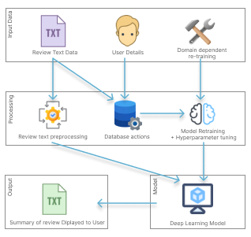

# **A.2. Project scope**

**In scope**

* ***System Generalization –*** Creating a generalized system to be able to **adapt** to any domain.
* ***Dataset reconstruction*** – Reconstructing the dataset to a format structure which can be used for data preprocessing + model training.
* ***Model refinement on hyperparameter tuning*** – Performing hyperparameter tuning on the top tier transformer architecture models*.*
* ***Evaluating the models*** – Evaluating all the architectures using appropriate metrics to filter out the best architecture from the rest*.*
* ***API integration development*** – REST API endpoints will be created to serve/call the final chosen model for interactions.
* ***GUI development*** – A graphical user interface will be developed; therefore, the end user will be able to perform abstractive text summarization and get visual results.

**Out scope**

* ***Limited architecture explored –*** The system will only be explored with few of the top tier architectures (roughly around 3 or 5 maximum), and will not be exploring more than that.
* ***Only single model integration–*** The final model which outperforms the rest with the best set of hyperparameters will be used as the summary generation model, options to select other architectures explored with their hyperparameters aren’t included.

# **APPENDIX B – LITERATURE REVIEW**

# **B.1. Related work in abstractive text summarization**

Table 37: Related Work in Abstractive Text Summarization

|  |  |  |  |
| --- | --- | --- | --- |
| **Ref.** | **Summary** | **Contribution** | **Limitations** |
| (Khan, Gul, Zareei, et al., 2020) | An automatic approach to summarize lengthy movie reviews and allow users to quickly recognize the positive and negative aspects of a movie. | Worked on feature extraction and converting reviews into vector space, followed by the Naïve Bayes machine learning algorithm used for review classification, using an undirected weighted graph based ranking algorithm to rank score for reach review sentence in graph. Finally, the top ranked sentences are chosen based on highest rank scores to produce ***extractive summary*.** | To use advanced deep learning approaches. |
| (Boorugu, Ramesh and Madhavi, 2019) | Using customer reviews on products when making purchasing decisions to give a proper summarization of the reviews to the customer, so that he doesn’t need to go through all the reviews to figure out if the product is what he is looking for and save time. | Using seq2seq model for summarization along with attention mechanism for increased accuracy, also using word embedding model Concept net Number batch which is better than Glove. Finally, using a 1D convolutional layer followed by max pooling layer, LSTM layer and then at the end a fully connected layer. | Focused on improving the accuracy by using the latest models in the field of text summarization. By using transformers architecture, we could improve this. |
| (Mukherjee et al., 2020) | A solution for generating personalized aspect-based opinion summaries from large collections of online tourist reviews, also able to customize the attributes of the summary based on the user’s interest. | Using an Integer Linear Programming (ILP [Unsupervised method]) based extractive technique to select an informative subset of opinions around the identified aspects. Evaluate and compare the summaries using ROUGE based metrics and obtain competitive results. | Motive for the need to create tourist review dataset for our experiments.  The need for also experimenting with the data of lesser known places (Tourist locations) |
| (Gupta et al., 2021) | A comprehensive comparison of a few transformer architecture based pre-trained models for text summarization. | Using the pretrained models such as Pipeline BART, BART modified, T5 and PEGASUS to work with the text summarization. Evaluation metrics we done using the ROUGE Scores. | Future work should focus on building more robust models which can further extend the algorithm to create summaries of variable length and apply for multi-document summarization. |
| (Mahajan et al., 2021) | Generate a text summary along with proper grammar and no repeated words using the Encoder-Decoder model with the attention layer | Developed an encoder-decoder model using Gated Recurrent Units and trained the model to generate abstractive summary from an article. | Real time training required if this is used in production, in order to train with the latest articles with time. |
| (Etemad, Abidi and Chhabra, 2021) | Experimenting the text summarization domain with deep learning approaches and finding which performs the best, from RNN, CNN, Transformers etc.… | Experimenting with RNN based models’ architectures, working with pre-trained transformer-based model architectures. Finally, using evaluation metrics such as BLEU and ROUGE to evaluate the models | NA |

# **APPENDIX C – SRS**

# **C.1. Requirement Elicitation Methodologies**

Table 38: Stakeholder groups (*Self-Composed*)

|  |  |  |  |
| --- | --- | --- | --- |
| **Group** | **Stakeholders** | **Reason** | **Instrument** |
| G1 | Domain experts (NLP Experts, AI Researchers, Data Scientists) | In order to respond to research questions and discover anything the author may have overlooked, gather any insights and information especially in the study area. | Interview |
| G2 | Domain and General Users | Gather requirements which will help develop features expected in the application. | Survey & LR |
| G3 | Competitors | Analyze any existing systems related to the research and understand how the project can be enhanced | Self-Evaluations & Brain Storming |
| G4 | Developers | Cross checking if the project is feasible to be continued with. | Prototyping |

# **C.2. Interview analysis**

Table 39: Interview thematic analysis (*Self-Composed*)

|  |  |
| --- | --- |
| **Code** | **Theme** |
| Data handling | Data Collection & Data Preprocessing |
| Transformer architectures | Best performing transformer architectures |
| Generalization | Handling adaptive generalization |
| Research scope | Research gap and scope |
| Hyperparameter tuning | Automatic hyperparameter tuning & model retraining |
| Hybrid transformers | Looking into hybrid transformer combinations |
| Custom transformers | Customizing the transformer architecture |
| Prototype | Prototype features and suggestions |
| Business benefits | Understanding which and how businesses would benefit |
| Evaluations | Understanding the importance and evaluation ways |

Table 40: Interview participant details

|  |  |  |
| --- | --- | --- |
| **ID** | **Affiliation** | **Expertise related to the research** |
| P1 | PhD Research Student in Computational Linguistics | NLP |
| P2 | Machine Learning Expertise | Lecturer with PhD | ML and Neural Networks |
| P3 | NLP Researcher | NLP |
| P4 | Software Architect | Algorithms |
| P5 | Software Architect & ML Researchers | ML & Algorithms |
| P6 | VP Innovations, Software Engineer | ML & Neural Networks |
| P7 | Lecturer with MSc | NLP |

Table 41: Interview thematic analysis themes, conclusions & evidence

|  |  |
| --- | --- |
| **Theme** | **Conclusion** |
| Data handling | Since this is a project connected to data science, the availability of data and the data preparation methods to be used are the main concerns. PhD candidates suggested to make use of verified and well researched datasets for the area of generalization since every domain will be using the same model initially to start off with, therefore the quality of data should be considered, it was recommended to use datasets that have already been studied and utilized by other researchers since they have done so and verified their findings. NLP researches were concerned on the language of text the project scope is into when performing text preprocessing, since text data can also contain other language characters unless the project is scoped down to only English language supportive. |
| Transformer architectures | Most of the interviewees pointed out similar transformers architectures which they have used and found impressive results, which are mostly BERT, GPT-2, Roberta, T5 etc... where they have explored not only with text summarization but also when other NLP areas such as sentiment analysis, proving again that transformers are well known for solving NLP problems. They also stated to check up with the daily stats (most downloads and likes) about the transformer architectures from Hugging Face, this is because new better versions of the transformers are always been produced/updated. |
| Generalization | The Software Engineers and Architects suggested to make use of document-oriented NoSQL database management system to handling data storage for the domain specific managers, this is because its easily scalable and provider superior performance especially for the idea of adaptative generalization for this project. Such services are like MongoDB, Firebase NoSQL DB etc. |
| Research scope | The technology exports and research experts find that the solution of solving this problem using optimized transformers is great but they find that creating a generalized adaptive solution would be challenging with the time frame of the project but also advised to solve for the domain of movies first and then get into the others if time permits. |
| Hyperparameter tuning | The NLP researchers and Lectures suggested several ways of using tools and libraries to help with hyperparameter tuning since doing this manually is very time consuming and unnecessary effort. |
| Hybrid transformers | PhD candidates liked the idea of using hybrid transformer combination by using ensemble approaches to combine the top best two transformer architecture but it seems the scope of the project for the time frame is becoming bigger and riskier. |
| Custom transformers | The NLP researchers recommended to customize the existing transformer architecture instead of Hybrid model creation because of the project scope. |
| Prototype | The interviewees are interested to see how the generalization system for domain specific retraining is going to work together since they haven’t seen any such approach earlier from their experience. They also suggested if time permits to make use of a pretrained model to get the sentiment of the summary aswell to be displayed on the GUI. |
| Business benefits | Most of the interviewees suggested the Movie domain, Tourism, Ecommerce, Book, Researchers would find this useful in summarizing their customer reviews on their businesses. |
| Evaluations | The PhD candidates and NLP experts suggested the importance of evaluations when it comes to dealing with the adaptive generalization model since this can be used in any domain, therefore suggesting the author of the project to explore maximum of 3 domains when working with so its easier to compare the evaluation results else it will be confusing when demonstrating the work to anyone. |

# **C.3. Self-Evaluation (Competitor Analysis)**

Table 43: Competitor Analysis (*Self-Composed*)

|  |  |  |  |  |  |
| --- | --- | --- | --- | --- | --- |
| **Competitor Analysis Table** | | | | | |
| **Tools**  **Feature** | Summarize Bot | Resoomer | Smmry | Text Compactor | **GenSum** |
| Summarizing Text | **✓** | **✓** | **✓** | **✓** | **✓** |
| Domain Specific Generalization | 🗶 | 🗶 | 🗶 | 🗶 | **✓** |
| Ease of Use via GUI | 🗶 | **✓** | **✓** | **✓** | **✓** |
| Summary sentiment and score | 🗶 | 🗶 | 🗶 | 🗶 | **✓** |

# **C.4. Use case descriptions**

Table 44: Usecase mappings (*Self-Composed*)

|  |  |
| --- | --- |
| **Use case Id** | **Use case name** |
| UC01 | Input Review |
| UC02 | Create Profile |
| UC03 | Retrain Model |
| UC04 | Search New Hyperparameters |
| UC05 | Create Model |
| UC06 | Prepare Dataset |
| UC07 | View Summary |
| UC08 | Generate Summary |
| UC09 | Store Data |
| UC10 | Delete reviews |

Table 45: Use case description UC:01 (*Self-Composed*)

|  |  |
| --- | --- |
| Use Case Name | Input Review |
| Use Case Id | UC:01 |
| Description | Requested the user to input a text review |
| Primary Actor | General User, Domain Specific User |
| Pre-Conditions | Domain Specific user needs to be login in before this action |
| Extended use cases | None |
| Included use cases | None |
| Trigger | A user selects the text input field to enter text review. |
| Main flow | The general user clicks on the input field to enter the review text, if it’s a domain specific user then user needs to login into the application for this action |
| Alternative flows | None |
| Expectational flows | Displays an error message if the network request fails (server is down, or internet issues from client). |
| Post Conditions | None |

Table 46: Use case description UC:02 (*Self-Composed*)

|  |  |  |
| --- | --- | --- |
| Use Case Name | Create Profile | |
| Use Case Id | UC:02 | |
| Description | Domain users will be able to create a unique profile to manage their content | |
| Primary Actor | Domain Specific User | |
| Pre-Conditions | None | |
| Extended use cases | None | |
| Included use cases | None | |
| Trigger | The domain user signups an account with in the system | |
| Main flow | Actor | System |
| 1. The domain user navigates to the sign-in page. 2. The domain user clicks on sign in, to register their self or login to the application | 1. Create a new user in the database and notify the user. |
| Alternative flows | None | |
| Expectational flows | Displays an error message if the network request fails (server is down, or internet issues from client). | |
| Post Conditions | Success message displayed. | |

Table 47: Use case description UC:10 (*Self-Composed*)

|  |  |  |
| --- | --- | --- |
| Use Case Name | Delete reviews | |
| Use Case Id | UC:10 | |
| Description | Domain users will only be able to perform this action to manage their own data reviews and delete | |
| Primary Actor | Domain Specific User | |
| Pre-Conditions | Domain user should be logged into the application | |
| Extended use cases | None | |
| Included use cases | None | |
| Trigger | Clicking on the delete action button on the review card list | |
| Main flow | Actor | System |
| 1. The domain user logins into the application 2. Navigates to the manage reviews area 3. Clicks on ‘Delete’ on the choice of review by the domain user | 1. Searches for the review with the user id and the review id on the database. 2. Deletes the review from the database. |
| Alternative flows | None | |
| Expectational flows | Displays an error message if the network request fails (server is down, or internet issues from client). | |
| Post Conditions | Success message displayed. | |

Table 48: Use case description UC:04 (*Self-Composed*)

|  |  |
| --- | --- |
| Use Case Name | Search new hyperparameters |
| Use Case Id | UC:04 |
| Description | Searching for new set of hyperparameters during model retraining process. |
| Primary Actor | Domain Specific User |
| Pre-Conditions | Domain user should have entered enough data into the system |
| Extended use cases | None |
| Included use cases | Retrain Model |
| Trigger | Domain user have triggered the model retraining from the UI by clicking on to the “Retrain model” button |
| Main flow | 1. New unseen data is fetched from the database. 2. The data is used for automated hyperparameter model training. 3. New hyperparameter is used for model training |
| Alternative flows | None |
| Expectational flows | None |
| Post Conditions | None |

Table 49: Use case description UC:05 (*Self-Composed*)

|  |  |
| --- | --- |
| Use Case Name | Create model |
| Use Case Id | UC:05 |
| Description | Using the new set of hyperparameters found the model is retrained to create a new updated version |
| Primary Actor | Domain Specific User |
| Pre-Conditions | Domain user should have entered enough data into the system |
| Extended use cases | None |
| Included use cases | Retrain Model |
| Trigger | Domain user have triggered the model retraining from the UI by clicking on to the “Retrain model” button |
| Main flow | 1. Newly found hyperparameters are used to retrain the model. 2. Old model is replaced with the new model. |
| Alternative flows | None |
| Expectational flows | None |
| Post Conditions | None |

Table 50: Use case description UC:06 (*Self-Composed*)

|  |  |
| --- | --- |
| Use Case Name | Prepare dataset |
| Use Case Id | UC:06 |
| Description | Pulling the new data from the database in order to create a new dataset for model retraining |
| Primary Actor | Domain Specific User |
| Pre-Conditions | Domain user should have entered enough data into the system |
| Extended use cases | None |
| Included use cases | Retrain Model |
| Trigger | Domain user have triggered the model retraining from the UI by clicking on to the “Retrain model” button |
| Main flow | 1. Gets the parameters sent from the request body. 2. Fetches data from the database related to the parameters. 3. Creating new dataset using the data. |
| Alternative flows | None |
| Expectational flows | None |
| Post Conditions | None |

Table 51: Use case description UC:08 (*Self-Composed*)

|  |  |  |
| --- | --- | --- |
| Use Case Name | Generate Summary | |
| Use Case Id | UC:08 | |
| Description | Generating summary for the input review using the latest model saved. | |
| Primary Actor | Domain Specific User, General User | |
| Pre-Conditions | User should have entered a review text from the frontend to generate a summary for. | |
| Extended use cases | None | |
| Included use cases | View Summary | |
| Trigger | User clicked on “Generate summary” after using the review text as input. | |
| Main flow | Actor | System |
| 1. User should have entered a text from the frontend in the input field requested. 2. User clicks on “General summary” | 1. System uses the input review to perform data preprocessing. 2. System uses the preprocessed text review to generate the summary |
| Alternative flows | None | |
| Expectational flows | Displays an error message if the network request fails (server is down, or internet issues from client). | |
| Post Conditions | Success message displayed. | |

Table 52: Use case description UC:09 (*Self-Composed*)

|  |  |  |
| --- | --- | --- |
| Use Case Name | Store data | |
| Use Case Id | UC:09 | |
| Description | Storing the review and summary data along with the sentiment. | |
| Primary Actor | Domain Specific User | |
| Pre-Conditions | Domain user should have entered input review and requested | |
| Extended use cases | None | |
| Included use cases | View summary | |
| Trigger | Domain user clicks on ‘Generate summary’ after adding a review text | |
| Main flow | Actor | System |
| 1. User should have entered a text from the frontend in the input field requested. 2. User clicks on “General summary” | 1. The review data is used to generate the summary. 2. Using the generated summary to get the sentiment and sentiment score. 3. The result of all these will be written into the database |
| Alternative flows | None | |
| Expectational flows | None | |
| Post Conditions | None | |

# **C.5. Functional requirements**

Table 53: ‘MoSCoW’ technique of requirement prioritization

|  |  |
| --- | --- |
| **Priority level** | **Description** |
| Must have (M) | The demand at this level is the fundamental functional requirement for a prototype, and it must be carried out. |
| Should have (S) | Although not strictly required for the anticipated prototype to function, important criteria do provide a lot of value. |
| Could have (C) | Optional, non-essential desirable needs are crucial to the project's scope. |
| Will not have (W) | Requirements that the system might not meet right now and that are not given first consideration. |

# **APPENDIX D – DESIGN**

# **D.1. UI wireframes**

Figure 30: Homepage Wireframe (Self-Composed)

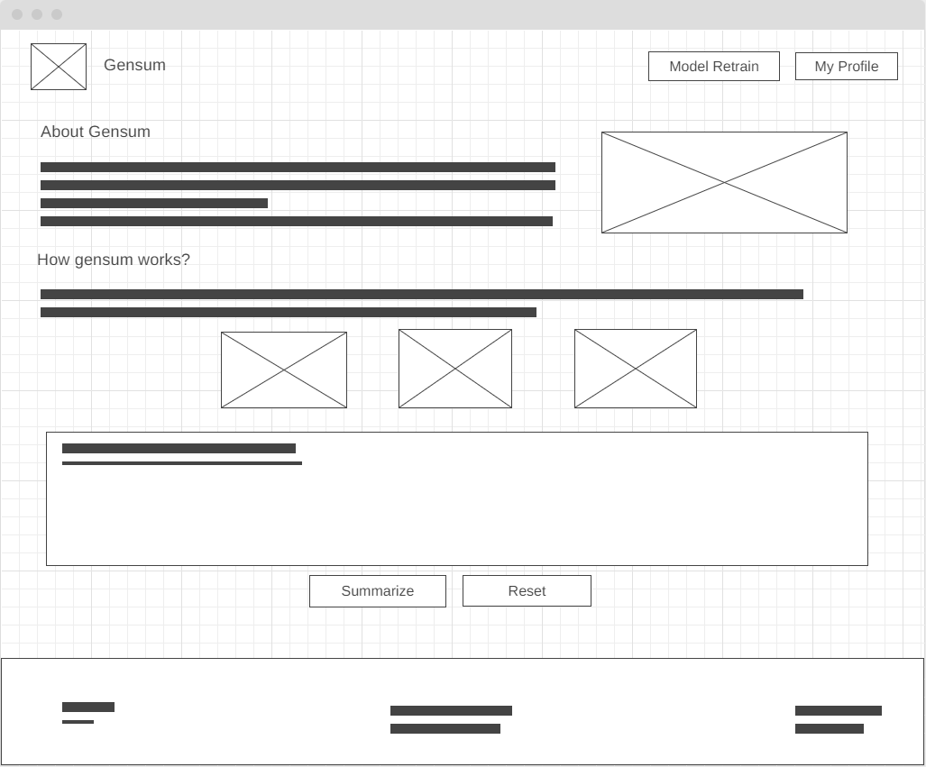

Figure 31: Review History Page (Self-Composed)

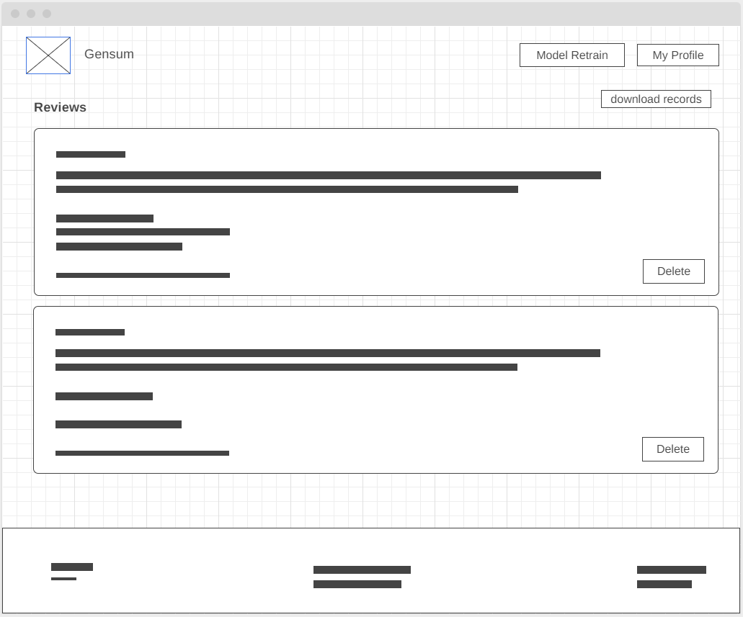

Figure 32: User Profile Page (Self-Composed)

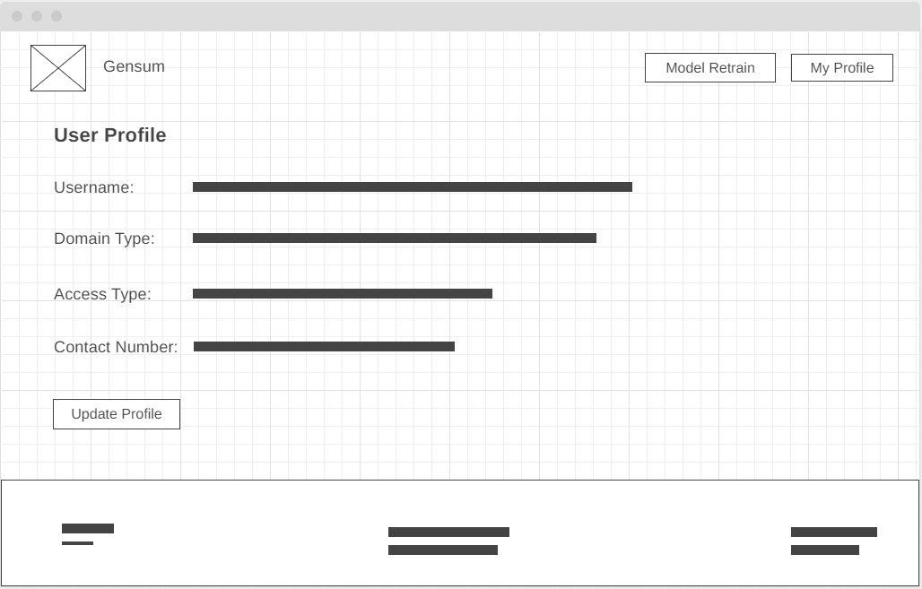

# **APPENDIX E – IMPLEMENTATION**

# **E.1. Dataset Resources**

* **CNN Dailymail**

Figure 33: CNN Dailymail Dataset ([*view*](https://www.tensorflow.org/datasets/catalog/cnn_dailymail))

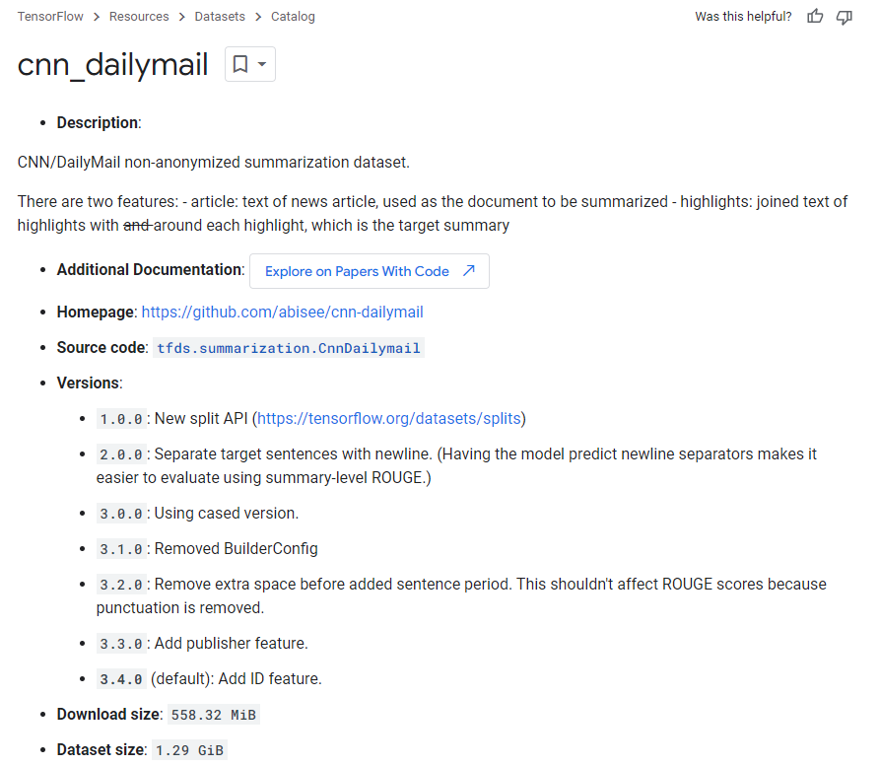

* **Gigaword**

Figure 34: Gigaword Dataset ([view](https://www.tensorflow.org/datasets/catalog/gigaword))

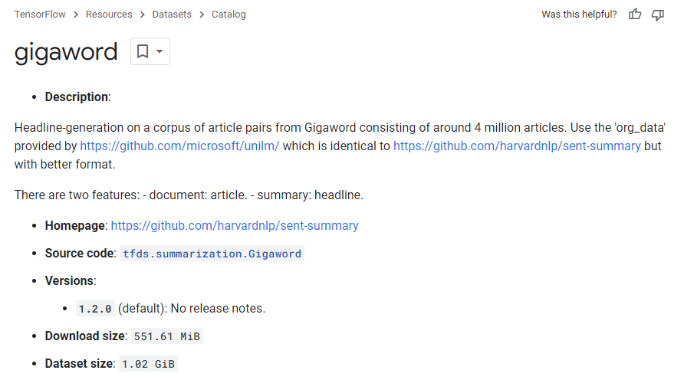

* **Xsum**

Figure 35: Xsum Dataset ([view](https://www.tensorflow.org/datasets/catalog/xsum))

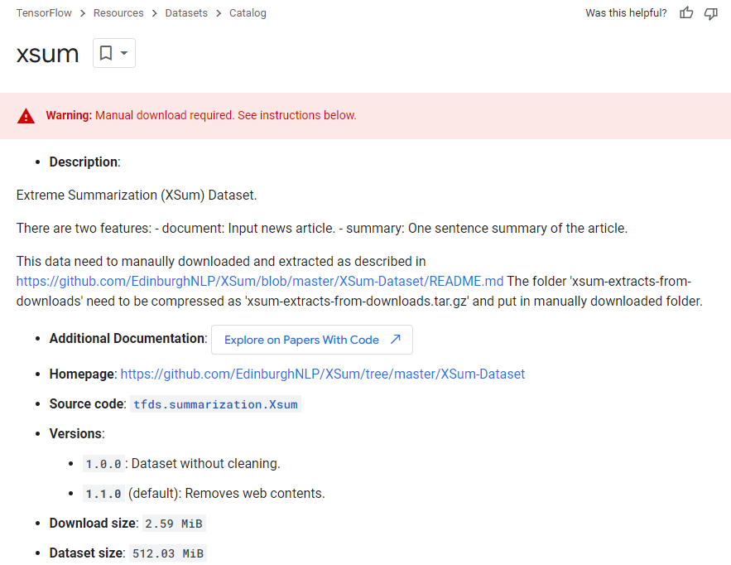

* **Amazon movie reviews**

Figure 36: Amazon Movie Reviews Dataset ([view](https://snap.stanford.edu/data/web-Movies.html))

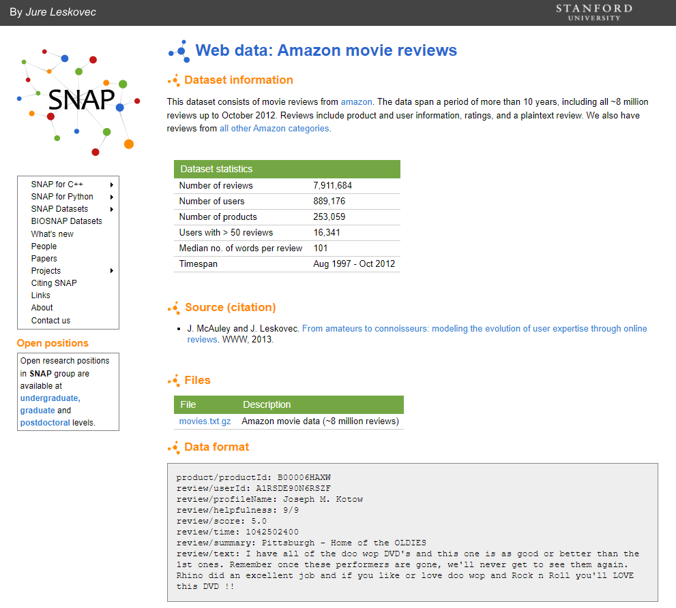

* **Hotel Reviews**

Figure 37: Hotel Reviews Dataset ([view](https://www.kaggle.com/code/jonathanoheix/sentiment-analysis-with-hotel-reviews/notebook))

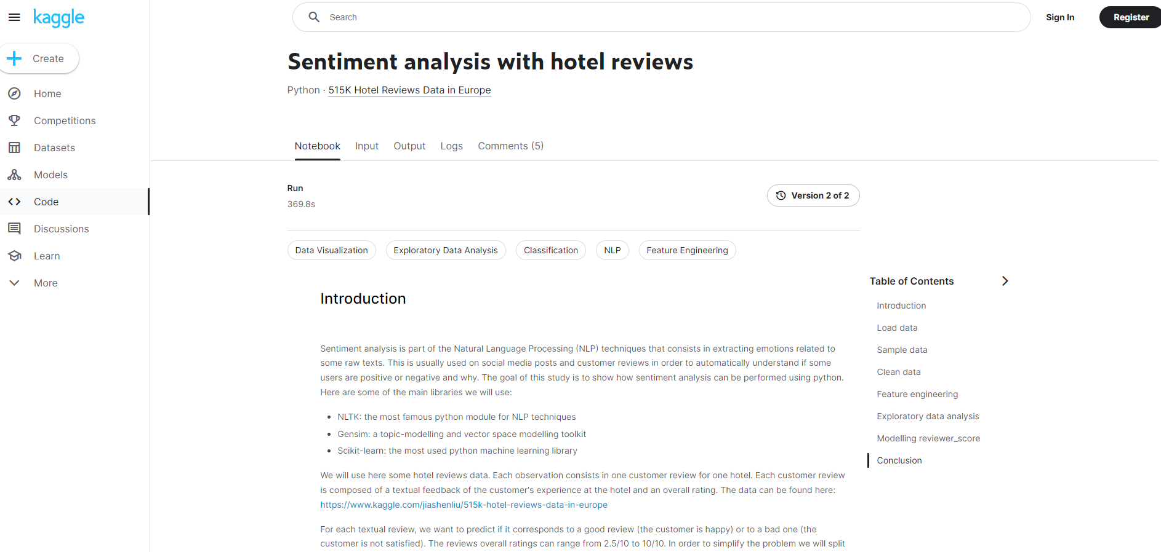

# **E.2. Selection of Programming Language**

The following table provides a summary of the evaluation of the programming language selected for the data science segment, in which each alternative was assigned a score ranging from H (High), M (Medium), to L (Low).

Table 54: Selection of Data Science Language

|  |  |  |  |
| --- | --- | --- | --- |
| **Data science**  An evaluation was conducted on two commonly utilized programming languages for data science to determine their suitability for implementing the fundamental components of data science. | | | |
| **Aspect** | **Relevance** | **Python** | **R** |
| Library availability and accessibility. | Essential to have a language that supports multiple libraries for the author to choose from, to gather data and build the model. | H | M |
| Author experience and implementation ease. | Efforts should be made to simplify the model application process, and it would be helpful if the author has experience with the chosen language. | H | M |
| Learning curve | Progress should not be hindered by the language's complexity since the goal is to utilize it as a tool to build a system, not to spend time learning it unnecessarily. | L | M |
| Documentation and Community | Clear documentation and a supportive community are vital since the author cannot afford to fix minor issues themselves. | H | M |
| **Conclusion**  After analyzing the options, the author opted for **Python** since it was more suitable. | | | |

# **E.3. Selection of Deep Learning (DL) framework**

Table 55: Selection of DL framework

|  |  |
| --- | --- |
| **Framework** | **Description** |
| TensorFlow | This tool is geared towards production-level applications and can handle large datasets. It is equipped with comprehensive documentation and has a supportive community. Additionally, it offers improved visualization options that simplify the process of debugging and monitoring training. |
| PyTorch | This tool has a higher-level development, making it more lightweight and user-friendly. It has a smaller learning curve, making it easier to start using, and it feels more intuitive since building models is simpler. |
| **Conclusion**  The author opted to use **PyTorch** due to lightweight and user-friendly feature which makes it easier to work with. | |

# **E.4. Selection of User Interface (UI) framework**

Table 56: Selection of UI framework

|  |  |
| --- | --- |
| **Framework** | **Description** |
| Angular | This tool is appropriate for large-scale applications and includes dedicated submodules for specific functionalities. However, it may be less performant than other options and can be unnecessarily heavy. |
| Vue | This framework is small and starts up quickly, and its code is straightforward, making it easy to use. Simulations have shown that it outperforms Angular and React. However, it has significantly fewer resources available. |
| Svelte | This option is the most lightweight and reactive, offering superior performance compared to others. However, it has a small community of developers and is relatively new. |
| React | This option allows for customization and promotes code reusability through functions as components. It has a large and active community and is open-source, as well as being SEO-friendly. Furthermore, the React developer tools are very useful. |
| **Conclusion**  After analyzing the options, the author selected **React** for building the GUI since it will be simple, and there is no need for a tool capable of handling large-scale applications, which is not the main focus. | |

# **E.5. Selection of Application Programming Interface (API) framework**

Table 57: Selection of web framework

|  |  |
| --- | --- |
| **Framework** | **Description** |
| Flask | This framework is extremely lightweight and offers only basic functionality. Nonetheless, it is the preferred option for ML API development due to its lightness. |
| Django | This option is appropriate for larger-scale applications that require a wide range of functionalities. However, it is more rigid and less flexible, making it more demanding and heavier. |
| **Conclusion**  The author opted for **Flask** since it provides only the essential features required for exposing an ML model. | |

# **E.6. Data Preprocessing**

Figure 38: Preprocessing: Remove Markdown (Self-Composed)

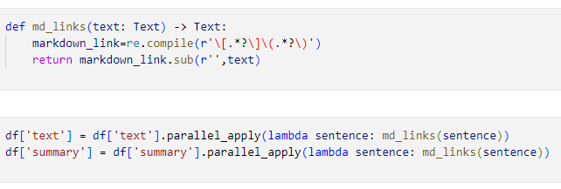

Figure 32: Preprocessing – Remove Hyperlinks (Self-Composed)

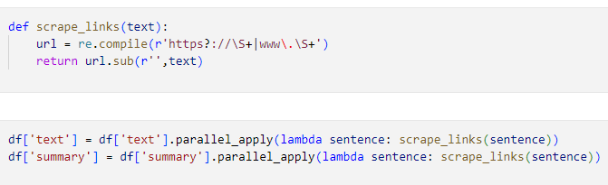

Figure 40: Preprocessing: Remove Html Tags (Self-Composed)

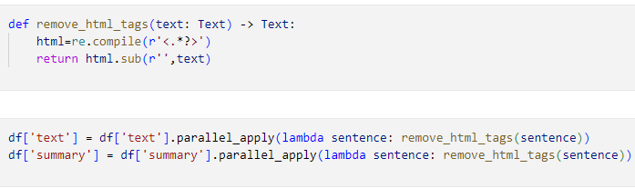

Figure 41: Preprocessing: Char Words Extension (Self-Composed)

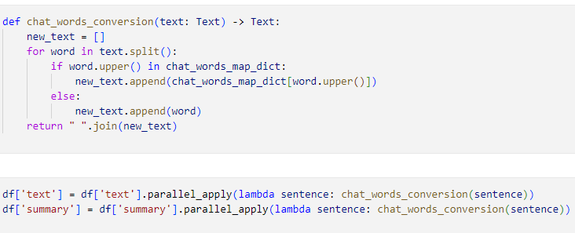

The above code snippets are used to convert the short key words into longer form, such as e.g.: ‘ATM’ is converted into ‘At the moment’

Figure 42: Preprocessing: Handling Common Contractions (Self-Composed)

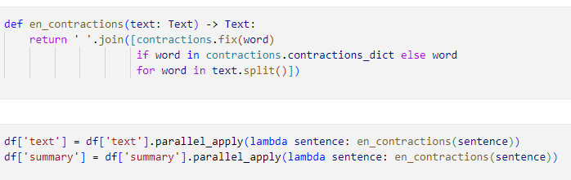

The above code snippets are used to handle/extend common contractions such as e.g.: ‘They’re’ into ‘They are’

Figure 43: Preprocessing: Removing Special Characters (Self-Composed)

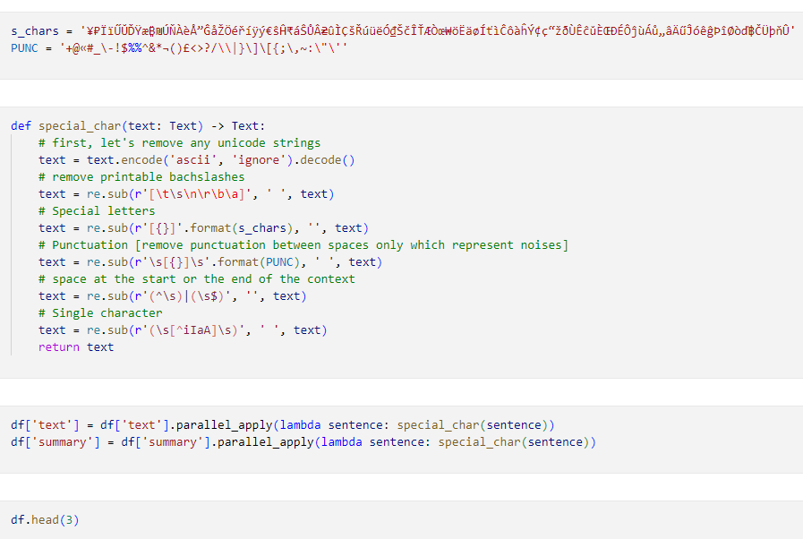

Figure 44: Preprocessing: Resolving Spelling Mistakes (Self-Composed)

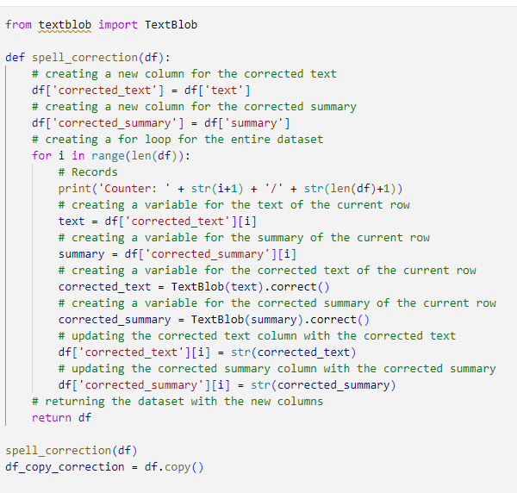

Figure 45: Preprocessing: Removing Duplicates (Self-Composed)

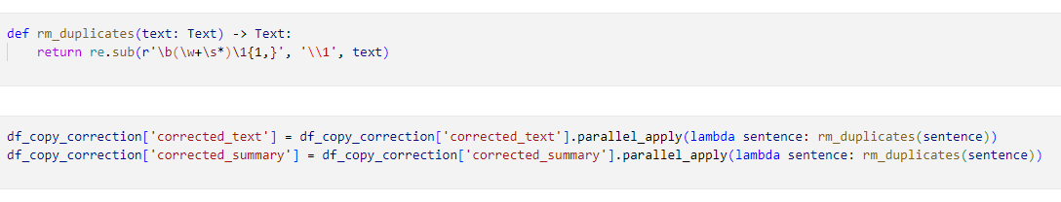

Figure 46: Preprocessing: Restoring Missing Punctuations (Self-Composed)

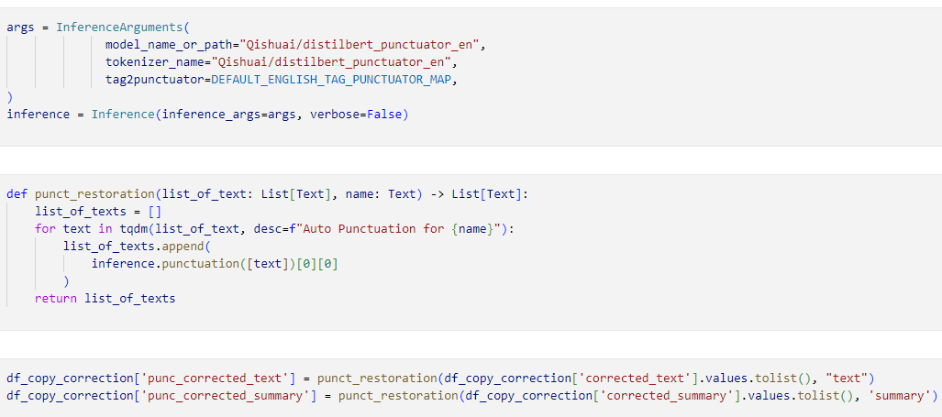

Figure 47: Preprocessing: Grammarly Correction (Self-Composed)

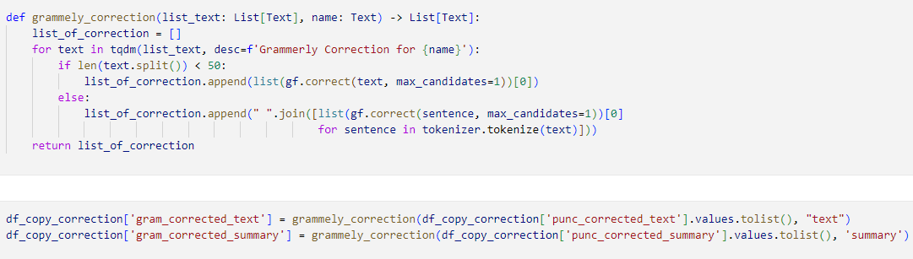

# **E.7. User interface**

Figure 48: GUI – Homepage (After Signup) (Self-Composed)

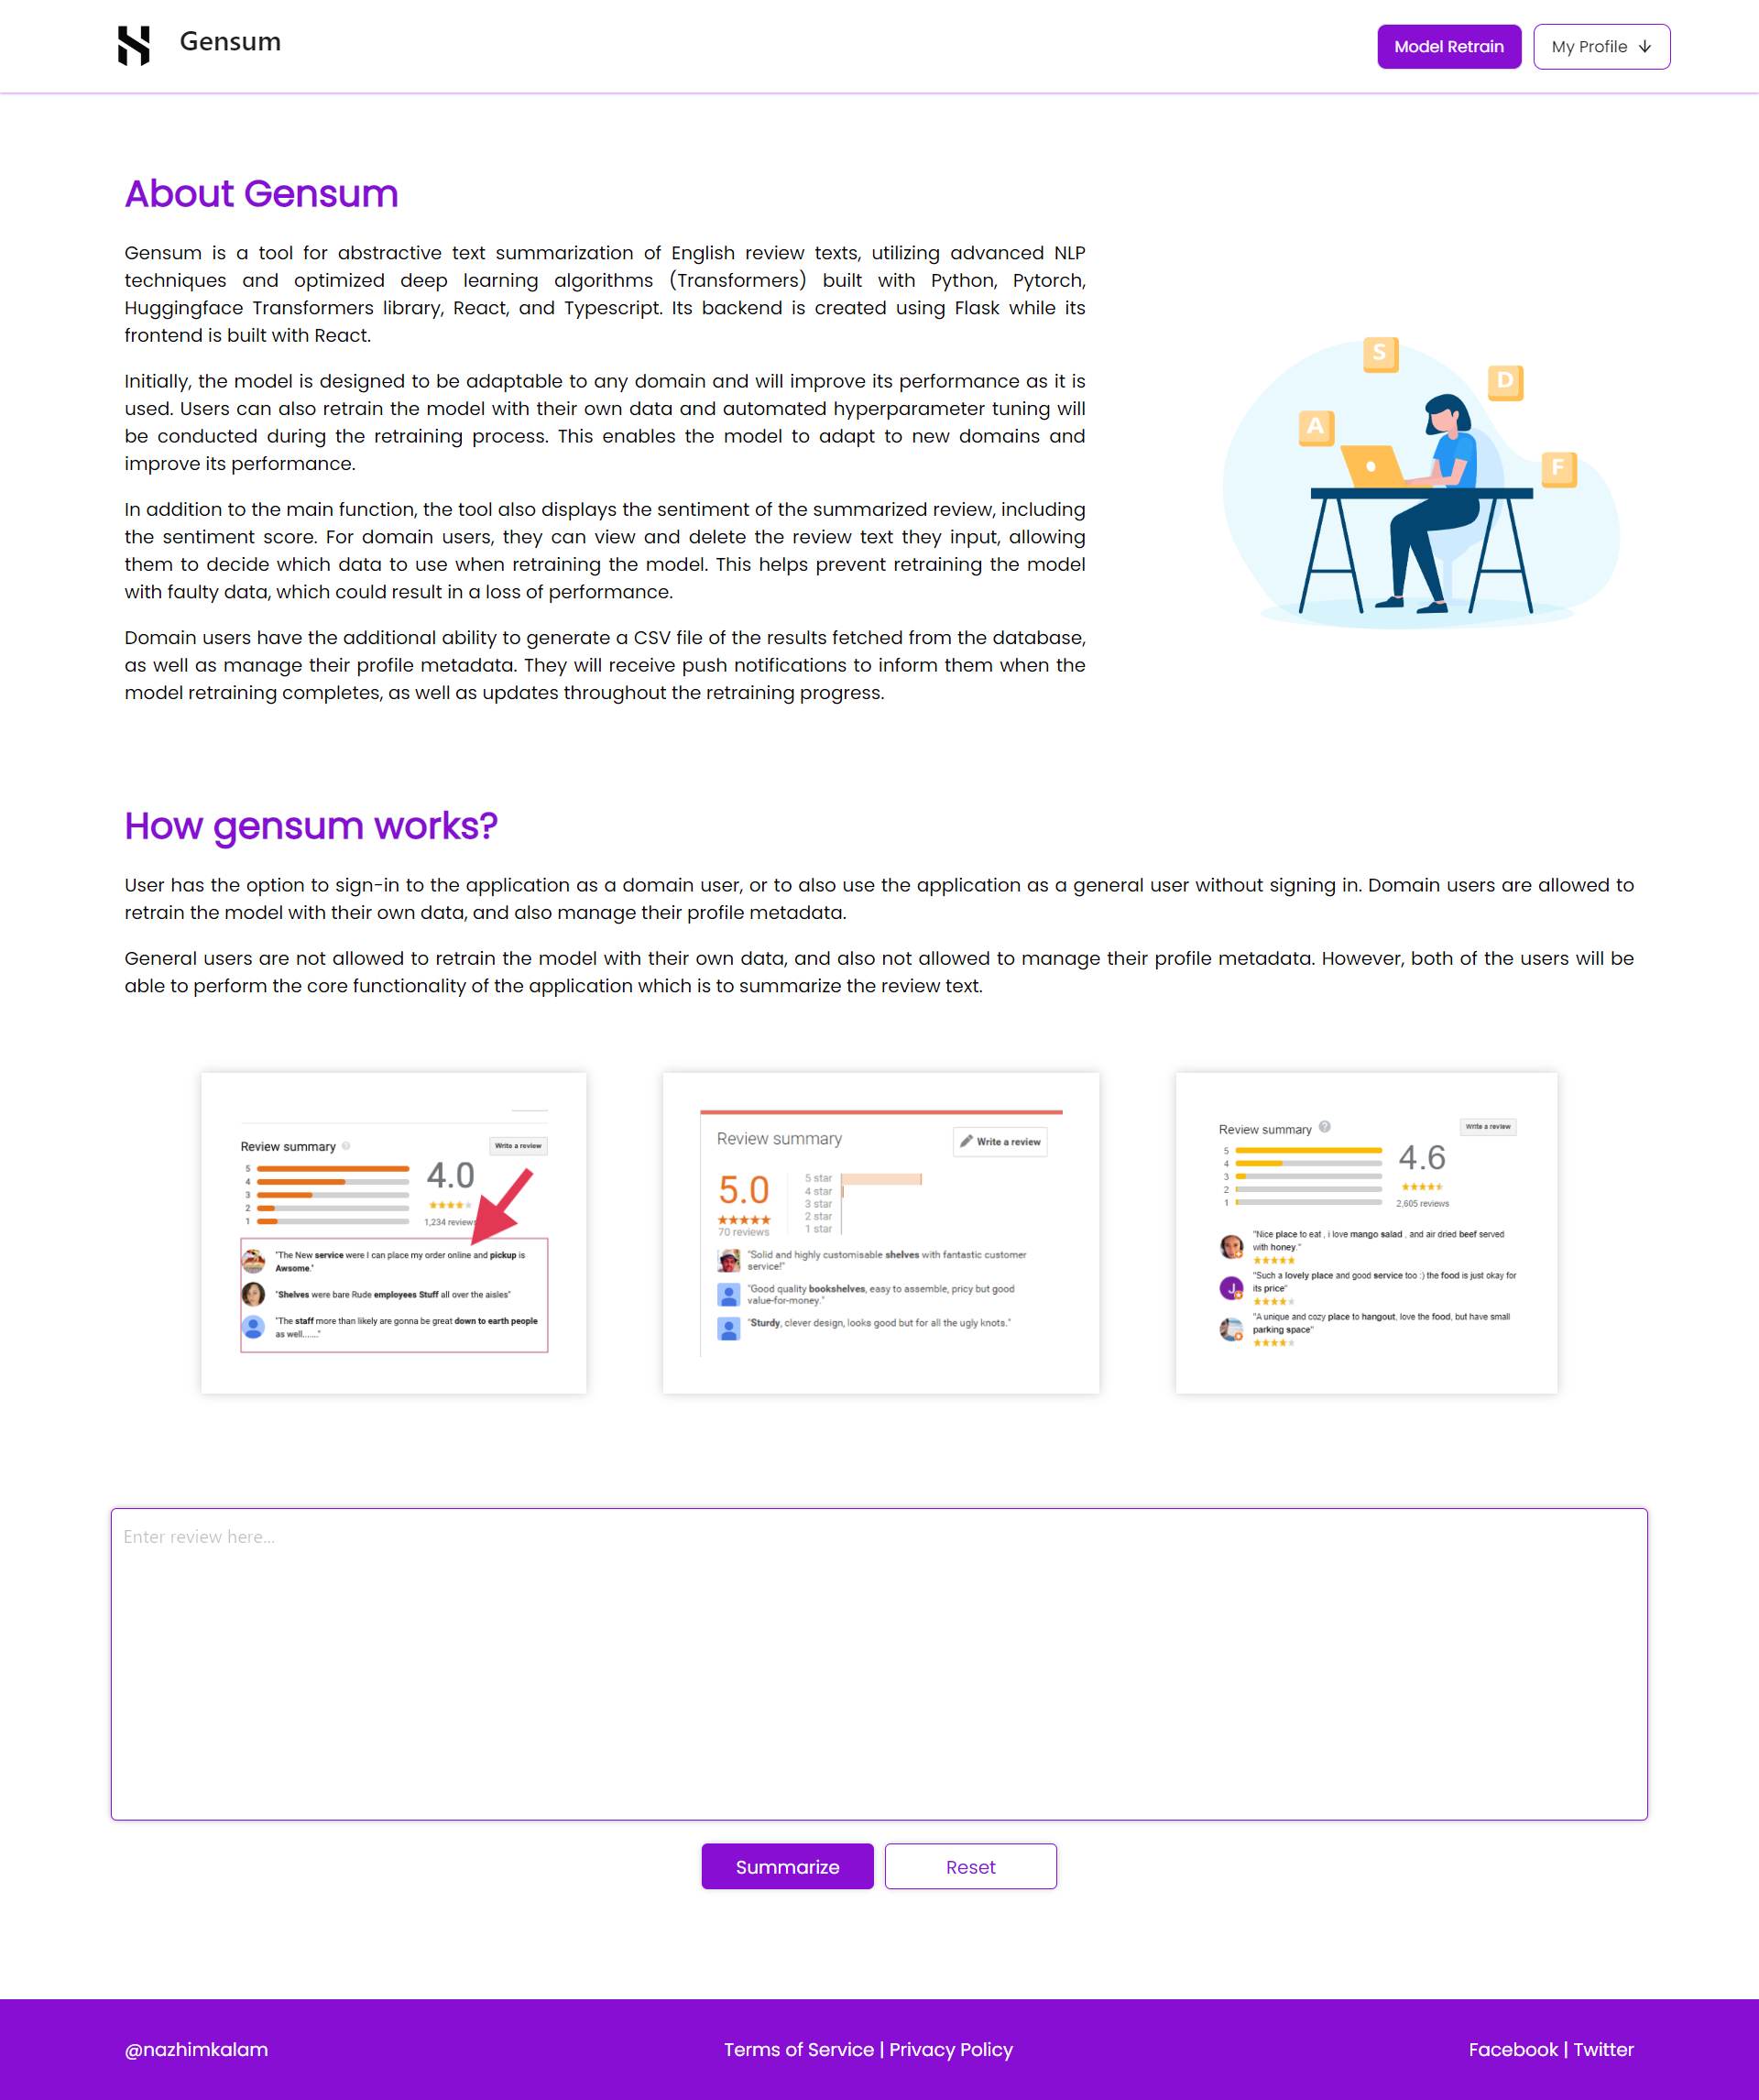

Figure 49: GUI – Review History Page (Self-Composed)

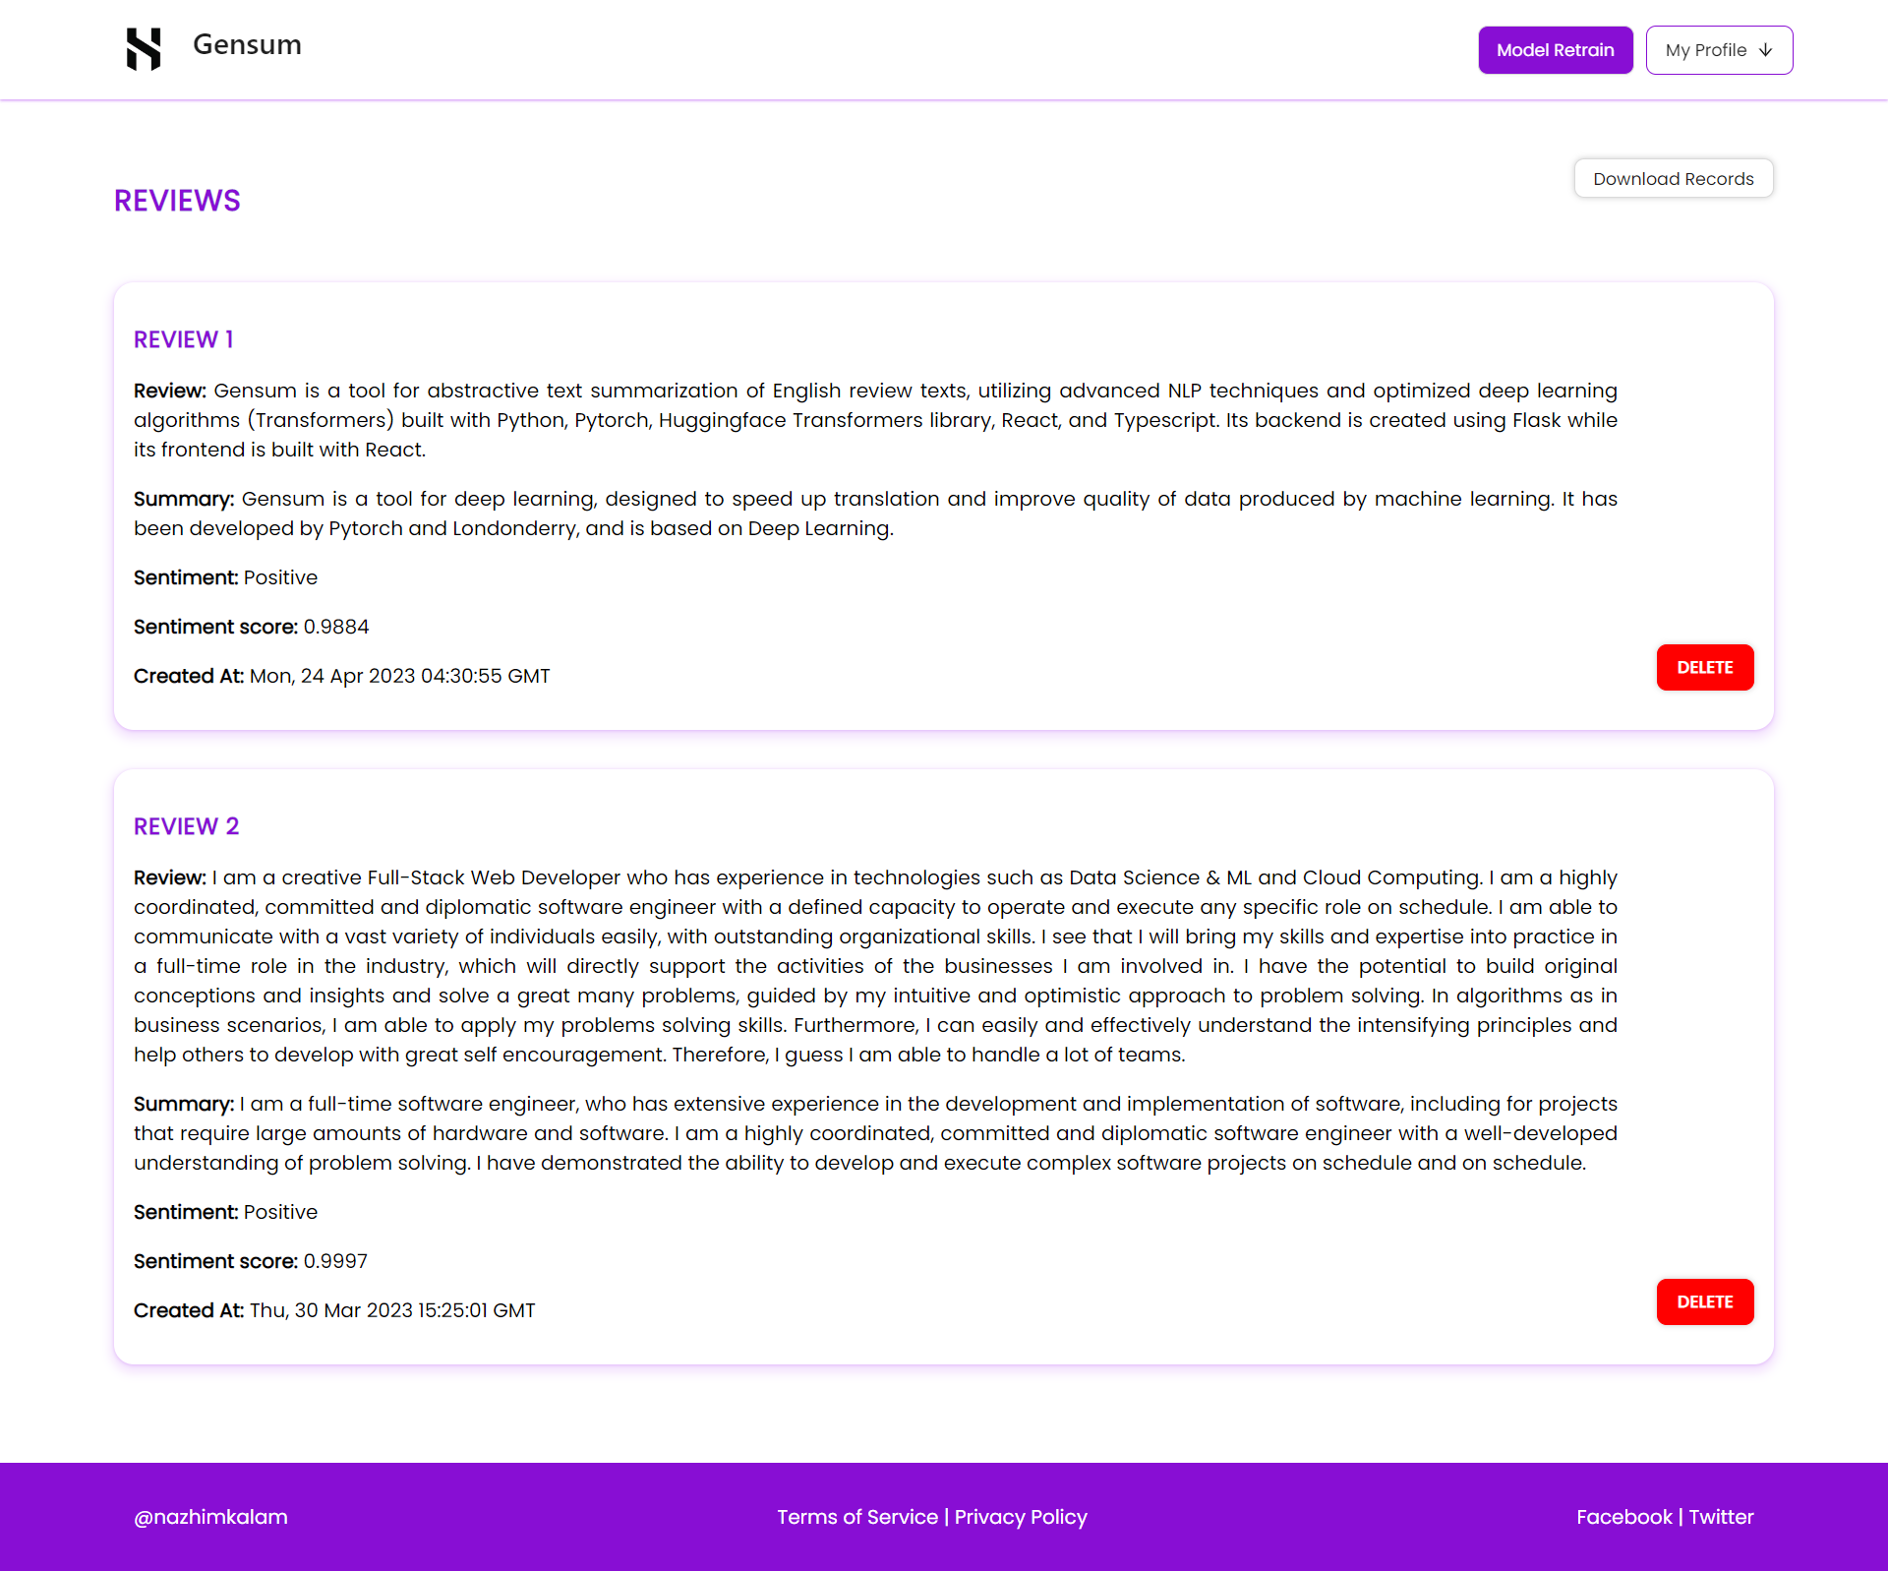

Figure 50: GUI – User Profile (Self-Composed)

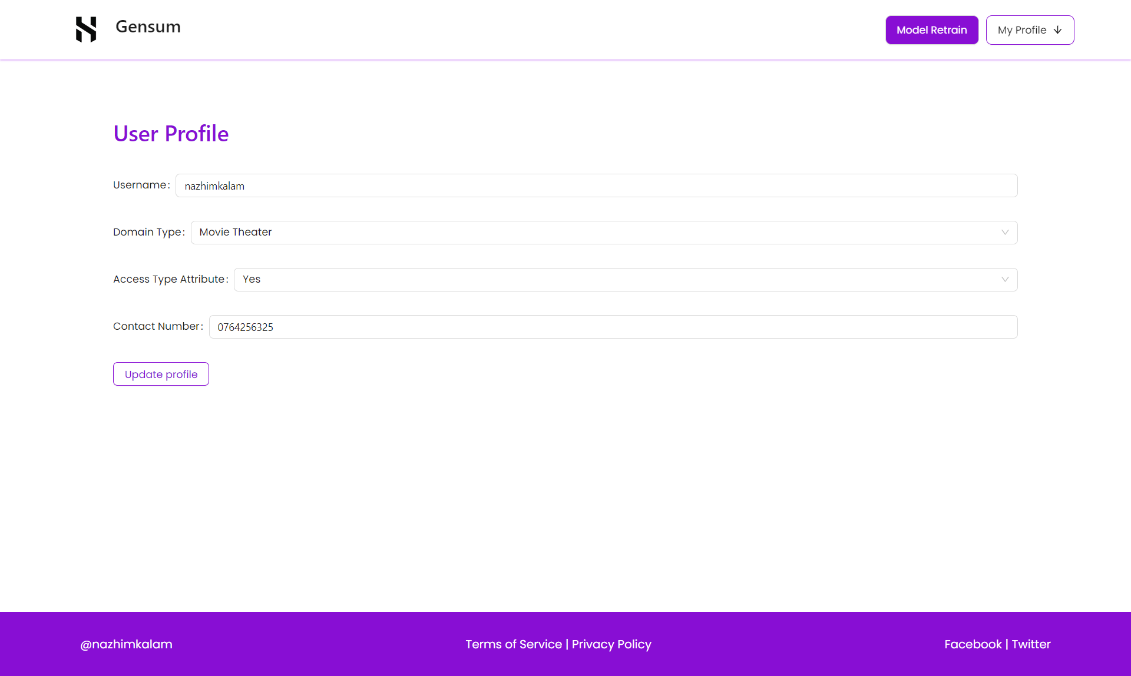

Figure 51: GUI – Model Retraining Modal (Self-Composed)

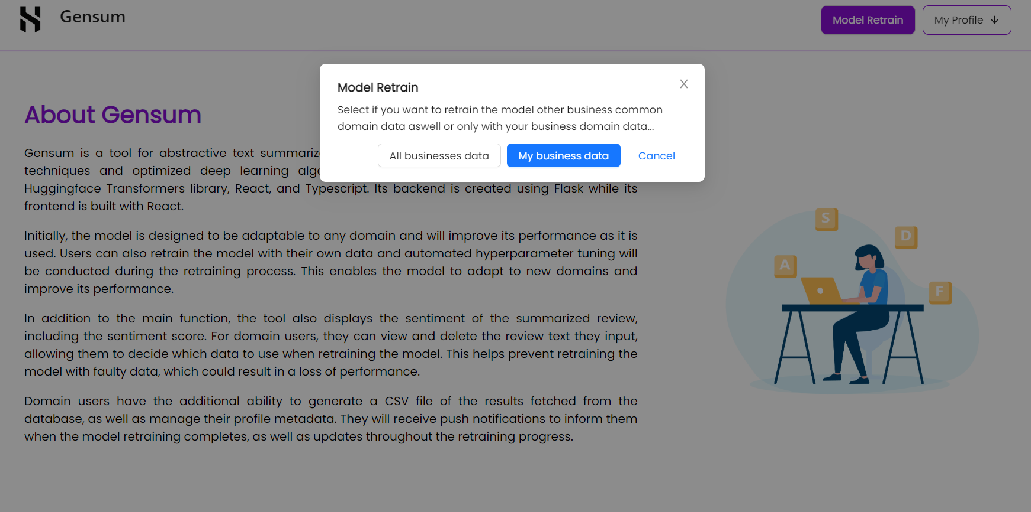

Figure 52: GUI – Homepage (Before Signup) (Self-Composed)

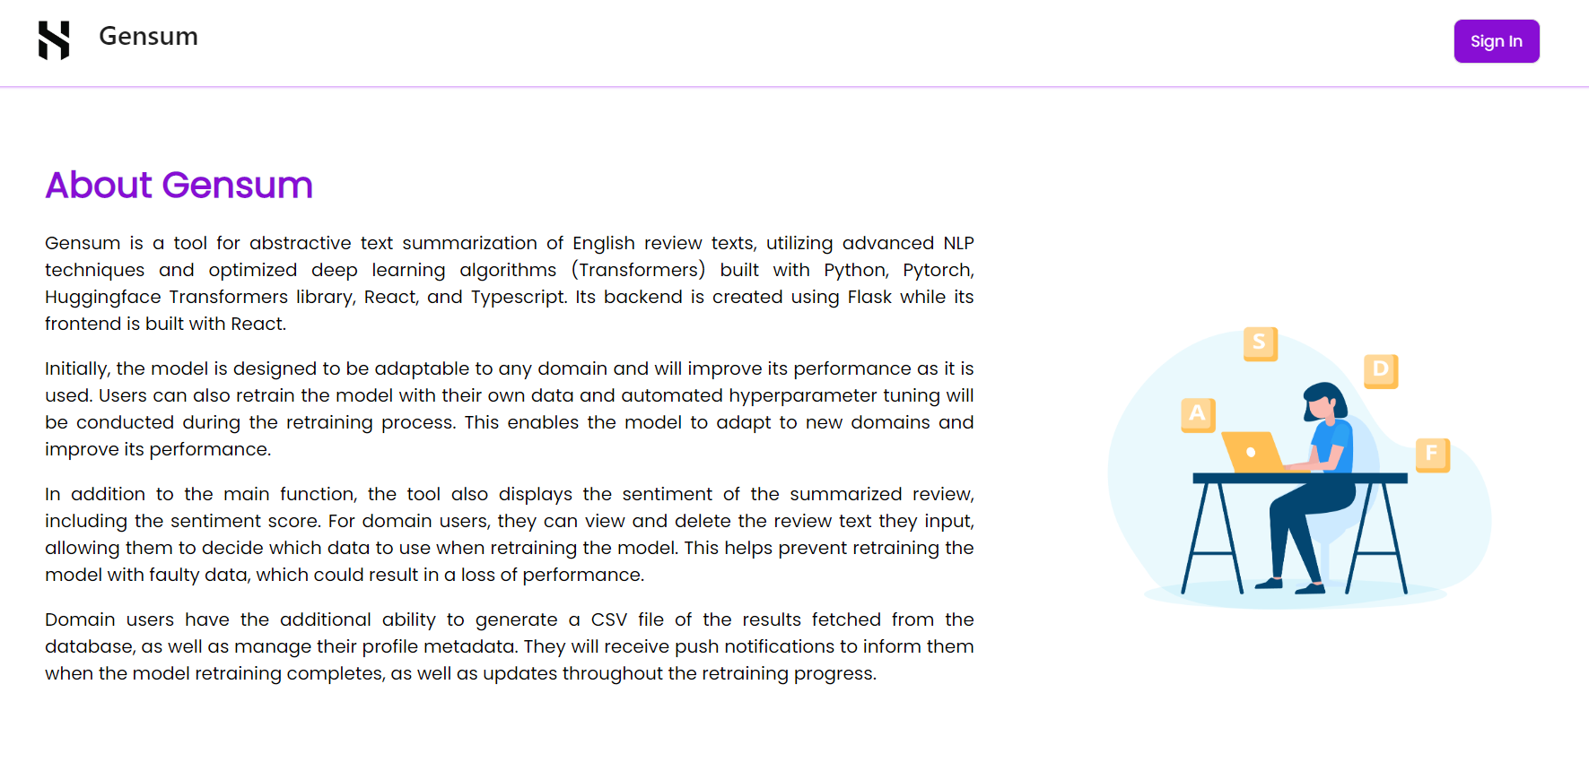

# **APPENDIX F – TESTING**

# **F.1. Functional Testing**

Table 58: Functional Testing

|  |  |  |  |  |  |
| --- | --- | --- | --- | --- | --- |
| **Test case** | **FR ID** | **User Action** | **Expected Result** | **Actual Result** | **Result Status** |
| 1 | FR1 | Users, both general and specific to the domain, can input review text to produce a summary. | Users can input review text in a provided field and generate a summary by clicking a button. | Users can input review text in a provided field and generate a summary by clicking a button. | Passed |
| 2 | FR2, FR3 | Users will click "signup" to create an account, then go to their profile to update it. | After signing up, domain users will see their personal profile and can access their pages. | After signing up, domain users will see their personal profile and can access their pages. | Passed |
| 3 | FR4 | If there is enough data in the database, domain users can click the "retrain model" button to initiate model retraining. | Users will receive a prompt to confirm model retraining, and email notifications will be sent to them to update them on the progress. | Users will receive a prompt to confirm model retraining, and email notifications will be sent to them to update them on the progress. | Passed |
| 4 | FR5 | User will be able to trigger model retraining during off peak hours. | Model retraining happens | Model retraining happens | Passed |
| 5 | FR6, FR7, FR8, FR9 | None | The system will find the new best set of hyperparameters by fetching the domain user data/groups and perform necessary preprocessing and trigger model retraining. | The system will find the new best set of hyperparameters by fetching the domain user data/groups and perform necessary preprocessing and trigger model retraining. | Passed |
| 6 | FR10 | None | The summary output will be displayed on the UI | The summary output will be displayed on the UI | Passed |
| 7 | FR11 | None | The system uses the latest retrained model for summary generation | The system uses the latest retrained model for summary generation | Passed |
| 8 | FR12 | Users can input review text to generate a summary and receive the sentiment and sentiment score of the review. | Displays the summary text along with the sentiment score and the sentiment. | Displays the summary text along with the sentiment score and the sentiment. | Passed |
| 9 | FR14 | None | The system encrypts the data and stores it in the database for model retraining purposes | The system encrypts the data and stores it in the database for model retraining purposes | Passed |

# **F.2. Non-functional testing**

In order to evaluate whether the system satisfies the non-functional requirements and design objectives, the writer utilized testing methodologies such as performance testing, GUI testing, maintainability testing, and a limited number of test cases.

**Performance testing**

At present, the author has configured the system to operate in a local environment, and the system resource manager graph below depicts the utilization of resources when the application is deployed and operational in this environment.

Figure 53: System Resource Manager Graph (Self-Composed)

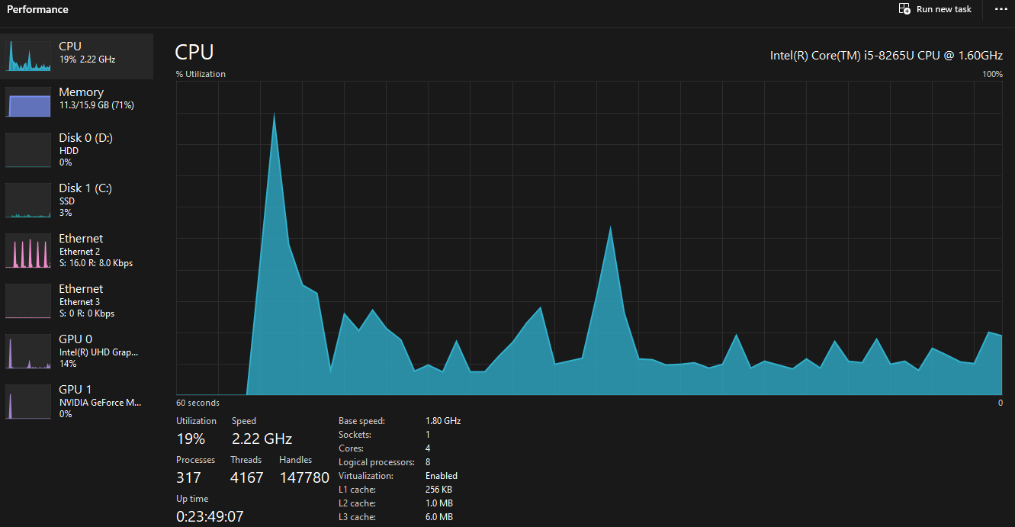

**GUI testing**

During the requirement gathering phase, it was established that developing a straightforward and efficient GUI was crucial. To assess its performance and accessibility, the GUI was evaluated using Google Lighthouse. The results of this evaluation are illustrated in the diagram below.

|  |  |
| --- | --- |
| Figure 54: Lighthouse landing page (*Self-Composed*) | Figure 55: Lighthouse login page (*Self-Composed*) |
| Figure 56: Lighthouse user profile page (*Self-Composed*) | Figure 57: Lighthouse records page (*Self-Composed*) |

**Maintainability testing**

Ensuring maintainability is essential to enable smooth future research on the system, particularly the developed algorithm. To achieve this, **CodeFactor** and **CodeQL** were employed to verify that the repositories are well-documented and maintained, and that there are no vulnerabilities present.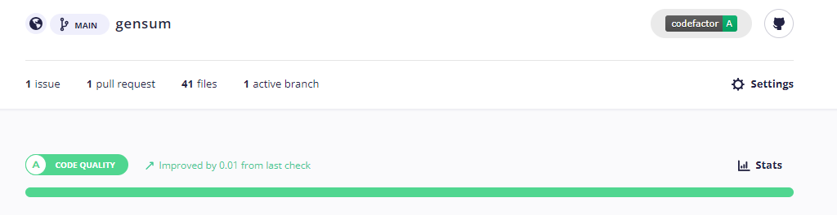

Figure 58: CodeFactor - Gensum repository (*Self-Composed*)

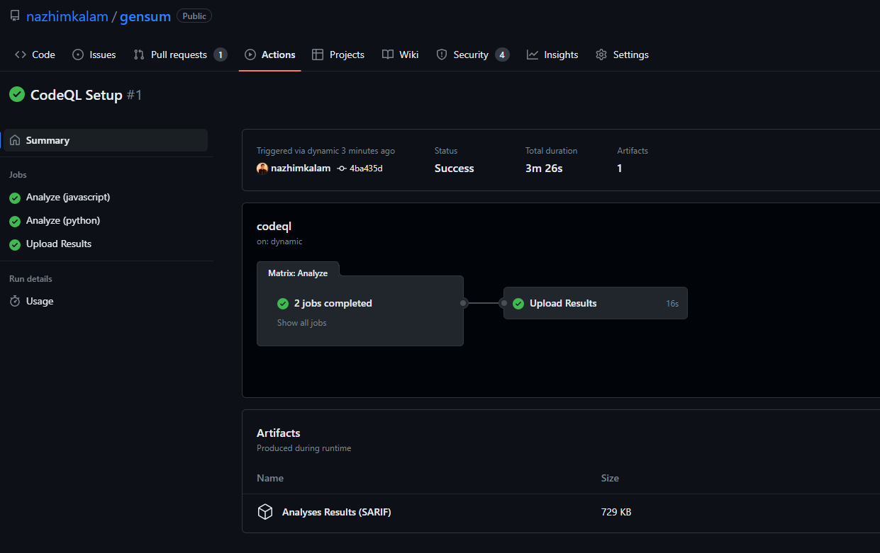

Figure 59: CodeQL - Gensum repository (*Self-Composed*)

**Test cases**

Table 59: Non-functional testing

|  |  |  |
| --- | --- | --- |
| **Non-functional requirements** | | |
| **Test case** | **ID** | **Result** |
| 1 | NFR1 | Created a minimalist UI design making it user friendly to all type of users. |
| 2 | NFR2 | Meaningful error messages are displayed on the GUI, if anything faulty happens. |
| 3 | NFR3 | The summary generation on the GUI takes an average of 5000ms |
| 4 | NFR4 | CodeQL and CodeFactor is used to maintain the coding standards up to the best quality. |
| 5 | NFR5 | The idea of model generalization with respect on the domain users works as expected. A domain specific model is created whenever a new domain user signup into the application. |
| 6 | NFR6 | Data encryption is applied for the data which are domain specific and stored in the database, to ensure that the meaning of the data is not retrained even if the data is lost. |

# **APPENDIX G – EVALUATION**

# **G.1. Expert evaluators**

Table 60: Details of the expert evaluator(s) selected.

|  |  |  |
| --- | --- | --- |
| **ID** | **Affiliation** | **Expertise related to the research** |
| EV1 | PhD Research Student in Computational Linguistics | NLP  . |
| EV2 | Machine Learning Expertise | Lecturer with PhD | ML and Neural Networks |
| EV3 | NLP Researcher | NLP |
| EV4 | Software Architect | Algorithms |
| EV5 | Software Architect & ML Researchers | ML & Algorithms |
| EV6 | VP Innovations, Software Engineer | ML & Neural Networks |
| EV7 | Lecturer with MSc | NLP |

# **G.2. Evaluation of functional requirements**

Table 61: Evaluation of the implementation of functional requirements

|  |  |  |  |  |
| --- | --- | --- | --- | --- |
| **ID** | **Description** | **Priority** | **Use Case** | **Evaluation** |
| FR1 | Both general and domain specific users must be able to enter a review text from the GUI considering as the starting point of the summary generation. | M | UC01 | Implemented |
| FR2 | Only Domain Specific Users should be able to sign up and create an account after entering the necessary details required | S | UC02 | Implemented |
| FR3 | The system could allow the ability to update the account details of the domain user after creating the account | C | UC02 | Implemented |
| FR4 | The system must undergo model retraining with the new data stored in the database for the specific domain user, when its triggered from the GUI with the user’s consent | M | UC03 | Implemented |
| FR5 | The system could be able to perform model retraining automatically during off peak hours every day. | C | UC03 | Implemented |
| FR6 | The system must be able to find the new set of best hyperparameters with the usage of the new data. | M | UC04 | Implemented |
| FR7 | The system must be able to able to retrain the model with the new best hyperparameters and create the model | M | UC05 | Implemented |
| FR8 | The system must be able to pull the new data from the database to recreate the new dataset for retraining. | M | UC06 | Implemented |
| FR9 | The system should be able to combine all the data from a common group of domains when creating the dataset only given that the consent is approved to use their data | C | UC06 | Implemented |
| FR10 | The system must be able to process the review text and display the summary output on the GUI | M | UC07 | Implemented |
| FR11 | The system must be able to use the latest trained model to generate the summary for the review text | M | UC08 | Implemented |
| FR12 | The system could also find the sentiment of the generated summary if its positive or negative and return the result. | C | UC08 | Implemented |
| FR13 | The system could make use of a hybrid model for the text summarization. | C | N/A | Not-considered |
| FR14 | The system must store the entered user review and generated summary to be stored in the database for retraining purposes. | M | UC09 | Implemented |
| FR15 | The system should encrypt the data when saving into the database (both the review and summary) | S | UC09 | Implemented |
| FR16 | The system could allow the domain users to delete the reviews from the database. | C | UC10 | Implemented |
| The percentage of functional requirements that have been fulfilled = $\frac{15}{16}*100=93.75\%$ | | | | |

# **G.3. Evaluation of non-functional requirements**

Table 62: Evaluation of the implementation of non-functional requirements

|  |  |  |  |  |
| --- | --- | --- | --- | --- |
| **ID** | **Specification** | **Description** | **Priority** | **Evaluation** |
| NFR1 | Usability | The system needs to be simple enough for non-technical individuals to utilize without much effort. | Important | Implemented |
| NFR2 | Usability | Meaningful error messages should be displayed if anything goes wrong | Desirable | Implemented |
| NFR3 | Performance | Summary generation should be done within 3000ms | Important | Implemented |
| NFR4 | Maintainability | Following coding standards and best practices | Important | Implemented |
| NFR5 | Generalization | Any domain users are able to use the application and model performance will adapt with respect to the domain | Important | Implemented |
| NFR6 | Security | The system should protect against data corruption by attackers, and testing can ensure this. | Desirable | Implemented |
| NFR7 | Scalability | The prototype can be used by several domains and multiple businesses under a single domain, then the system may have to support many concurrent user-requests. | Desirable | Not -Implemented |
| The percentage of non-functional requirements that have been fulfilled = $\frac{6}{7}*100=85.7\%$ | | | | |

Table 63: Evaluation of the achievement of design goals

|  |  |  |
| --- | --- | --- |
| **ID** | **Goal** | **Evaluation** |
| DG1 | Performance | Achieved |
| DG2 | Usability | Achieved |
| DG3 | Quality | Achieved |
| DG4 | Maintainability | Achieved |
| The percentage of achievement of design objectives. $\frac{4}{4}*100=100\%$ | | |

# **APPENDIX H – CONCLUSION**

# **H.1. Status of Research Objectives**

Table 64: Status of research objectives

|  |  |  |
| --- | --- | --- |
| **Objective** | **Description** | **Status** |
| Problem Identification | Comprehend and document the identified issue.  **RO1:** Perform research in a domain of interest and identify a sufficiently comprehensive problem that needs to be addressed.  **RO2**: Thoroughly explore and analyze potential solutions for addressing the problem.  **RO3**: Explore methods for developing an adaptive and generalized approach.  **RO4**: Create a schedule, determine associated deliverables, and develop a Gantt chart for the project. | Completed |
| Literature Review | Complete a thorough critical review of earlier related work.  **RO1:** Make a preliminary investigation on existing abstractive text summarization using deep learning approaches.  **RO2:** Make a preliminary investigation on why transformers architecture was the chosen deep learning choice for this research.  **RO3:** Analyze the top tier transformer architectures widely used.  **RO4:** Analyzing how the models can be fine-tuned via hyperparameter optimization.  **RO5:** Analyzing the different approaches used for model evaluation.  **RO6:** Analyze how the model can be generalized for every other domain. | Completed |
| Requirement Elicitation | Defining the project's needs utilizing relevant approaches and tools in order to solve the projected research gaps and obstacles based on prior related research.  **RO1:** Gathering information related to the expected metadata required for the dataset to contain for the model training.  **RO2:** Gathering the requirements of transformer architectures for fine-tuning and understand the end to end user expectations.  **RO3:** Getting insights from domain experts to build a suitable system.  **RO4:** Gathering the requirements for handling generalization. | Completed |
| Design | Considering the following when developing the suggested system:  **RO1:** Design a component to preprocess the dataset for the respective model inputs.  **RO2:** Design a component to store the top tier transformer models with their respective metadata, to use throughout.  **RO3:** Design a hyperparameter tuning component that can improve accuracy of the transformer model.  **RO4**: Design high-level architecture for the system. | Completed |
| Implementation | Setting up a mechanism capable of addressing the gaps that were intended to be covered.  **RO1**: To develop data preprocessing component.  **RO2**: To develop a component that handles and stores the top tier transformer architectures for fine-tuning.  **RO3**: To develop the automated hyperparameter search component that handles all the top tier architectures assigned.  **RO4**: To develop a component for the model evaluations for the measured hyperparameters  **RO5**: Consider legal, social, ethical, and professional issues during implementation. | Completed |
| Evaluation | Effectively test the algorithm implemented, the system, and the respective data science model using recommended techniques.  **R**O27: Evaluate the developed algorithm and the respective model against the evaluation metrics researched in the literature review.  **R**O28: Create a test plan & test cases and perform unit, performance, and integration testing. | Completed |
| Documentation | Record the progress of the research project and report any encountered challenges.  **R**O29: Produce a cohesive report that details newly acquired skills, evaluations, contributions, etc., and verify that all previously stated objectives have been accomplished. | Completed |

# **H.2. Achievement of Learning Outcomes**

Table 65: Achievement of learning outcomes

|  |  |
| --- | --- |
| **Description** | **LO(s)** |
| The project was divided into smaller problems, and each problem was further broken down into manageable parts. Each part was addressed separately by using relevant techniques obtained from analyzing literature and project requirements. | LO1 |
| The project plan was designed by identifying the components and setting them as milestones to be accomplished within a specific timeframe, ensuring the project's timely completion. | LO2 |
| The author collected and analyzed project requirements from two groups: academic researchers and end-users, which provided valuable insights for developing the system and determining which features to prioritize. | LO3 |
| The author critically reviewed the literature to comprehend the concepts pertinent to the domain. | LO4 |
| Upon obtaining the requirements, insights, and knowledge, the author proceeded to address the two subproblems incrementally, acquiring new skills where necessary. The supervisor provided regular guidance to ensure that the project was progressing as planned, with milestone deliverables being produced accordingly. Any SLEP considerations were considered and documented as well. | LO5,  LO6,  LO7 |
| The author documented the progress of the research by presenting each chapter to the supervisor as a milestone and incorporating feedback from both the supervisor and module leader. Prior to completing the dissertation, two document artifacts - the project proposal and PSDP - were submitted. Additionally, the author presented papers at conferences to validate their proposed solution. | LO8 |

# **APPENDIX I – CONCEPT MAP**

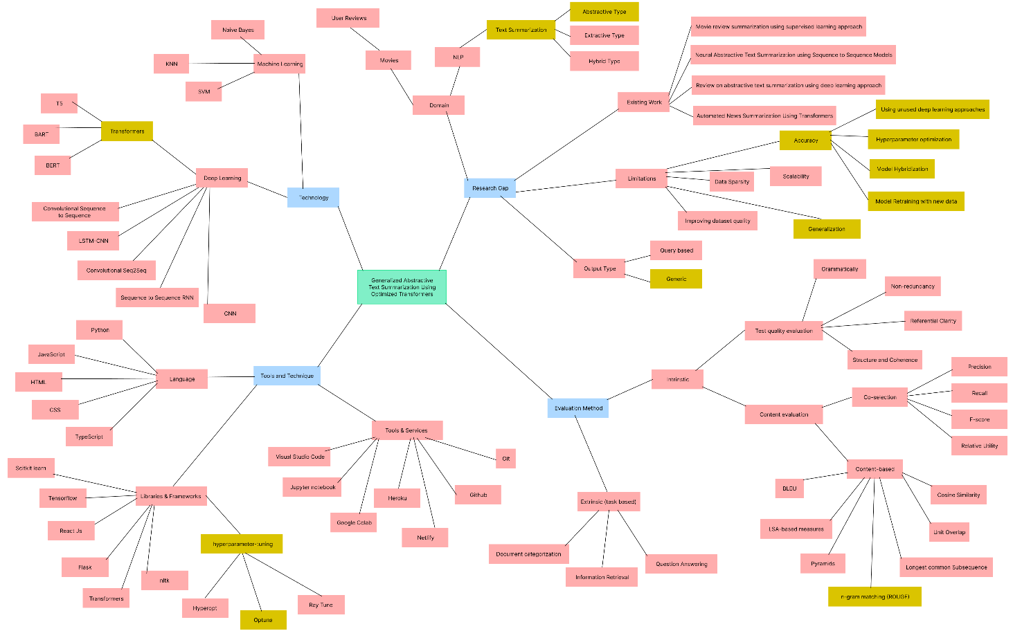

*An enhanced version of the concept map can be found* [*here*](https://drive.google.com/file/d/1o8CbD8ZbRQpNbYviCQPYxUWLKO3GctUl/view)*.*

# **APPENDIX J – REVIEW PAPER**

